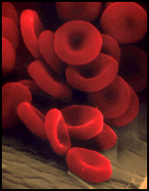
The CELL THEORY, or cell doctrine, states that all organisms are composed of similar units of organization, called cells. The concept was formally articulated in 1839 by Schleiden & Schwann and has remained as the foundation of modern biology. The idea predates other great paradigms of biology including Darwin's theory of evolution (1859), Mendel's laws of inheritance (1865), and the establishment of comparative biochemistry (1940).
Modern molecular biology has added many tenets to the cell theory, but it remains as the preeminent theory of biology. The Cell Theory is to Biology as Atomic Theory is to Physics.
Formulation of the Cell Theory
In 1838, Theodor Schwann and Matthias Schleiden were enjoying after-dinner coffee and talking about their studies on cells. It has been suggested that when Schwann heard Schleiden describe plant cells with nuclei, he was struck by the similarity of these plant cells to cells he had observed in animal tissues. The two scientists went immediately to Schwann's lab to look at his slides. Schwann published his book on animal and plant cells (Schwann 1839) the next year, a treatise devoid of acknowledgments of anyone else's contribution, including that of Schleiden (1838). He summarized his observations into three conclusions about cells:
1) The cell is the unit of structure, physiology, and organization in living things.
2) The cell retains a dual existence as a distinct entity and a building block in the
construction of organisms.
3) Cells form by free-cell formation, similar to the formation of crystals (spontaneous generation).
We know today that the first two tenets are correct, but the third is clearly wrong. The correct interpretation of cell formation by division was finally promoted by others and formally enunciated in Rudolph Virchow's powerful dictum, "Omnis cellula e cellula"... "All cells only arise from pre-existing cells".
The modern tenets of the Cell Theory include:
1. all known living things are made up of cells.
2. the cell is structural & functional unit of all living things.
3. all cells come from pre-existing cells by division.
(Spontaneous Generation does not occur).
4. cells contains hereditary information which is passed from
cell to cell during cell division.
5. All cells are basically the same in chemical composition.
6. all energy flow (metabolism & biochemistry) of life occurs within cells.
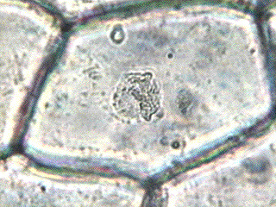

As with any theory, its tenets are based upon previous observations and facts, which are synthesized into a coherent whole via the scientific method. The Cell Theory is no different being founded upon the observations of many. (Landmarks in the Study of Cells)
Credit for the first compound (more than one lens) microscope is usually given to Zacharias Jansen, of Middleburg, Holland, around the year 1595. Since Jansen was very young at that time, it's possible that his father Hans made the first one, but young Jansen perfected the production. Details about the first Jansen microscopes are not clear, but there is some evidence which allows us to make some guesses about them (Jansen microscopes).
In 1663 an English scientist, Robert Hooke, discovered cells in a piece of cork, which he examined under his primitive microscope (figures). Actually, Hooke only observed cell walls because cork cells are dead and without cytoplasmic contents. Hooke drew the cells he saw and also coined the word CELL. The word cell is derived from the Latin word 'cellula' which means small compartment. Hooke published his findings in his famous work, Micrographia: Physiological Descriptions of Minute Bodies made by Magnifying Glasses (1665).
Ten years later Anton van Leeuwenhoek (1632-1723), a Dutch businessman and a contemporary of Hooke used his own (single lens) monocular microscopes and was the first person to observe bacteria and protozoa. Leeuwenhoek is known to have made over 500 "microscopes," of which fewer than ten have survived to the present day. In 1673, Leeuwenhoek began writing letters to the newly formed Royal Society of London, describing what he had seen with his lenses. His first letter contained some observations on the stings of bees. For the next fifty years he corresponded with the Royal Society. His observations, written in Dutch, were translated into English or Latin and printed in the Philosophical Transactions of the Royal Society. Leeuwenhoek looked at animal and plant tissues, at mineral crystals, and at fossils. He was the first to see microscopic single celled protists with shells, the foraminifera, which he described as "little cockles. . . no bigger than a coarse sand-grain." He discovered blood cells, and was the first to see living sperm cells of animals. He discovered microscopic animals such as nematodes (round worms) and rotifers. The list of his discoveries is long. Leeuwenhoek soon became famous as his letters were published and translated. In 1680 he was elected a full member of the Royal Society.
Between 1680 and the early 1800's it appears that not much was accomplished in the study of cell structure. This may be due to the lack of quality lens for microscopes and the dedication to spend long hours of detailed observation over what microscopes existed at that time. Leeuwenhoek did not record his methodology for grinding quality lenses and thus microscopy suffered for over 100 years.
German natur-philosopher and microscopist, Lorenz Oken had been trained in medicine at Freiburg University. He went on to become a renowned philosopher and thinker of the 19th century. It is reported that in 1805 Oken stated that "All living organisms originate from and consist of cells"... which may have been the first statement of a cell theory.
Around 1833 Robert Brown reported the discovery of the nucleus. Brown was a naturalist who visited the "colonies of Australia" from 1801 through 1805, where he cataloged and described over 1,700 new species of plants. In the course of his microscopic studies of the epidermis of orchids, discovered in these cells "an opaque spot," which he named the nucleus. Doubtless the same "spot" had been seen often enough before by other observers, but Brown was the first to recognize it as a component part of the vegetable cell and to give it a name. This nucleus of the cell was not confined to only orchids, but was equally manifest in many other monocotyledonous families and in the epidermis of dicotyledonous plants, and even in the early stages of development of the pollen.
It is upon the works of Hooke, Leeuwenhoek, Oken, and Brown that Schleiden and Schwann built their Cell Theory. It was the German professor of botany at the University of Jena, Dr. M. J. Schleiden, who brought the nucleus to popular attention, and to asserted its all-importance in the function of a cell. Schleiden freely acknowledged his indebtedness to Brown for first knowledge of the nucleus, but he soon carried out his own observations of the nucleus, far beyond those of Brown. He came to believe that the nucleus is really the most important portion of the cell, in that it is the original structure from which the remainder of the cell is developed. He called it the cytoblast. He outlined his views in an epochal paper published in Muller's Archives in 1838, under title of "Beitrage zur Phytogenesis." This paper is in itself of value, yet the most important outgrowth of Schleiden's observations of the nucleus did not spring from his own labors, but from those of a friend to whom he mentioned his discoveries the year previous to their publication. This friend was Dr. Theodor Schwann, professor of physiology in the University of Louvain.
Schwann was puzzling over certain details of animal histology which he could not clearly explain. He had noted a strange resemblance of embryonic cord material, from which the spinal column develops, to vegetable cells. Schwann recognized a cell-like character of certain animal tissues. Schwann felt that this similarity could not be mere coincidence, and it seemed to fit when Schleiden called his attention to the nucleus. Then at once he reasoned that if there really is the correspondence between vegetable and animal tissues that he suspected, and if the nucleus is so important in the vegetable cell as Schleiden believed, the nucleus should also be found in the ultimate particles of animal tissues. A closer study of animal tissues under the microscope showed, in particular in embryonic tissues, that the "opaque spots" that Schleiden described were found in abundance. The location of these nuclei at comparatively regular intervals suggested that they are found in definite compartments of the tissue, as Schleiden had shown to be the case with vegetables; indeed, the walls that separated such cell-like compartments one from another were in some cases visible. Soon Schwann was convinced that his original premise was correct, and that all animal tissues are composed of cells not unlike the cells of vegetables. Adopting the same designation, Schwann propounded what soon became famous as the CELL THEORY. So expeditious was his observations that he published a book early in 1839, only a few months after the appearance of Schleiden's paper.
The main theme of his book was to unify vegetable and animal tissues. Accepting cell-structure as the basis of all vegetable tissues, he sought to show that the same is true of animal tissues.
And by cell Schwann meant, as did Schleiden also, what the word ordinarily implies--a cavity walled in on all sides. He knew that the cell might be filled with fluid contents, but he regarded these as relatively subordinate in importance to the nucleus and cell wall.
Their main thesis, the similarity of development of vegetable and animal tissues and the cellular nature of life, was supported almost immediately by a mass of carefully gathered evidence which a multitude of microscopists confirmed. So Schwann's work became a classic almost from the moment of its publication. Various other workers disputed Schwann's claim to priority of discovery, in particular an English microscopist, Valentin, who asserted that he was working closely along the same lines. So did many others, such as Henle, Turpin, Du-mortier, Purkinje, and Muller, all of whom Schwann himself had quoted in his work. Many physiologists had, earlier than any of the above, foreshadowed the cell theory, including Kaspar Friedrich Wolff around the close of the previous century, and Treviranus in 1807.
But, as we have seen in the scientific method, it is one thing to foreshadow a discovery, it is quite another to give it full expression and make it the cornerstone of future discoveries. And when Schwann put forward the explicit claim that "there is one universal principle of development for the elementary parts, of organisms, however different, and this principle is the formation of cells," he enunciated a doctrine which was for all practical purposes absolutely new and opened up a novel field for the microscopist to enter. A most important era in Cell Biology dates from the publication of his book in 1839.
Prior to 1931 when the first electron microscope (Fig. 1.9) was developed, magnification of microscopes was limited to about 2 000 times. The small cell structures did not show up well or remained invisible. The electron microscope not only showed more detail of previously known parts of the cell but also revealed new parts. Cells and cell structures can now be examined at magnifications of up to 500 000 times and more.
Cell Theory
The discovery of cells and their structure is linked to the development of the magnifying lenses, particularly the microscope.
1665 Robert Hooke
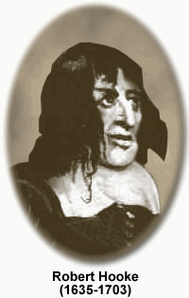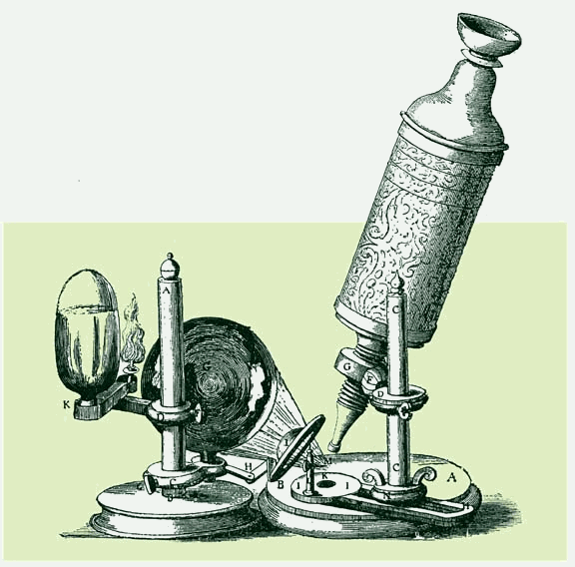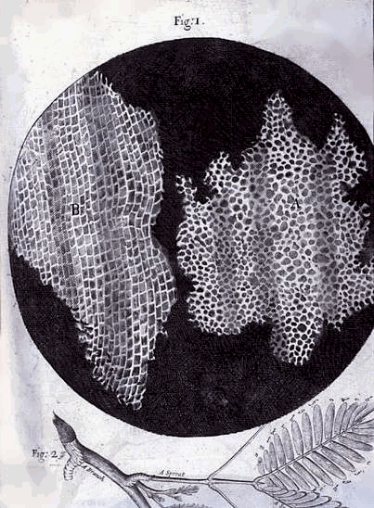
Reported to the Royal Society of London his observation of "Cells" in a piece of cork.
"These pores or cells, were not very deep, but consisted of a great many little boxes, separated out of one continued long pore, by certain diaphragms."
It was over 100 years however, until the study of cells took in the importance that we now give it.
Many scientists of the time recognised the importance of cells as building blocks of living tissue. But not until 1838-39 did the general statement of "cell theory" receive general acceptance.

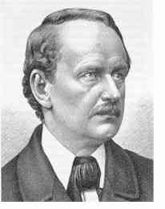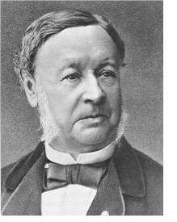
M.J. Schleiden Theodor Schwann
M.J. Schleiden and Theodor Schwann both published separate conclusions that expressed the principle of cell theory.
"all living things are composed of living cells"
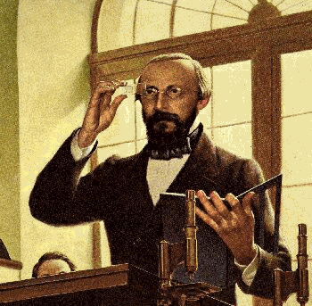 Rudolf Virchow
Twenty years later in 1855 Rudolf Virchow proposed an important extension of cell theory that "All living cells arise from pre-existing cells". ("Omnis cellula e celula") This statement has become what is known as the "Biogenic law".
This idea flew in the face of current doctrine. It implied that there was no spontaneous creation of cells from non-living matter.
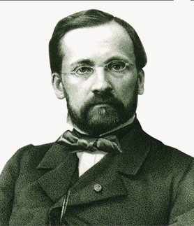 Loisis Pasteur
Loisis Pasteur in 1862 provided proof of this idea with the following classic experiment.
Pasteur's Experiment
Nutrient broths were heated and sterilized in a flask with a straight neck and a curved neck.
a) As his control, Pasteur used flasks with straight necks that permitted bacteria to settle into the broth. In these flasks, the broth was soon teaming with bacteria.
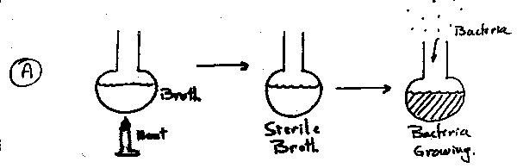
b) Pasteur's experimental flasks had long S-shaped necks. With such necks bacteria could not enter, even though they were exposed to air. Therefore no bacteria grew.
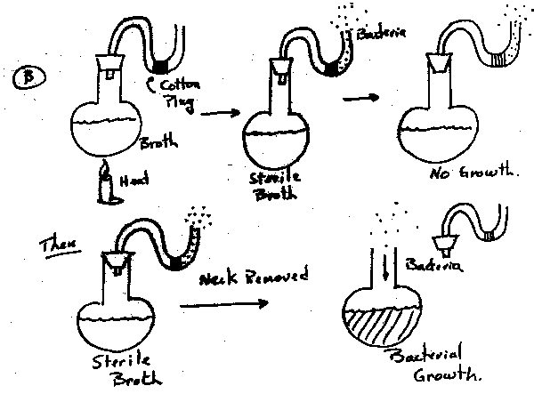
c) When the S-shaped neck was removed bacteria began to grow in the sterile media.
August Weissman 1880 introduce an important corollary to the biogenic law which was:
"that cells living today can trace their ancestry back to ancient times" i.e. there must be a common ancestral cell.
All living organisms are composed of cells, and all cells arise from other cells. These simple and powerful statements form the basis of the cell theory, first formulated by a group of European biologists in the mid-1800s. So fundamental are these ideas to biology that it is easy to forget they were not always thought to be true.
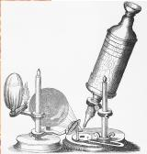
Robert Hooke's microscope. Hooke first described cells in 1665.

Early Observations
The invention of the microscope allowed the first view of cells. English physicist and microscopist Robert Hooke (1635–1702) first described cells in 1665. He made thin slices of cork and likened the boxy partitions he observed to the cells (small rooms) in a monastery. The open spaces Hooke observed were empty, but he and others suggested these spaces might be used for fluid transport in living plants. He did not propose, and gave no indication that he believed, that these structures represented the basic unit of living organisms.
Marcello Malpighi (1628–1694), and Hooke's colleague, Nehemiah Grew (1641–1712), made detailed studies of plant cells and established the presence of cellular structures throughout the plant body. Grew likened the cellular spaces to the gas bubbles in rising bread and suggested they may have formed through a similar process. The presence of cells in animal tissue was demonstrated later than in plants because the thin sections needed for viewing under the microscope are more difficult to prepare for animal tissues. The prevalent view of Hooke's contemporaries was that animals were composed of several types of fibers, the various properties of which accounted for the differences among tissues.
At the time, virtually all biologists were convinced that organisms were composed of some type of fundamental unit, and it was these "atomistic" preconceptions that drove them to look for such units. While improvements in microscopy made their observations better, it was the underlying belief that there was some fundamental substructure that made the microscope the instrument of choice in the study of life.
In 1676 the Dutch microscopist Antony van Leeuwenhoek (1632–1723) published his observations of single-cell organisms, or "little animalcules" as he called them. It is likely that Leeuwenhoek was the first person to observe a red blood cell and a sperm cell. Leeuwenhoek made numerous and detailed observations on his microorganisms, but more than one hundred years passed before a connection was made between the obviously cellular structure of these creatures and the existence of cells in animals or plants.

The Development of the Cell Theory
In 1824 Frenchman Henri Milne-Edwards suggested that the basic structure of all animal tissues was an array of "globules," though his insistence on uniform size for these globules puts into question the accuracy of his observations. Henri Dutrochet (1776–1847) made the connection between plant cells and animal cells explicit, and he proposed that the cell was not just a structural but also a physiological unit: "It is clear that it constitutes the basic unit of the organized state; indeed, everything is ultimately derived from the cell" (Harris 1999, p. 29). Dutrochet proposed that new cells arise from within old ones, a view that was echoed by his contemporary François Raspail (1794–1878). Raspail was the first to state one of the two major tenets of cell theory: Omnis cellula e cellula, which means "Every cell is derived from another cell." However, despite this ringing and famous phrase, his proposed mechanism of cell generation was incorrect. Raspail was also the founder of cell biochemistry, making experiments on the chemical composition of the cell and their response to changing chemical environments.
In 1832 Barthelemy Dumortier (1797–1878) of France described "binary fission" (cell division) in plants. He observed the formation of a mid-line partition between the original cell and the new cell, which, Dumortier noted, "seems to us to provide a perfectly clear explanation of the origin and development of cells, which has hitherto remained unexplained" (Harris 1999, p. 66) These observations led him to reject the idea that new cells arise from within old ones, or that they form spontaneously from noncellular material. The discovery of cell division is usually attributed to Hugo von Mohl (1805–1872), but Dumortier proceeded him in this regard. Von Mohl did coin the word "protoplasm" for the material contained in the cell.
The first unequivocal description of the cell nucleus was made by a Czech, Franz Bauer, in 1802 and was given its name in 1831 by Robert Brown (1773–1858) of Scotland, who is best remembered for discovering the random "Brownian" motion of molecules. The first accurate description of the nucleolus was made in 1835.
Schleiden and Schwann, who are usually given credit for elucidating the cell theory, made their marks in 1838 and 1839. In 1838 Matthais Schleiden (1804–1881) proposed that every structural element of plants is composed of cells or the products of cells. However, Schleiden insisted on priority for several ideas that were not his and clung to the idea that cells arise by a crystallization-like process either within other cells or from outside, which Dumortier had dispensed with some years earlier. (In Schleiden's defense, it should be remembered that drawing incorrect conclusions from limited observations is a risk inherent in science, especially when working on the frontier of a new field.)
In 1839 a fellow German, Theodor Schwann (1810–1882), proposed that in animals too every structural element is composed of cells or cell products. Schwann's contribution might be regarded as the more groundbreaking, since the understanding of animal structure lagged behind that of plants. In addition, Schwann made the explicit claim that the fundamental laws governing cells were identical between plants and animals: "A common principle underlies the development of all the individual elementary subunits of all organisms" (Harris 1999, p. 102).
A special word should be said here about the Czech Jan Purkyňe (1787–1869), or Purkinje, as his name is usually given. Purkinje was the premiere cytologist of his day, and one of the most influential formulators of the cell theory. He gave his name to structures throughout the body, including the Purkinje cells of the cerebellum. Purkinje, in fact, deserves much of the credit that usually goes to Schwann, for in 1837 he proposed not only that animals were composed principally of cells and cell products (though he left room for fibers) but also that the "basic cellular tissue is again clearly analogous to that of plants" (Harris 1999, p. 92). Unfortunately, Schwann did not credit Purkinje in his influential publication.

Reproduction and Inheritance
Despite the work of Dumortier, the origins of new cells remained controversial and confused. In 1852 a German, Robert Remak (1852–1865), published his observations on cell division, stating categorically that the generation schemes proposed by Schleiden and Schwann were wrong. Based on his observations of embryos, Remak stated instead that binary fission was the means of reproduction of new animal cells. This view was widely publicized not by Remak but by Rudolf Virchow (1821–1902), unfortunately without crediting Remak. Virchow is also usually given the credit for the phrase Omnis cellula e cellula, indicating the importance of cell division in the creation of new cells.
The understanding of the central importance of chromosomes lagged well behind their discovery. In 1879 Walther Flemming (1843–1905) noted that the chromosomes split longitudinally during mitosis (a term he introduced). Wilhelm Roux (1850–1924) proposed that each chromosome carried a different set of hereditable elements and suggested that the longitudinal splitting observed by Flemming ensured the equal division of these elements. This scheme was confirmed in 1904 by Theodor Boveri (1862–1915). Combined with the rediscovery of Gregor Mendel's 1866 paper on heritable elements in peas, these results highlighted the central role of the chromosomes in carrying genetic material. The chemical nature of the gene was determined in a series of experiments over the next fifty years, culminating in the determination of the structure of deoxyribonucleic acid (DNA) in 1953 by James Watson and Francis Crick.

Modern Advances
The modern understanding of cellular substructure began with the use of the electron microscope. Keith Porter (1912–1997) was a pioneer in this field and was the first to identify the endoplasmic reticulum and many elements of the cytoskeleton . The explosion of knowledge brought about by improvements in microscopy, biochemistry, and genetics has led to a depth of understanding of cell structure and function undreamed of by the earliest cell biologists.

WILSON, EDMUND B. (1865–1939)
Premier cell biologist of the early twentieth century, Wilson described how a fertilized egg divides up into hundreds of cells to form an embryo and which parts of the body develop from which cells. His student Walter Sutton discovered the role of chromosomes as the units of heredity.

