Enzyme Inquiry Lab
Enzymes are proteins that speed up the rate of reactions that would otherwise happen more slowly. For this activity you will be designing an experiment testing the function of catalase in different situations. Catalase is an enzyme that breaks down hydrogen peroxide (H₂O₂) – a toxic chemical into two harmless substances. See the reaction below:
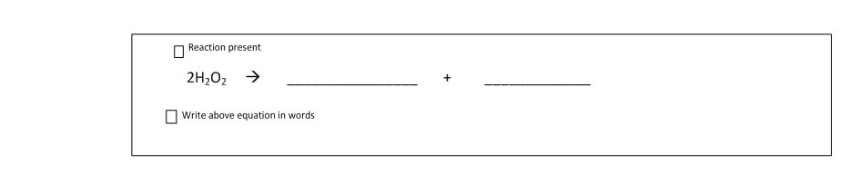
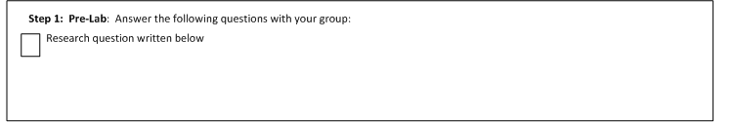
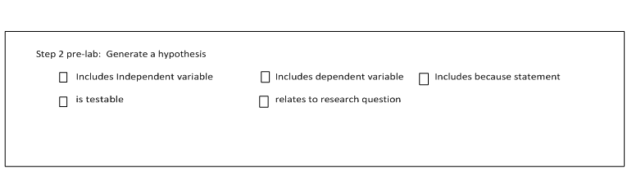
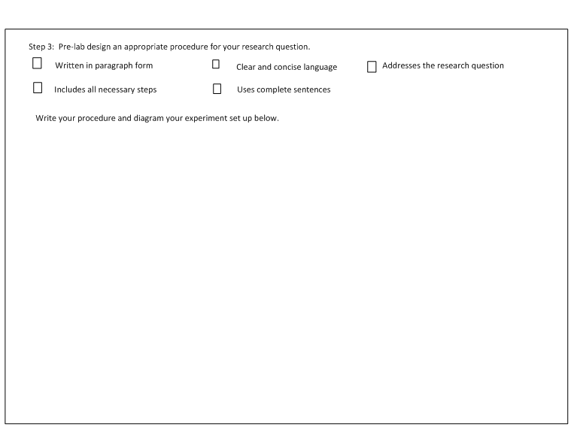
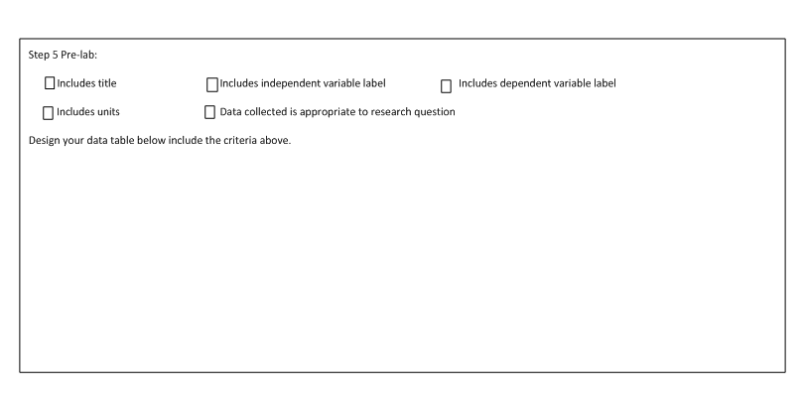
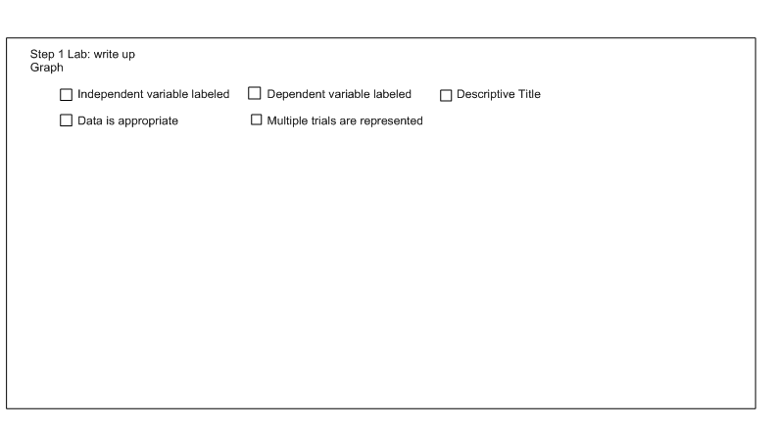
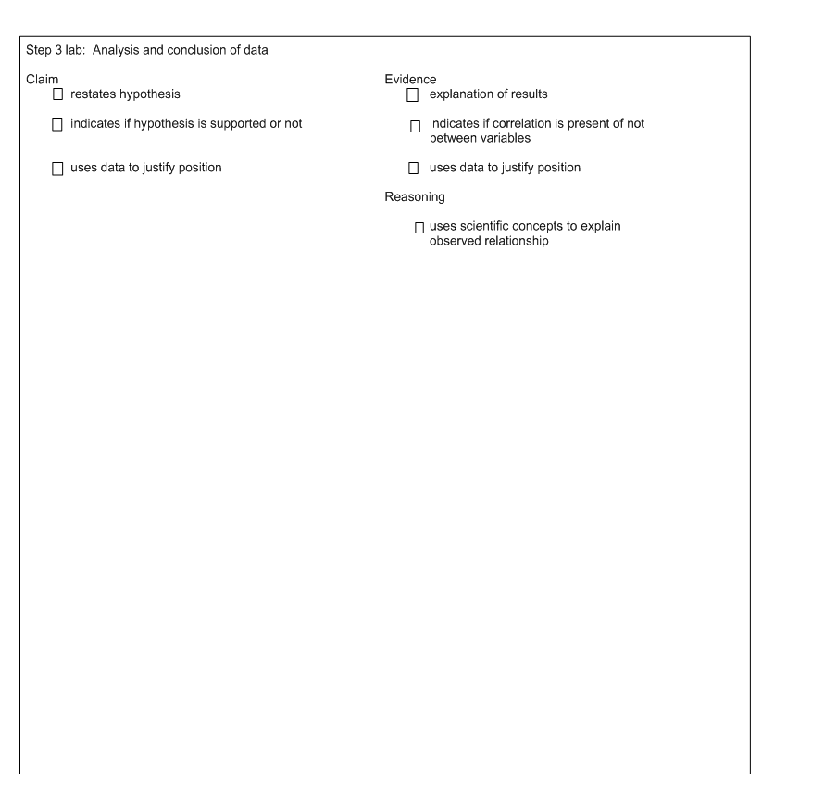
Step 3: Presentation
- Presentation:
  - You will be doing a 3-5 minute presentation with your group
  - You will need to present your research question, procedures, results, and conclusions
  - You will be graded according to the attached rubric
Criteria | Exemplary (4) | Proficient (3) | Developing (2) | Limited (1)
Clarity of presentation | - Data is clearly displayed in at least two forms (e.g. graphs, tables, charts, diagrams)  - Presentation uses correct terminology and is clearly spoken | - Data is clearly displayed in at least two forms  - Presentation lacks some accuracy or clarity | - Data is displayed in at least one form  - Presentation lacks some accuracy | - Data is displayed in at least one form  - Presentation lacks accuracy and clarity

Enzyme Research Summary
Question | Results

Based on your research and the research of your peers, write a summary about enzymes, including the factors that affect their rate of action.

