Starting "The Modern Synthesis": Theodosius Dobzhansky
Ronald Fisher and his colleagues set Darwin's concept of natural selection on a new foundation of genetics. They left an equally major project open for later biologists: to explain in the language of genes, what species are and how they originate. The answer only began to emerge in the 1930s, thanks in large part to the work of a Soviet-born geneticist named Theodosius Dobzhansky (right).
Dobzhansky, who emigrated to the United States in 1928, worked in Thomas Hunt Morgan's "Fly Room," where mutations were being studied closely for the first time. He also paid careful attention to the work of population geneticists such as Sewall Wright, who were showing how the size of a population affects the rate at which a mutation can spread. Dobzhansky was interested in discovering the genetics that determined the differences between populations of a species.
Genetically variable populations
At the time, most biologists assumed that all of the members of any given species had practically identical genes. But these were assumptions bred in the lab. Dobzhansky began analyzing the genes of wild fruit flies, traveling from Canada to Mexico to catch members of the species Drosophila pseudoobscura. He found that different populations of D. pseudoobscura did not have identical sets of genes. Each population of fruit flies he studied bore distinctive markers in its chromosomes that distinguished it from other populations.
Dobzhansky helped discover that different fruit fly populations have different frequencies of two different versions of the same chromosome; chromosome A might be more frequent in one population while chromosome A' is more frequent in a neighboring population.
If there was no standard set of genes that distinguished a species, what kept species distinct from each other? The answer, Dobzhansky correctly realized, was sex. A species is simply a group of animals or plants that reproduces primarily among themselves. Two animals belonging to different species are unlikely to mate, and even if they do, they will rarely produce viable hybrids. Dobzhansky ran experiments on fruit flies that demonstrated that this incompatibility is caused by specific genes carried by one species that clash with the genes from another species.
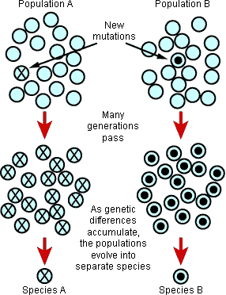
Making a new species
In 1937, Dobzhansky published these results in a landmark book, Genetics and the Origin of Species. In it, he sketched out an explanation for how species actually came into existence. Mutations crop up naturally all the time. Some mutations are harmful in certain circumstances, but a surprising number have no effect one way or the other. These neutral changes appear in different populations and linger, creating variability that is far greater than anyone had previously imagined.
This variability serves as the raw material for making new species. If the members of a population of flies should breed among themselves more than with other members of the species, their genetic profile would diverge. New mutations would arise in the isolated population, and natural selection might help them to spread until all the flies carried them. But because these isolated flies were only breeding within their own population, the mutations could not spread to the rest of the species. The isolated population of flies would become more and more genetically distinct. Some of their new genes would turn out to be incompatible with the genes of flies from outside their own population.
If this isolation lasted long enough, Dobzhansky argued, the flies might lose the ability to interbreed completely. They might simply become unable to mate with the other flies successfully, or their hybrid offspring might become sterile. If the flies were now to come out of their isolation, they could live alongside the other insects but still continue mating only among themselves. A new species would be born.
The Modern Synthesis
Dobzhansky's ability to combine genetics and natural history attracted many other biologists to join him in the effort to find a unified explanation of how evolution happens. Their combined work, known as "The Modern Synthesis," brought together genetics, paleontology, systematics, and many other sciences into one powerful explanation of evolution, showing how mutations and natural selection could produce large-scale evolutionary change. The Modern Synthesis certainly did not bring the study of evolution to an end, but it became the foundation for future research.
Speciation: Ernst Mayr
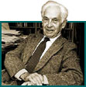
Dobzhansky's Genetics and the Origin of Species captivated biologists far beyond the confines of genetics. In the mountains of New Guinea, an ornithologist named Ernst Mayr (right) found the book to be an enormous inspiration. Mayr specialized in discovering new species of birds and mapping out their ranges. It is no easy matter determining exactly which group of birds deserves the title of species. A bird of paradise species might be recognizable by the color of its feathers, but from place to place, it might have a huge amount of variation in other traits — on one mountain it might have an extravagantly long tail while on another its tail would be cut square (below right).
Variation between populations
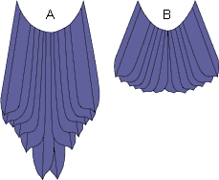
The tails of birds of paradise living in the mountains of western New Guinea (A) are longer than those of birds living in the more central mountains (B).
Biologists typically tried to bring order to this confusion by recognizing subspecies — local populations of a species that were distinct enough to warrant a special label of their own. But Mayr saw that the subspecies label was far from a perfect solution. In some cases, subspecies weren't actually distinct from each other, but graded into each other like colors in a rainbow. In other cases, what looked like a subspecies might, on further inspection, turn out to be a separate species of its own.
Like many other naturalists of his day, Mayr suspected at first that some kind of Lamarckian heredity might be at work in evolution. But when he read Dobzhansky and other architects of the Modern Synthesis, he realized that it was possible to explain the origin of species with genetics. Mayr also realized that the puzzle of species and subspecies shouldn't be considered a headache: they were actually a living testimony to the evolutionary process Dobzhansky wrote about. Variations emerge in different parts of a species' range, creating differences between populations (see example below). In one part of a range the birds may possess long tails, in others, square tails. But because the birds also mate with their neighbors, they do not become isolated into a species of their own.
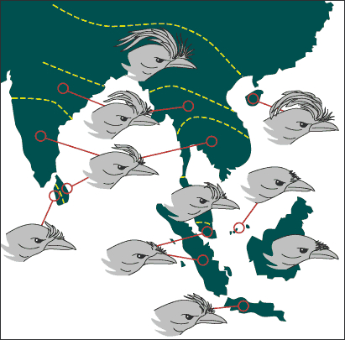
The size and shape of Dicrurus paradiseus' crest varies considerably across southeast Asia.
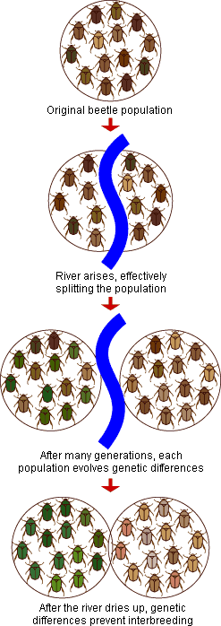
Geographic isolation
A population of birds, or any organism, can speciate if isolated from its neighbors. In his 1942 book, Systematics and the Origin of Species, Mayr argued that the most significant way to cut off a population is by geographical isolation (see illustration at right). For example, a glacier may thrust down a valley, creating two separate populations, one on either side of the glacier. A rising ocean may turn a peninsula into a chain of islands, stranding the beetles on each of them. This sort of isolation doesn't have to last forever; it needs only form a barrier long enough to let the isolated population become genetically incompatible with the rest of its species. Once the glacier melts, or the ocean drops and turns the islands back into a peninsula, the animals will be unable to interbreed. They will live side by side, but follow separate evolutionary fates.
Other modes of speciation
Today, scientists studying the origin of species can compare not just the bodies of species, but their genes as well. Geographic isolation remains a crucial element in forming new species, but a number of biologists now argue that the formation of species can take several different paths. It may be possible, for example, for a population to continue breeding with other members of its species — and trading genes — while still diverging into a distinct group. All that may be required is that a few of its genes diverge, thanks to strong natural selection. If the conditions are right, this genetically distinct population may then become a new species.
Others argue that organisms can diverge into genetically distinct populations even if they are living side by side. For example, females may be born with different preferences for mates, and those preferences may get strengthened over time into reproductive isolation. Even as biology's understanding of species formation evolves, Mayr's work remains hugely important to the understanding of how the millions of species on Earth came to be.
DNA, the Language of Evolution: Francis Crick & James Watson
DNA may be the most famous molecule in the world today, but it came to the attention of scientists rather late in the history of biology. Gregor Mendel found some of the underlying regularities of heredity almost a century before DNA was discovered. At the turn of the century scientists discovered similar principles then rediscovered Mendel's work and rapidly realized that life was somehow encoded in genes. Just what those genes were made of was a mystery, but that did not prevent scientists from starting to work out the dynamics of genes and mutations, and how new forms of life could result from natural selection. The Modern Synthesis of evolution, the foundation on which most research on evolution has rested for the past 50 years, was already set in place years before DNA was discovered.
The structure of DNA
But there's no denying that the discovery of DNA was a tremendous milestone in the exploration of evolution. While evolutionary biologists were fashioning the Modern Synthesis, geneticists around the world searched furiously for the molecules that carried genetic information. They knew that cells contained several different types of molecules, such as proteins and nucleic acids. But which had the capacity to bear information and be copied into new cells? Experiments showed that nucleic acids could affect hereditary traits. A young American geneticist named James Watson (left) was one of the researchers who realized that the only way to determine whether they did in fact carry genes was to understand their structure.
This was an agonizing task because scientists could only see molecules by shining x-ray beams on them, which then bounce off the atoms and strike a piece of film in various distinctive patterns. At Cambridge University he joined up with Francis Crick (right) to analyze the x-ray data collected by Rosalind Franklin and others. In a sudden burst of insight, Watson and Crick built a model out of brass plates and clamps and other bits of laboratory equipment in 1953. As they worked, they realized that nucleic acids are arranged on a twisted ladder, with two runners made of phosphates and sugars, and a series of rungs made of pairs of organic compounds known as bases. Years later, they won the Nobel Prize for this frenzy of discovery of DNA's double helix.
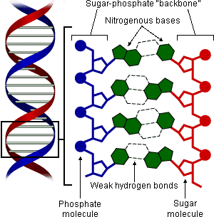
Life's cookbook
In the years that followed, Watson, Crick, and other researchers figured out the basics of how DNA works. Each gene, they realized, consists of a stretch of base pairs. A single-stranded copy of the gene was created (known as messenger RNA) and transported to protein-building factories in the cell called ribosomes. There, the sequence of the bases guided the assembly of a string of amino acids that became a new protein. When a cell divides, the double helix is unzipped and the DNA is replicated. It is life’s cookbook.
Using DNA
Evolutionary biology was revolutionized by the discovery of DNA. Mutations, researchers realized, change the spelling of the cookbook. A single base pair may change, or a set of genes may be duplicated. Those mutations that confer a selective advantage to an individual become more common over time, and ultimately these mutant genes may drive the older versions out of existence.
Thanks to the discovery of DNA, it is now possible for scientists to identify not just the genes, but the individual bases. Before the discovery of DNA, scientists could only uncover the evolutionary tree of life by comparing the bodies and cells of different species. Now they can compare their genetic codes, working their way down to the deepest branches of life dating back billions of years.
Radiometric Dating: Clair Patterson
Radioactive elements decay, releasing particles and energy.
Nineteenth century geologists recognized that rocks formed slowly as mountains eroded and sediments settled on the ocean floor. But they could not say just how long such processes had taken, and thus how old their fossils were. Darwin had argued that the Earth was immensely old — which gave his gradual process of evolution plenty of time to unfold. The great physicist Lord Kelvin had countered that the planet was actually relatively young — perhaps 20 million years old. He came up with that figure by estimating how long it had taken for the planet to cool down to its current temperature from its molten infancy. But Kelvin didn't, and couldn't, know that radioactive atoms such as uranium were breaking down and keeping the planet warmer than it would be otherwise.
An older Earth
At the dawn of the twentieth century, physicists made a revolutionary discovery: elements are not eternal. Atoms can fuse together to create new elements; they can also spontaneously break down, firing off subatomic particles and switching from one element to another in the process (see figure, right). While some physicists used these discoveries for applications ranging from nuclear weapons to nuclear medicine, others applied them to understanding the natural world. The sun was once thought to burn like a coal fire, but physicists showed that it actually generates energy by slamming atoms together and creating new elements. The primordial cloud of dust that came to form the Earth contained unstable atoms, known as radioactive isotopes. Since its birth, these isotopes have been breaking down and releasing energy that adds heat to the planet's interior.
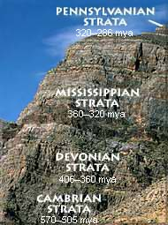
Scientists measure the ages of rock layers on Earth using radiometric dating.
Radioactivity also gave the history of life an absolute calendar. By measuring the atoms produced by these breakdowns inside rocks, physicists were able to estimate their ages (right). And by comparing the ratios of those atoms to atoms from meteorites, they could estimate how long ago it was that the Earth formed along with the rest of the solar system. In 1956 the American geologist Clair Patterson (left) announced that the Earth was 4.5 billion years old. Darwin had finally gotten the luxury of time he had craved.
Ancient life
The dates that radioactive clocks have put on evolutionary history are astonishing. Life is well over 3.5 billion years old, and until about 600 million years ago, the planet was dominated by microbes. Radioactive clocks have shown that evolution can change its pace — the Cambrian Explosion of about 535 million years ago saw the relatively rapid emergence of many major lineages of animals in just a few million years. Mammals, which for 150 million years had been small, rodent-sized creatures, rapidly evolved to massive proportions in the wake of the Cretaceous-Tertiary extinction 65 million years ago. Geological timekeeping continues to be a lively science, with new methods emerging all the time. Some of these methods have helped to pin down the evolution of our hominid ancestors; anatomically modern humans evolved about 100,000 years ago. While that's nearly 20 times older than the Earth was once thought to be, it's a geological eye blink.
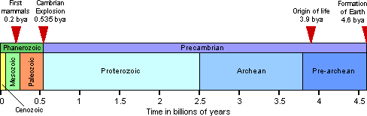
Endosymbiosis: Lynn Margulis
Margulis and others hypothesized that chloroplasts (bottom) evolved from cyanobacteria (top).
The Modern Synthesis established that over time, natural selection acting on mutations could generate new adaptations and new species. But did that mean that new lineages and adaptations only form by branching off of old ones and inheriting the genes of the old lineage? Some researchers answered no. Evolutionist Lynn Margulis showed that a major organizational event in the history of life probably involved the merging of two or more lineages through symbiosis.
Symbiotic microbes = eukaryote cells?
In the late 1960s Margulis (left) studied the structure of cells. Mitochondria, for example, are wriggly bodies that generate the energy required for metabolism. To Margulis, they looked remarkably like bacteria. She knew that scientists had been struck by the similarity ever since the discovery of mitochondria at the end of the 1800s. Some even suggested that mitochondria began from bacteria that lived in a permanent symbiosis within the cells of animals and plants. There were parallel examples in all plant cells. Algae and plant cells have a second set of bodies that they use to carry out photosynthesis. Known as chloroplasts, they capture incoming sunlight energy. The energy drives biochemical reactions including the combination of water and carbon dioxide to make organic matter. Chloroplasts, like mitochondria, bear a striking resemblance to bacteria. Scientists became convinced that chloroplasts (below right), like mitochondria, evolved from symbiotic bacteria — specifically, that they descended from cyanobacteria (above right), the light-harnessing small organisms that abound in oceans and fresh water.
When one of her professors saw DNA inside chloroplasts, Margulis was not surprised. After all, that's just what you'd expect from a symbiotic partner. Margulis spent much of the rest of the 1960s honing her argument that symbiosis (see figure, below) was an unrecognized but major force in the evolution of cells. In 1970 she published her argument in The Origin of Eukaryotic Cells.
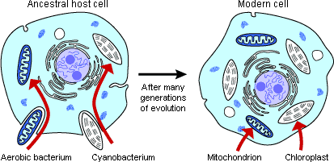
Mitochondria are thought to have descended from close relatives of typhus-causing bacteria.
The genetic evidence
In the 1970s scientists developed new tools and methods for comparing genes from different species. Two teams of microbiologists — one headed by Carl Woese, and the other by W. Ford Doolittle at Dalhousie University in Nova Scotia — studied the genes inside chloroplasts of some species of algae. They found that the chloroplast genes bore little resemblance to the genes in the algae's nuclei. Chloroplast DNA, it turns out, was cyanobacterial DNA. The DNA in mitochondria, meanwhile, resembles that within a group of bacteria that includes the type of bacteria that causes typhus (see photos, right). Margulis has maintained that earlier symbioses helped to build nucleated cells. For example, spiral-shaped bacteria called spirochetes were incorporated into all organisms that divide by mitosis. Tails on cells such as sperm eventually resulted. Most researchers remain skeptical about this claim.
It has become clear that symbiotic events have had a profound impact on the organization and complexity of many forms of life. Algae have swallowed up bacterial partners, and have themselves been included within other single cells. Nucleated cells are more like tightly knit communities than single individuals. Evolution is more flexible than was once believed.

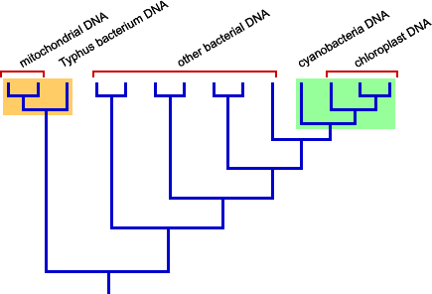
Phylogenetic analyses based on genetic sequences support the endosymbiosis hypothesis.
Evolution and Development for the 21st Century: Stephen Jay Gould
With the fall of Ernst Haeckel's Biogenetic Law in the 1920s, the evolutionary study of embryos receded into the intellectual backwaters for decades. Haeckel's notion that ontogeny recapitulates phylogeny was deeply flawed, but it was at least straightforward. The few researchers who tried to carry on the study of embryos and evolution proposed a confusing jumble of different kinds of evolutionary change — for which they invented a jumble of hideously confusing names such as paedomorphosis, proterogenesis, and phyloembryogenesis. Most embryologists chose instead to focus on understanding how embryos develop — a formidable question in itself — without thinking much about the evolutionary implications of their work. Meanwhile, evolutionary biologists concentrated much of their efforts on the blossoming field of genetics.
Evo meets devo again
More than anyone else, the Harvard paleontologist Stephen Jay Gould (left) drew attention back to embryos as evolutionary time capsules. In his landmark 1977 book Ontogeny and Phylogeny, Gould documented the history of scientific research that had led to so much confusion. But he also demonstrated that the wealth of cases could be organized by some simple principles. Imagine that the timing of development is controlled by two knobs like you'd find on a radio. One controls the rate at which an organism grows. The other controls the rate at which it changes shape over time. Random mutation may end up changing the settings of each knob, thereby speeding up or slowing down the rate at which a species' embryos develop. These kinds of adjustments can alter the entire body of an organism, or individual organs.
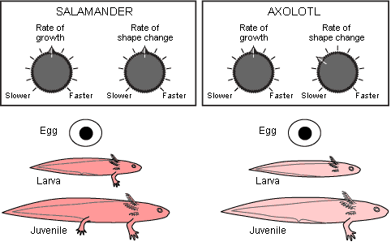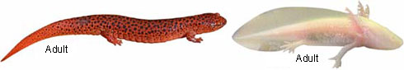
If evolution had slowed the rate of shape change of a salamander, but kept everything else the same, we would have ended up with the axolotl.
Genetic triggers for developmental change
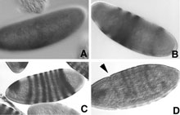
Developing Drosophila embryo expresses the hairy gene (dark bands) over the course of its first four hours of life. Four stages of this expression are shown in the sequence above. Different species turn on the gene at slightly different times. In frame D, an arrow marks the furrow that will eventually separate the head from the rest of the body.
These changes in timing, known collectively as heterochrony, have proved to be numerous and significant. But Gould knew very well that the ultimate explanation for heterochrony would be found not in metaphorical radio knobs but in the genes whose effects those knobs represented. Around the time that Ontogeny and Phylogeny was published, biologists began to isolate genes involved in development for the first time. Since then they've gotten a much better look at how these genes send signals that trigger other genes, and how they induce embryonic cells to proliferate, die off, crawl to new locations or stick together.
At the dawn of this new scientific age, Gould predicted that heterochrony and similar evolutionary changes would not be directed by the genes that actually build various body parts. Instead, the genes that regulate other genes would hold the key to the evolution of embryos. His prediction has now been borne out. In 2000, for example, Junhyong Kim and his fellow Yale biologists compared the timing at which a crucial developmental gene (see photos, right) became active in the fruit fly, Drosophila melanogaster, and two closely related species, D. simulans and D. pseudoobscura. They found that the gene started to make its proteins 24 minutes later in D. pseudoobscura than D. melanogaster. Meanwhile, D. simulans gets a head start: its gene becomes active 14 minutes earlier. And that change led to differences in their anatomy — even though the developmental gene itself is identical in all three species.
As scientists have begun to isolate these regulatory genes, they've been shocked at how powerful they are and how long they've been in power over the course

