Use DNA Mutations links to define different types
of mutations in your notes

http://evolution.berkeley.edu/evolibrary/article/0_0_0/mutations_03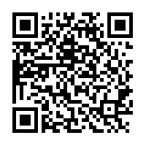
http://www.youtube.com/watch?v=eDbK0cxKKsk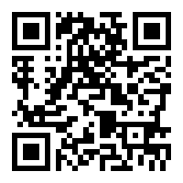video

Use chromosome Mutations links to define different types
of mutations in your notes

http://highered.mcgraw-hill.com/sites/9834092339/student_view0/chapter15/changes_in_chromosome_structure.html

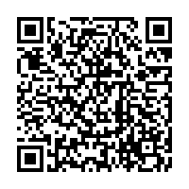
Video

http://www.youtube.com/watch?v=jfN1Naa3in0
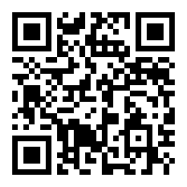
Video

https://facultystaff.richmond.edu/~lrunyenj/bio554/lectnotes/chapter8.pdf
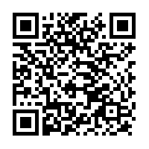notes

http://www.uic.edu/classes/bms/bms655/lesson10.html for above and beyond students
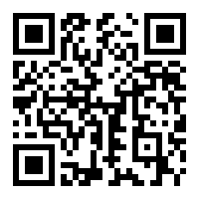note

Use transcription links to add information
to your notes

http://www.ndsu.edu/pubweb/~mcclean/plsc731/transcript/transcript1.htm
notes
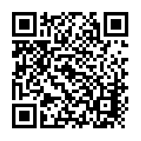
http://www.johnkyrk.com/DNAtranscript.swf
video
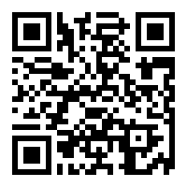
http://bcs.whfreeman.com/thelifewire/content/chp12/1202001.html
video
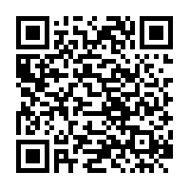
http://www.stolaf.edu/people/giannini/flashanimat/molgenetics/transcription.swf

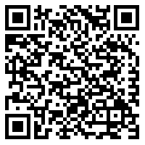
Video

Use translation links to augment your
notes

http://biology.unm.edu/ccouncil/Biology_124/Summaries/T&T.html
notes
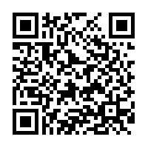

http://highered.mcgraw-hill.com/sites/9834092339/student_view0/chapter15/how_translation_works.html
video

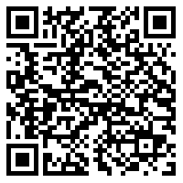

http://www.brightstorm.com/science/biology/molecular-biology/biology-translation/
video

Use protein synthesis links to gain an
understanding of the process

http://www.dartmouth.edu/~cbbc/courses/bio4/bio4-lectures/ProteinSynthesis.html
notes
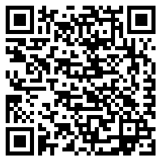

http://www.pbs.org/wgbh/aso/tryit/dna/protein.html
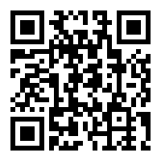
Tutorial

http://learn.genetics.utah.edu/content/molecules/
go to transcribe and translate a gene
