http://biology.unm.edu/ccouncil/Biology_124/Summaries/Macromol.html

Biological Macromolecules

Base Elements, Monomers and Polymers

Importance of carbon

Bonding behavior can form four covalent bonds. Bonding arrangements can form chains or rings. Forms the backbone of many necessary organic molecules. Inorganic compounds can be bonded to carbon, but not carbon and hydrogen. Organic compounds are hydrogen and other elements covalently bonded to carbon usually made by living organisms.
Biological macromolecules are defined as large molecules made up of smaller organic molecules. There are four classes of macromolecules: carbohydrates, lipids, proteins and nucleic acids. The base elements of carbohydrates and lipids are Carbon (C), Hydrogen (H) and Oxygen (O). Protein is also made up of these base elements but it also contains Nitrogen (N). When viewing the chemical structures of carbohydrates, lipids and proteins you can distinguish proteins from the other two by the presence of N in its chemical structure.
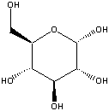
Carbohydrate (glucose) molecule in ring form.
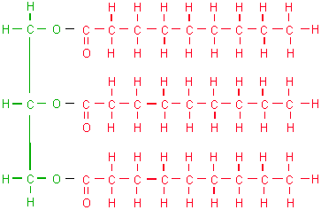
A lipid (triglyceride) molecule.
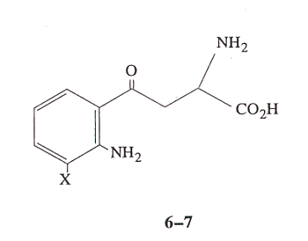
A protein molecule. X denotes a functional group. Note the presence of N.
Functional groups are atoms or clusters of atoms that are covalently bonded to a carbon backbone. Give organic compounds their different properties.
Examples
- Hydroxyl-OH
- Methyl-COOH
- Carboxyl-COOH
- Amino-NH3

Each macromolecule is made up of smaller organic molecules. For carbohydrates and proteins these smaller molecules are known as monomers. These similar or identical monomers are covalently bonded together to create a large polymer molecule. The monomer unit for carbohydrates is a monosaccharide or a simple sugar. When two monosaccharides are linked by covalent bonds a disaccharide is created. When several monosaccharides are bonded together a polysaccharide, or complex sugar, is created. Polysaccharides are the polymers of carbohydrates. Proteins are made up of monomers called amino acids. There are twenty amino acids and they can be strung together in unique combinations known as polypeptide chains, the polymer unit for proteins. A protein is only complete and functional when the polypeptide chain is folded into a unique 3-D shape.
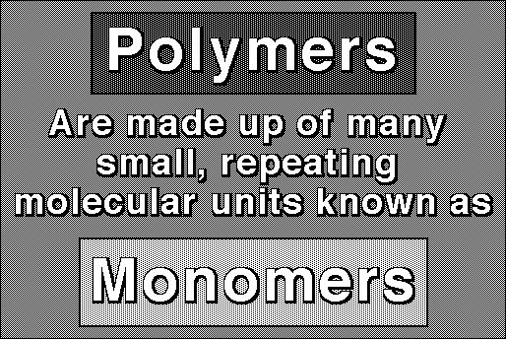
The exception to the monomer/polymer rule is lipids. Lipid base units are not considered monomers. One type of lipid or fat is made up of fatty acids and glycerol molecules in a 3:1 ratio. The bonding of three fatty acids to one glycerol molecule creates a triglyceride.
Monomers, or base units are bonded together to create larger molecules via dehydration. This involves the removal of a water molecule at the bonding site. The larger molecule can be broken down by the reverse process, hydrolysis. This occurs when water is added to break the covalent bonds created during dehydration.

Carbohydrates
The body uses carbohydrates as “fast fuel.” It is the first macromolecule used to obtain energy for the body because very little energy is required to break down carbohydrates. Carbohydrates are sugar molecules. They are made up of the base elements C, H and O in a 1:2:1 ratio. The simplest carbohydrate is a monosaccharide (a simple sugar). An example of a simple sugar is glucose, which is created during photosynthesis. Monosaccharides are covalently bonded together to create more complex sugars. A disaccharide is two covalently bonded simple sugars or monosaccharides. A polysaccharide is the carbohydrate polymer and consists of several monosaccharides bonded together. A common polysaccharide is starch. Starch is a storage polysaccharide found in plants. Another plant polysaccharide is cellulose, a major component of a plant’s cell wall.

Carbohydrates
Carbohydrates have the general molecular formula CH₂O, and thus were once thought to represent "hydrated carbon". However, the arrangement of atoms in carbohydrates has little to do with water molecules.
Starch and cellulose are two common carbohydrates. Both are macromolecules with molecular weights in the hundreds of thousands. Both are polymers (hence "polysaccharides"); that is, each is built from repeating units, monomers, much as a chain is built from its links.
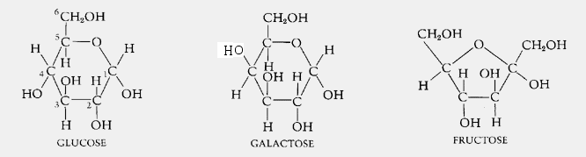
The monomers of both starch and cellulose are the same: units of the sugar glucose.

Sugars

Monosaccharides
Three common sugars share the same molecular formula: C₆H₁₂O₆. Because of their six carbon atoms, each is a hexose.
They are:
- glucose, "blood sugar", the immediate source of energy for cellular respiration
- galactose, a sugar in milk (and yogurt), and
- fructose, a sugar found in honey.
Although all three share the same molecular formula (C₆H₁₂O₆), the arrangement of atoms differs in each case. Substances such as these three, which have identical molecular formulas but different structural formulas, are known as structural isomers.
Glucose, galactose, and fructose are "single" sugars or monosaccharides. Two monosaccharides can be linked together to form a "double" sugar or disaccharide.

Disaccharides
Three common disaccharides:
- sucrose — common table sugar = glucose + fructose
- lactose — major sugar in milk = glucose + galactose
- maltose — product of starch digestion = glucose + glucose
Although the process of linking the two monomers is rather complex, the end result in each case is the loss of a hydrogen atom (H) from one of the monosaccharides and a hydroxyl group (OH) from the other. The resulting linkage between the sugars is called a glycosidic bond. The molecular formula of each of these disaccharides is
C₁₂H₂₂O₁₁ = 2 C₆H₁₂O₆ − H₂O
All sugars are very soluble in water because of their many hydroxyl groups. Although not as concentrated a fuel as fats, sugars are the most important source of energy for many cells.
Carbohydrates provide the bulk of the calories (4 kcal/gram) in most diets, and starches provide the bulk of that. Starches are polysaccharides.

Polysaccharides

Starches
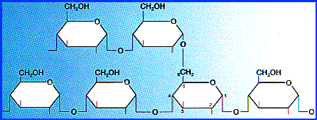
Starches are polymers of glucose. Two types are found:
- amylose consists of linear, unbranched chains of several hundred glucose residues (units). The glucose residues are linked by a glycosidic bond between their #1 and #4 carbon atoms.
- amylopectin differs from amylose in being highly branched. At approximately every thirtieth residue along the chain, a short side chain is attached by a glycosidic bond to the #6 carbon atom (the carbon above the ring). The total number of glucose residues in a molecule of amylopectin is several thousand.
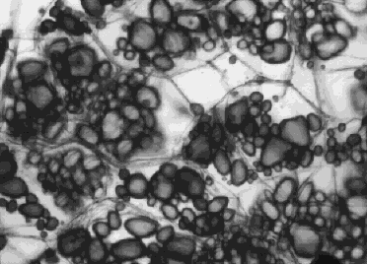
Starches are insoluble in water and thus can serve as storage depots of glucose. Plants convert excess glucose into starch for storage. The image shows starch grains (lightly stained with iodine) in the cells of the white potato. Rice, wheat, and corn (maize) are also major sources of starch in the human diet.
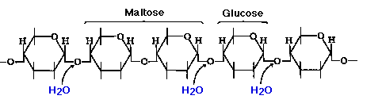
Before starches can enter (or leave) cells, they must be digested. The hydrolysis of starch is done by amylases. With the aid of an amylase (such as pancreatic amylase), water molecules enter at the 1 -> 4 linkages, breaking the chain and eventually producing a mixture of glucose and maltose. A different amylase is needed to break the 1 -> 6 bonds of amylopectin.

Glycogen
Animals store excess glucose by polymerizing it to form glycogen. The structure of glycogen is similar to that of amylopectin, although the branches in glycogen tend to be shorter and more frequent.
Glycogen is broken back down into glucose when energy is needed (a process called glycogenolysis).
In glycogenolysis,
- Phosphate groups — not water — break the 1 -> 4 linkages
- The phosphate group must then be removed so that glucose can leave the cell.
The liver and skeletal muscle are major depots of glycogen.
There is some evidence that intense exercise and a high-carbohydrate diet ("carbo-loading") can increase the reserves of glycogen in the muscles and thus may help marathoners work their muscles somewhat longer and harder than otherwise. But for most of us, carbo loading leads to increased deposits of fat.

Cellulose
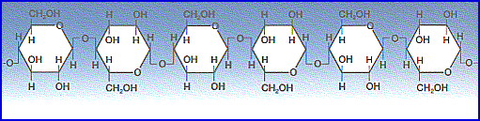
Cellulose is probably the single most abundant organic molecule in the biosphere. It is the major structural material of which plants are made. Wood is largely cellulose while cotton and paper are almost pure cellulose.
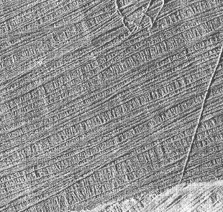
Like starch, cellulose is a polysaccharide with glucose as its monomer. However, cellulose differs profoundly from starch in its properties.
- Because of the orientation of the glycosidic bonds linking the glucose residues, the rings of glucose are arranged in a flip-flop manner. This produces a long, straight, rigid molecule.
- There are no side chains in cellulose as there are in starch. The absence of side chains allows these linear molecules to lie close together.
- Because of the many -OH groups, as well as the oxygen atom in the ring, there are many opportunities for hydrogen bonds to form between adjacent chains.
The result is a series of stiff, elongated fibrils — the perfect material for building the cell walls of plants.
This electron micrograph (courtesy of R. D. Preston) shows the cellulose fibrils in the cell wall of a green alga. These long, rigid fibrils are a clear reflection of the nature of the cellulose molecules of which they are composed.

Lipids: Fats, Oils, Waxes, etc.
The body stores lipids as reserve energy. All Lipids are hydrophobic: that’s the one property they have in common. Much harder to break down for energy than carbohydrates. Lipids, however, contain more energy per unit weight then carbohydrates. Therefore it is more efficient for the body to use lipids as stored energy. The body will use its carbohydrate source for initial fuel, but if the “fast fuel” runs out, the body will turn to breaking down lipids for a rich energy source. Lipids are fat molecules and there are many different kinds.
This group of molecules includes fats and oils, waxes, phospholipids, steroids (like cholesterol), and some other related compounds.
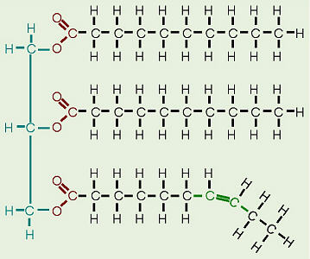
Fats and oils are made from two kinds of molecules: glycerol (a type of alcohol with a hydroxyl group on each of its three carbons) and three fatty acids joined by dehydration synthesis. Since there are three fatty acids attached, these are known as triglycerides. The main distinction between fats and oils is whether they’re solid or liquid at room temperature, and this, as we’ll soon see, is based on differences in the structures of the fatty acids they contain.
Structure of Fatty Acids
The “tail” of a fatty acid is a long hydrocarbon chain, making it hydrophobic. The “head” of the molecule is a carboxyl group which is hydrophilic. Fatty acids are the main component of soap, where their tails are soluble in oily dirt and their heads are soluble in water to emulsify and wash away the oily dirt. However, when the head end is attached to glycerol to form a fat, that whole molecule is hydrophobic.

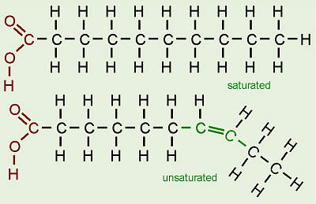
The terms saturated, mono-unsaturated, and poly-unsaturated refer to the number of hydrogens attached to the hydrocarbon tails of the fatty acids as compared to the number of double bonds between carbon atoms in the tail. Fats, which are mostly from animal sources, have all single bonds between the carbons in their fatty acid tails, thus all the carbons are also bonded to the maximum number of hydrogens possible. Since the fatty acids in these triglycerides contain the maximum possible amount of hydrogens, these would be called saturated fats. The hydrocarbon chains in these fatty acids are, thus, fairly straight and can pack closely together, making these fats solid at room temperature. Oils, mostly from plant sources, have some double bonds between some of the carbons in the hydrocarbon tail, causing bends or “kinks” in the shape of the molecules. Because some of the carbons share double bonds, they’re not bonded to as many hydrogens as they could if they weren’t double bonded to each other. Therefore these oils are called unsaturated fats. Because of the kinks in the hydrocarbon tails, unsaturated fats can’t pack as closely together, making them liquid at room temperature. Many people have heard that the unsaturated fats are “healthier” than the saturated ones. Hydrogenated vegetable oil (as in shortening and commercial peanut butters where a solid consistency is sought) started out as “good” unsaturated oil. However, this commercial product has had all the double bonds artificially broken and hydrogens artificially added (in a chemistry lab-type setting) to turn it into saturated fat that bears no resemblance to the original oil from which it came (so it will be solid at room temperature).
In unsaturated fatty acids, there are two ways the pieces of the hydrocarbon tail can be arranged around a C=C double bond. In cis bonds, the two pieces of the carbon chain on either side of the double bond are either both “up” or both “down,” such that both are on the same side of the molecule. In trans bonds, the two pieces of the molecule are on opposite sides of the double bond, that is, one “up” and one “down” across from each other. Naturally-occurring unsaturated vegetable oils have almost all cis bonds, but using oil for frying causes some of the cis bonds to convert to trans bonds. If oil is used only once like when you fry an egg, only a few of the bonds do this so it’s not too bad. However, if oil is constantly reused, like in fast food French fry machines, more and more of the cis bonds are changed to trans until significant numbers of fatty acids with trans bonds build up. The reason this is of concern is that fatty acids with trans bonds are carcinogenic, or cancer-causing. The levels of trans fatty acids in highly-processed, lipid-containing products such as margarine are quite high, and I have heard that the government is considering requiring that the amounts of trans fatty acids in such products be listed on the labels.
We need fats in our bodies and in our diet. Animals in general use fat for energy storage because fat stores 9 KCal/g of energy. Plants, which don’t move around, can afford to store food for energy in a less compact but more easily accessible form, so they use starch (a carbohydrate, NOT A LIPID) for energy storage. Carbohydrates and proteins store only 4 KCal/g of energy, so fat stores over twice as much energy/gram as fat. By the way, this is also related to the idea behind some of the high-carbohydrate weight loss diets. The human body burns carbohydrates and fats for fuel in a given proportion to each other. The theory behind these diets is that if they supply carbohydrates but not fats, then it is hoped that the fat needed to balance with the sugar will be taken from the dieter’s body stores. Fat is also is used in our bodies to a) cushion vital organs like the kidneys and b) serve as insulation, especially just beneath the skin.
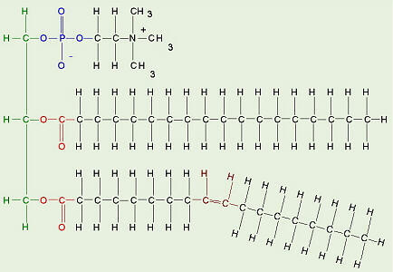
Phospholipids
Phospholipids are made from glycerol, two fatty acids, and (in place of the third fatty acid) a phosphate group with some other molecule attached to its other end. The hydrocarbon tails of the fatty acids are still hydrophobic, but the phosphate group end of the molecule is hydrophilic because of the oxygens with all of their pairs of unshared electrons. This means that phospholipids are soluble in both water and oil.

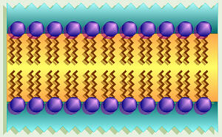
Our cell membranes are made mostly of phospholipids arranged in a double layer with the tails from both layers “inside” (facing toward each other) and the heads facing “out” (toward the watery environment) on both surfaces.

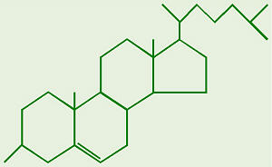
Steroids
The general structure of cholesterol consists of two six-membered rings side-by-side and sharing one side in common, a third six-membered ring off the top corner of the right ring, and a five-membered ring attached to the right side of that. The central core of this molecule, consisting of four fused rings, is shared by all steroids, including estrogen (estradiol), progesterone, corticosteroids such as cortisol (cortisone), aldosterone, testosterone, and Vitamin D. In the various types of steroids, various other groups/molecules are attached around the edges. Know how to draw the four rings that make up the central structure.
Cholesterol is not a “bad guy!” Our bodies make about 2 g of cholesterol per day, and that makes up about 85% of blood cholesterol, while only about 15% comes from dietary sources. Cholesterol is the precursor to our sex hormones and Vitamin D. Vitamin D is formed by the action of UV light in sunlight on cholesterol molecules that have “risen” to near the surface of the skin. At least one source I read suggested that people not shower immediately after being in the sun, but wait at least ½ hour for the new Vitamin D to be absorbed deeper into the skin. Our cell membranes contain a lot of cholesterol (in between the phospholipids) to help keep them “fluid” even when our cells are exposed to cooler temperatures.
Many people have hear the claims that egg yolk contains too much cholesterol, thus should not be eaten. An interesting study was done at Purdue University a number of years ago to test this. Men in one group each ate an egg a day, while men in another group were not allowed to eat eggs. Each of these groups was further subdivided such that half the men got “lots” of exercise while the other half were “couch potatoes.” The results of this experiment showed no significant difference in blood cholesterol levels between egg-eaters and non-egg-eaters while there was a very significant difference between the men who got exercise and those who didn’t.
Lipoproteins are clusters of proteins and lipids all tangled up together. These act as a means of carrying lipids, including cholesterol, around in our blood. There are two main categories of lipoproteins distinguished by how compact/dense they are. LDL or low density lipoprotein is the “bad guy,” being associated with deposition of “cholesterol” on the walls of someone’s arteries. HDL or high density lipoprotein is the “good guy,” being associated with carrying “cholesterol” out of the blood system, and is more dense/more compact than LDL.
carterjs@uc.edu

http://biology.clc.uc.edu/courses/bio104/lipids.htm

The Structure of Proteins

Proteins
Proteins are polymers of amino acids covalently linked through peptide bonds into a chain. Within and outside of cells, proteins serve a myriad of functions, including structural roles (cytoskeleton), as catalysts (enzymes), transporter to ferry ions and molecules across membranes, and hormones to name just a few.

Amino Acids
Proteins are polymers of amino acids joined together by peptide bonds. There are 20 different amino acids that make up essentially all proteins on earth. Each of these amino acids has a fundamental design composed of a central carbon (also called the alpha carbon) bonded to:
- a hydrogen
- a carboxyl group
- an amino group
- a unique side chain or R-group
Thus, the characteristic that distinguishes one amino acid from another is its unique side chain, and it is the side chain that dictates an amino acids chemical properties. Examples of three amino acids are shown below, and structures of all 20 are available. Note that the amino acids are shown with the amino and carboxyl groups ionized, as they are at physiologic pH.

Peptides and Proteins
Amino acids are covalently bonded together in chains by peptide bonds. If the chain length is short (say less than 30 amino acids) it is called a peptide; longer chains are called polypeptides or proteins. Peptide bonds are formed between the carboxyl group of one amino acid and the amino group of the next amino acid. Peptide bond formation occurs in a condensation reaction involving loss of a molecule of water.
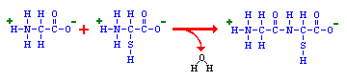
The head-to-tail arrangment of amino acids in a protein means that there is a amino group on one end (called the amino-terminus or N-terminus) and a carboxyl group on the other end (carboxyl-terminus or C-terminus). The carboxy-terminal amino acid corresponds to the last one added to the chain during translation of the messenger RNA.

Levels of Protein Structure
Structural features of proteins are usually described at four levels of complexity:
- Primary structure: the linear arrangment of amino acids in a protein and the location of covalent linkages such as disulfide bonds between amino acids.
- Secondary structure: areas of folding or coiling within a protein; examples include alpha helices and pleated sheets, which are stabilized by hydrogen bonding.
- Tertiary structure: the final three-dimensional structure of a protein, which results from a large number of non-covalent interactions between amino acids.
- Quaternary structure: non-covalent interactions that bind multiple polypeptides into a single, larger protein. Hemoglobin has quaternary structure due to association of two alpha globin and two beta globin polyproteins.
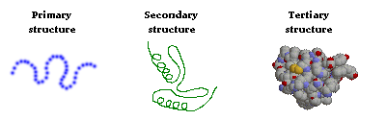
The primary structure of a protein can readily be deduced from the nucleotide sequence of the corresponding messenger RNA. Based on primary structure, many features of secondary structure can be predicted with the aid of computer programs. However, predicting protein tertiary structure remains a very tough problem, although some progress has been made in this important area.

http://www.vivo.colostate.edu/hbooks/genetics/biotech/basics/prostruct.html

The Nucleic Acids
The nucleic acids are the building blocks of living organisms. You may have heard of DNA described the same way. DNA is just one type of nucleic acid. Some other types are RNA, mRNA, and tRNA.

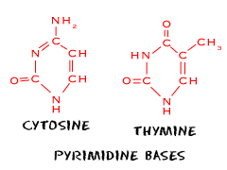

While you probably don't have to remember the full words right now, we should tell you that DNA stands for deoxyribonucleic acid. RNA stands for ribonucleic acid. The mRNA and tRNA are messenger RNA and transfer RNA, respectively. You may even hear about rRNA which stands for ribosomal RNA. They are called nucleic acids because scientists first found them in the nucleus of cells. Now that we have better equipment, nucleic acids have been found in mitochondria, chloroplasts, and cells that have no nucleus, such as bacteria and viruses.

The Basics
We already told you about the biggie nucleic acids (DNA, mRNA, tRNA). They are actually made up of chains of base pairs of nucleic acids stretching from as few as three to millions. When those pairs combine in super long chains (DNA), they make a shape called a double helix. The double helix shape is like a twisty ladder. The base pairs are the rungs. We're very close to talking about the biology of cells here. While it doesn't change your knowledge of the chemistry involved, know that DNA holds your genetic information. Everything you are in your body is encoded in the DNA found in your cells. Scientists still debate how much of your personality is even controlled by DNA.

Five Easy Pieces
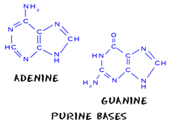
There are five easy parts of nucleic acids. All nucleic acids are made up of the same building blocks (monomers). Chemists call the monomers "nucleotides." The five pieces are uracil, cytosine, thymine, adenine, and guanine. No matter what science class you are in, you will always hear about ATCG when looking at DNA. Uracil is only found in RNA. Just as there are twenty (20) amino acids needed by humans to survive, we also require five (5) nucleotides.

These nucleotides are made of three parts:
1. A five-carbon sugar
2. A base that has nitrogen (N) atoms
3. An ion of phosphoric acid known as phosphate (PO4³⁻)

Nucleic Acids
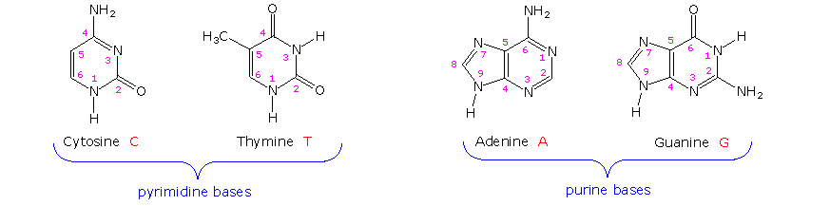.
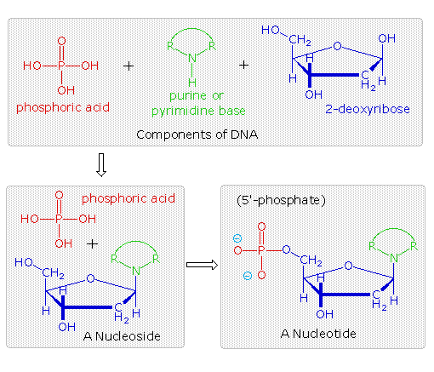
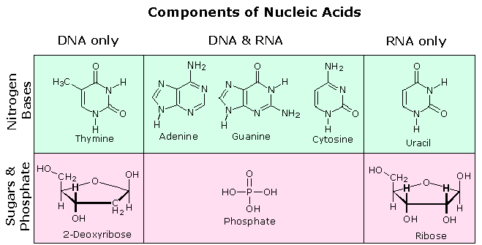
Base Pairing
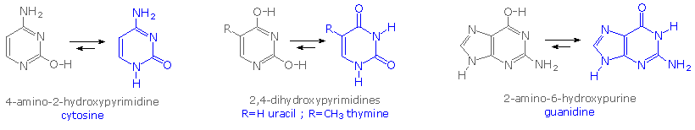
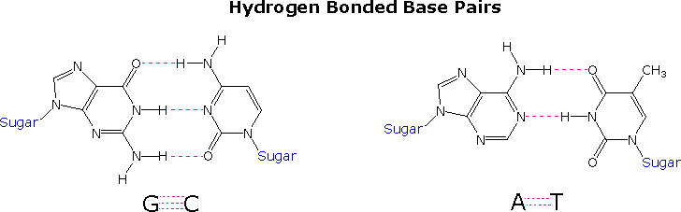

The Double Helix Structure for DNA
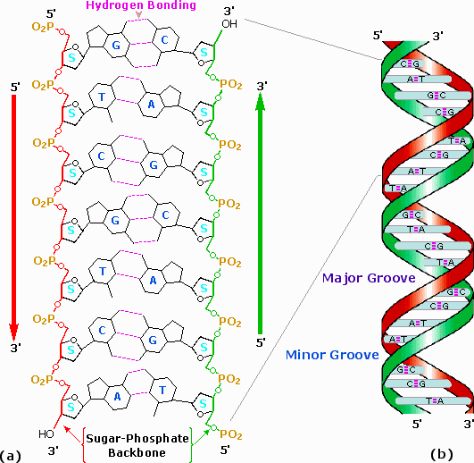 | Space-Filling Molecular Model  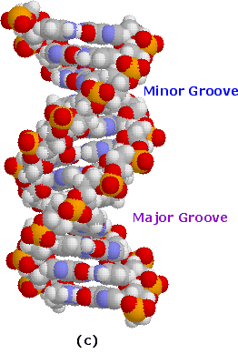
A model of a short DNA segment may be examined by

The Structure of Nucleic Acids

DNA (deoxyribonucleic acid) and RNA (ribonucleic acid) are polymers of nucleotides linked in a chain through bonds.

Bases, Nucleosides and Nucleotides
Nucleotides are the building blocks of all nucleic acids. Nucleotides have a distinctive structure composed of three components covalently bound together:
- a nitrogen-containing "base" - either a pyrimidine (one ring) or purine (two rings)
- a 5-carbon sugar - ribose or deoxyribose
- a phosphate group
The combination of a base and sugar is called a nucleoside. Nucleotides also exist in activated forms containing two or three phosphates, called nucleotide diphosphates or triphosphates. If the sugar in a nucleotide is deoxyribose, the nucleotide is called a deoxynucleotide; if the sugar is ribose, the term ribonucleotide is used.
In the right-hand figure, note also the 5' and 3' carbons on ribose (or deoxyribose) - understanding this concept and nomenclature is critical to understanding polarity of nucleic acids, as discussed below. The 5' carbon has an attached phosphate group, while the 3' carbon has a hydroxyl group.
There are five common bases, and four are generally represented in either DNA or RNA. Those bases and their corresponding nucleosides are described in the following table:
Abbr. | Base | Nucleoside | Nucleic Acid
A | Adenine | deoxyadenosine | DNA
 |  | adenosine | RNA
G | Guanine | deoxyguanosine | DNA
 |  | guanosine | RNA
C | Cytosine | deoxycytidine | DNA
 |  | cytidine | RNA
T | Thymine | deoxythymidine (thymidine) | DNA
U | Uracil | uridine | RNA
Another useful way to categorize nucleotide bases is as purines (A and G) versus pyrimidines (C, T and U). Although committing this to memory is often difficult, the importance is that in double-stranded nucleic acids, base pairs are always formed between a purine and a pyrimidine.

Nucleic Acids
DNA and RNA are synthesized in cells by DNA polymerases and RNA polymerases. Short fragments of nucleic acids also are commonly produced without enzymes by oligonucleotide synthesizers. In all cases, the process involves forming phosphodiester bonds between the 3' carbon of one nucleotide and the 5' carbon of another nucleotide. This leads to formation of the so-called "sugar-phosphate backbone", from which the bases project.
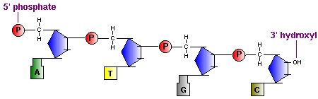
A key feature of all nucleic acids is that they have two distinctive ends: the 5' (5-prime) and 3' (3-prime) ends. This terminology refers to the 5' and 3' carbons on the sugar. For both DNA (shown above) and RNA, the 5' end bears a phosphate, and the 3' end a hydroxyl group.
Another important concept in nucleic acid structure is that DNA and RNA polymerases add nucleotides to the 3' end of the previously incorporated base. Another way to put this is that nucleic acids are synthesized in a 5' to 3' direction.

Base Pairing and Double Stranded Nucleic Acids
Most DNA exists in the famous form of a double helix, in which two linear strands of DNA are wound around one another. The major force promoting formation of this helix is complementary base pairing: A's form hydrogen bonds with T's (or U's in RNA), and G's form hydrogen bonds with C's. If we mix two ATGC's together, the following duplex will form:
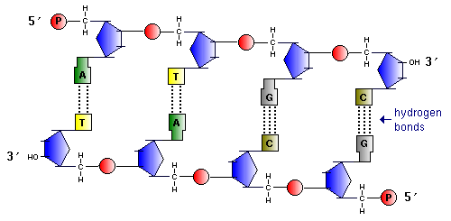
Examine the figure above and note two very important features:
- The two strands of DNA are arranged antiparallel to one another: viewed from left to right the "top" strand is aligned 5' to 3', while the "bottom" strand is aligned 3' to 5'. This is always the case for duplex nucleic acids.
- G-C base pairs have 3 hydrogen bonds, whereas A-T base pairs have 2 hydrogen bonds: one consequence of this disparity is that it takes more energy (e.g. a higher temperature) to disrupt GC-rich DNA than AT-rich DNA.
The figures above fail to impart any appreciation of the three-dimensional structure of DNA. This deficiency can be rectified to some extent by viewing and manipulating a 3-D model of duplex DNA.
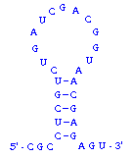
What about double stranded RNA? RNAs are usually single stranded, but many RNA molecules have secondary structure in which intramolecular loops are formed by complementary base pairing. A simple example of this is shown in the figure to the right, and much more extensive and complex examples are known. Base pairing in RNA follows exactly the same principles as with DNA: the two regions involved in duplex formation are antiparallel to one another, and the base pairs that form are A-U and G-C.
OK, what about RNA-DNA hybrids? Can they form? The answer is yes. Complementary sequences of RNA and DNA readily anneal with one another to form duplexes. In fact, RNA-DNA hybrids are more stable than the corresponding DNA-DNA and RNA-RNA duplexes.
Finally, does understanding base-pairing have relevance to biotechnology per se? Absolutely yes! This simple chemistry is at the heart of nucleic acid hybridization, polymerase chain reaction, antisense technology, mutagenesis, and many other of the techniques commonly applied in biotechnology labs.
Videos
http://www.youtube.com/watch?v=Udq7dX7jJMw

Review Questions
- Monosaccharides and polysaccharides are two classes of ______________.
- Long chains of amino acids make up ___________ and contain the atom _____________ which is unique to this macromolecule.
- Fats like triacylglycerols are the macromolecule _______________.
- We looked at two typed of carbohydrates in lab. Glucose is a simple sugar called a _____________, whereas starch contains compound carbon chains and is a _____________.
- All cells that have organelles are called ______________.
- What is the difference between an aldose and a ketose?
- Polysaccharides are formed by a dehydration synthesis reaction between monosaccharides. What does this mean?
- All proteins contain carbon, hydrogen, oxygen and what other element?
- When one glycerol molecule covalently bonds via dehydration synthesis with three fatty acid molecules the resulting macromolecule is called a _____________.
- What are the two general categories of carbohydrates?
- Protein molecules contain carbon, oxygen, hydrogen and _______________.
- ID the test: Sudan IV, Benedict's, Biuret, Starch
1. The cloudy, orange color that shows a positive result for the ___________ test is due to simple sugars reducing cupric ions to cuprous ions which oxidize to form copper oxide.
2. If a solution contains macromolecules that test positive for the ___________ test, light refracts from copper-containing rings to produce a violet color.
3. The reagent used in the ____________ test is soluble in lipid, but not in water. Adding ethanol to test solutions is necessary.
- Explain the difference between lipids and carbohydrates with respect to energy use and storage.
- What caused the food dye to diffuse faster in hot water than in cold water?

