Mitosis
Cells can divide, and in unicellular organisms, this makes more organisms. In multicellular organisms, cell division is used for growth, development, and repair of the organism. Cell division is controlled by DNA, but exact copies of the DNA must be given to the daughter cells (note use of “mother” and “daughter”). Bacteria reproduce by a simple process called binary fission. They have one chromosome which is attached to the cell membrane. This chromosome replicates, then the two copies are pulled apart as the cell grows. Eventually the cell pinches in two to make two cells. Eukaryotes do mitosis. In mitosis, each daughter cell gets about half of the cytoplasm from the mother cell and one set or copy of the DNA.
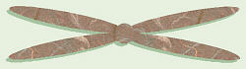
Before cell division occurs, the cell first has to replicate the chromosomes so each daughter cell can have a set. When the chromosomes are replicated and getting ready to divide, they consist of two, identical halves called sister chromatids which are joined by a central region, the centromere. Each chromosome is one long molecule of DNA and special proteins. Genes are sections of DNA. Genes are “on” chromosomes, or chromosomes “contain” or are made of genes. Some of the proteins in the chromosomes “turn off” the genes that are not needed in that cell. For example, while every cell in your body contains exactly the same genes, you don’t need your eye-color gene operational in cells in your big toe, nor toenail-shape genes active in cells in your stomach.
Two basic types of cells occur in the bodies of eukaryotes. Somatic cells are general body cells. These have the same number of chromosomes as each other within the body of an organism. The number of chromosomes in somatic cells is consistent among organisms of the same species, but varies from species to species. These chromosomes come in pairs, where one chromosome in each pair is from the mother and one is from the father. Actually, since most organisms have more than one pair of chromosomes, it would also be correct to say that the organism received one set of chromosomes from its mother and one matching set from its father, and that these sets match in pairs. The other type of cells found in eukaryotes is gametes or sex cells, consisting of eggs in females and sperm in males. These special reproductive cells have only one set (half as many) of chromosomes consisting of one chromosome from each pair. In humans ONLY, the somatic cells have 46 chromosomes arranged in 23 pairs (= two sets of 23 each), while gametes have 23 individual chromosomes (= one set). In fruit flies, somatic cells have 8 chromosomes (= 4 pairs or 2 sets) and gametes have 4 chromosomes (= 1 set). Geneticists use the term “-ploid” to refer to one set of chromosomes in an organism, and that term is typically combined with another wordstem that describes the number of sets of chromosomes present. For example, a cell with one set of chromosomes is called haploid, a cell with two sets of chromosomes is diploid, and a cell with four sets of chromosomes (not usually a “normal” condition, but sometimes possible) is tetraploid.
Technically, mitosis is specifically the process of division of the chromosomes, while cytokinesis is officially the process of division of the cytoplasm to form two cells. In most cells, cytokinesis follows or occurs along with the last part of mitosis.
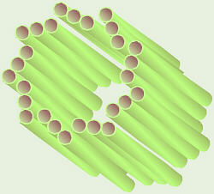
Remember centrioles? They consist of nine sets of three microtubules, occur in animal cells only, and are involved in division of the chromosomes. Each animal cell has a pair of centrioles located just outside the nucleus. The two centrioles in the pair are oriented at right angles to each other. Just before mitosis, the centrioles replicate, so the cell now has four (two sets of two) as it starts mitosis.

The stages in mitosis include (interphase), prophase, metaphase, anaphase, and telophase. Remembering “IPMAT” or Intelligent People Meet At Three (or is that Twelve?) can help you remember the stages in order. Strictly speaking, interphase is the stage in which a cell spends most of its life and is not part of the process of mitosis, per se, but is usually discussed along with the other stages.
Interphase may appears to be a “resting” stage, but cell growth, replication of the chromosomes, and many other activities are taking place during this time. Near the end of interphase just before the cell starts into the other stages of mitosis, if the cell is an animal cell, the centrioles replicate so there are two pairs. At this time, the strands of DNA that make up the chromsosomes are unwound within the nucleus and do not appear as distinct chromosomes. Thus, at this stage, the genetic material is often referred to as chromatin. From here, the cell goes through all other stages of mitosis.
In prophase, the chromosomes start to coil, shorten, and become distinct. In animals, the centrioles begin to migrate to the poles of the cell. The mitotic spindle or polar fibers begin to form from the poles of the cell towards the equator. In animals, this starts as asters around the centrioles. Eventually, the spindle mechanism finishes growing toward the equator and interacts with the centromeres to line up and, later, move the chromosomes. Also at this time, the nuclear envelope starts to disintegrate.  Metaphase is characterized by the lining up of the chromosomes along the equator of the cell or what is called the metaphase plate. The nuclear envelope has totally disintegrated and the polar fibers have reached the centromeres of the chromosomes and have begun interacting with them.  In anaphase, the sister chromatids separate at the centromeres, thus can now be called chromosomes. These are pulled to the poles of the cell by the mitotic spindle. | 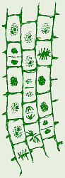  Mitosis in  onion root tip
In telophase, the new daughter nuclei and nuclear envelopes start to reform and the chromosomes uncoil. Telophase frequently includes the start of cytokinesis. In animal cells, cytokinesis starts with a cleavage furrow or indentation around the middle that eventually pinches in, dividing the cell in two. In plants, cytokinesis begins with a series of vesicles that form at the equator of the cell, which subsequently join until the cell is divided in two.
Animal Cytokinesis | Plant Cytokinesis
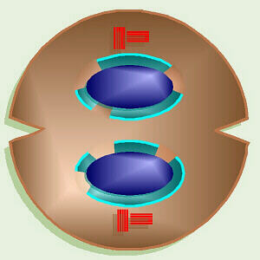 | 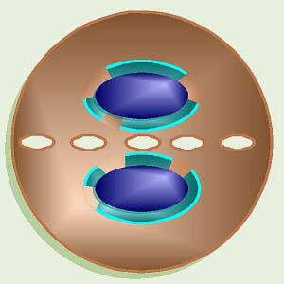
One interesting offshoot of the study of mitosis is tissue culture. In tissue culture, the cells to be studied are removed from the organism’s body and grown on a sterile, artificial medium. When grown in this manner, typically normal cells grow one layer thick on the surface of the sterile medium and will undergo only 20 to 50 mitotic divisions then cease to be able to reproduce. Also, typically, when all cells are touching neighbors all around, they stop dividing. This phenomenon is known as contact inhibition. In sharp contrast, cancer cells will not stop growing with one layer on the surface of the medium, but grow multiple layers and fill the dish. They do not exhibit contact inhibition: they don’t stop growing when touching on all sides. Also cancer cells appear to have no limit to the number of generations they can produce. Back in the mid-1950s, a biopsy of cervical cancer was removed from a woman named Henrietta Lacks and grown in tissue culture. While Ms. Lacks died long ago, HeLa cells are a widely-cultured research “organism” available through a number of biological supply companies. Within the past few years, an interesting issue has arisen regarding these cells: are they still “human”? While HeLa cells currently being grown in tissue culture are descendents of the original human cancer cells, by now they have mutated so much that it’s questionable whether they can still be considered “human” tissue, especially since they were abnormal, cancer cells to begin with.
Tissue culture is now a widely-used means of more effectively and quickly finding the right drugs to treat cancer. Typically, in the past, people with cancer were subjected to one toxic drug after another in hopes of finding one that would be effective against that particular cancer. Unfortunately, by the time the right drug was found, it frequently was too late to do any good. Now, when a person is diagnosed with cancer, a biopsy can be taken and a number of cultures of cells can be grown. Each of these cultures can be subjected to a different drug, thus enabling doctors to find the right drug sooner, while it may still be of help, and without needlessly subjecting the person to many kinds of toxic chemicals.
Within our bodies, different cells do mitosis at different rates. Skin cells continuously do mitosis and divide, thus our skin is constantly renewed and repaired. In sharp contrast, most nerve cells stop doing mitosis soon after birth (Caution: overconsumption of alcohol can kill nerve/brain cells, and they can never be replaced, they will never “grow back.”). Liver cells are somewhere in between. In a healthy adult, liver cells normally do not divide, but can divide to repair minor damage. Major liver damage or a disease like cirrhosis is too much damage to be repaired through mitosis. In contrast, it is possible to use one adult liver to do liver transplants for four babies, and if all goes well, these pieces can eventually regenerate whole livers.

Meiosis
Sexual reproduction occurs only in eukaryotes. During the formation of gametes, the number of chromosomes is reduced by half, and returned to the full amount when the two gametes fuse during fertilization.

Ploidy
Haploid and diploid are terms referring to the number of sets of chromosomes in a cell. Gregor Mendel determined his peas had two sets of alleles, one from each parent. Diploid organisms are those with two (di) sets. Human beings (except for their gametes), most animals and many plants are diploid. We abbreviate diploid as 2n. Ploidy is a term referring to the number of sets of chromosomes. Haploid organisms/cells have only one set of chromosomes, abbreviated as n. Organisms with more than two sets of chromosomes are termed polyploid. Chromosomes that carry the same genes are termed homologous chromosomes. The alleles on homologous chromosomes may differ, as in the case of heterozygous individuals. Organisms (normally) receive one set of homologous chromosomes from each parent.
Meiosis is a special type of nuclear division which segregates one copy of each homologous chromosome into each new "gamete". Mitosis maintains the cell's original ploidy level (for example, one diploid 2n cell producing two diploid 2n cells; one haploid n cell producing two haploid n cells; etc.). Meiosis, on the other hand, reduces the number of sets of chromosomes by half, so that when gametic recombination (fertilization) occurs the ploidy of the parents will be reestablished.
Most cells in the human body are produced by mitosis. These are the somatic (or vegetative) line cells. Cells that become gametes are referred to as germ line cells. The vast majority of cell divisions in the human body are mitotic, with meiosis being restricted to the gonads.

Life Cycles
Life cycles are a diagrammatic representation of the events in the organism's development and reproduction. When interpreting life cycles, pay close attention to the ploidy level of particular parts of the cycle and where in the life cycle meiosis occurs. For example, animal life cycles have a dominant diploid phase, with the gametic (haploid) phase being a relative few cells. Most of the cells in your body are diploid, germ line diploid cells will undergo meiosis to produce gametes, with fertilization closely following meiosis.
Plant life cycles have two sequential phases that are termed alternation of generations. The sporophyte phase is "diploid", and is that part of the life cycle in which meiosis occurs. However, many plant species are thought to arise by polyploidy, and the use of "diploid" in the last sentence was meant to indicate that the greater number of chromosome sets occur in this phase. The gametophyte phase is "haploid", and is the part of the life cycle in which gametes are produced (by mitosis of haploid cells). In flowering plants (angiosperms) the multicelled visible plant (leaf, stem, etc.) is sporophyte, while pollen and ovaries contain the male and female gametophytes, respectively. Plant life cycles differ from animal ones by adding a phase (the haploid gametophyte) after meiosis and before the production of gametes.
Many protists and fungi have a haploid dominated life cycle. The dominant phase is haploid, while the diploid phase is only a few cells (often only the single celled zygote, as in Chlamydomonas ). Many protists reproduce by mitosis until their environment deteriorates, then they undergo sexual reproduction to produce a resting zygotic cyst.

Phases of Meiosis
Two successive nuclear divisions occur, Meiosis I (Reduction) and Meiosis II (Division). Meiosis produces 4 haploid cells. Mitosis produces 2 diploid cells. The old name for meiosis was reduction/ division. Meiosis I reduces the ploidy level from 2n to n (reduction) while Meiosis II divides the remaining set of chromosomes in a mitosis-like process (division). Most of the differences between the processes occur during Meiosis I.

Prophase I
Prophase I has a unique event -- the pairing (by an as yet undiscovered mechanism) of homologous chromosomes. Synapsis is the process of linking of the replicated homologous chromosomes. The resulting chromosome is termed a tetrad, being composed of two chromatids from each chromosome, forming a thick (4-strand) structure. Crossing-over may occur at this point. During crossing-over chromatids break and may be reattached to a different homologous chromosome.
The alleles on this tetrad:
A B C D E F G
A B C D E F G
a b c d e f g
a b c d e f g
will produce the following chromosomes if there is a crossing-over event between the 2nd and 3rd chromosomes from the top:
A B C D E F G
A B c d e f g
a b C D E F G
a b c d e f g
Thus, instead of producing only two types of chromosome (all capital or all lower case), four different chromosomes are produced. This doubles the variability of gamete genotypes. The occurrence of a crossing-over is indicated by a special structure, a chiasma (plural chiasmata) since the recombined inner alleles will align more with others of the same type (e.g. a with a, B with B). Near the end of Prophase I, the homologous chromosomes begin to separate slightly, although they remain attached at chiasmata.
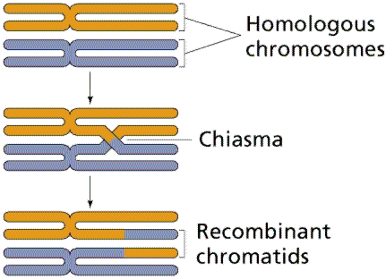
Crossing-over between homologous chromosomes produces chromosomes with new associations of genes and alleles.
Events of Prophase I (save for synapsis and crossing over) are similar to those in Prophase of mitosis: chromatin condenses into chromosomes, the nucleolus dissolves, nuclear membrane is disassembled, and the spindle apparatus forms.
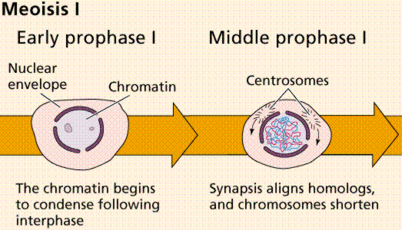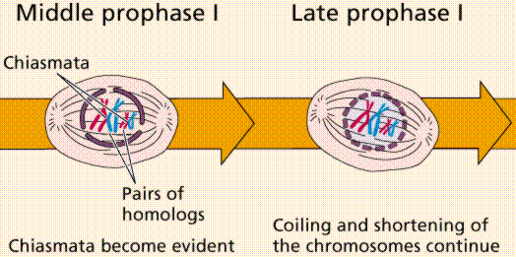
Major events in Prophase I.

Metaphase I
Metaphase I is when tetrads line-up along the equator of the spindle. Spindle fibers attach to the centromere region of each homologous chromosome pair. Other metaphase events as in mitosis.

Anaphase I
Anaphase I is when the tetrads separate, and are drawn to opposite poles by the spindle fibers. The centromeres in Anaphase I remain intact.
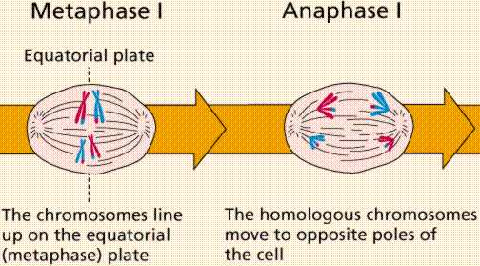
Events in prophase and metaphse I.

Telophase I
Telophase I is similar to Telophase of mitosis, except that only one set of (replicated) chromosomes is in each "cell". Depending on species, new nuclear envelopes may or may not form. Some animal cells may have division of the centrioles during this phase.
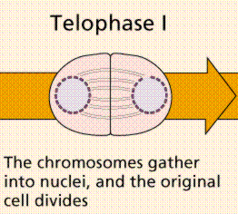
The events of Telophase I.

Prophase II
During Prophase II, nuclear envelopes (if they formed during Telophase I) dissolve, and spindle fibers reform. All else is as in Prophase of mitosis. Indeed Meiosis II is very similar to mitosis.
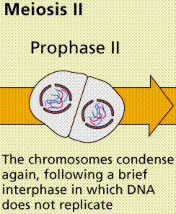
The events of Prophase II.
Metaphase II is similar to mitosis, with spindles moving chromosomes into equatorial area and attaching to the opposite sides of the centromeres in the kinetochore region.

Anaphase II
During Anaphase II, the centromeres split and the former chromatids (now chromosomes) are segregated into opposite sides of the cell.
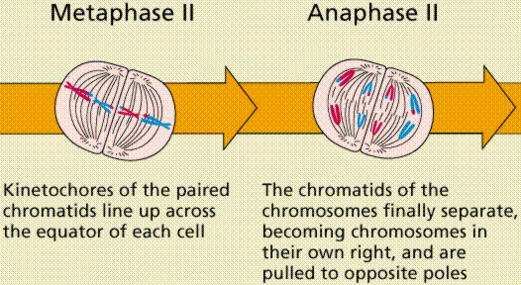
The events of Metaphase II and Anaphase II.

Telophase II
Telophase II is identical to Telophase of mitosis. Cytokinesis separates the cells.
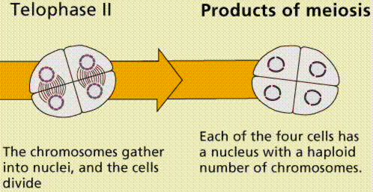
The events of Telophase II.

Comparison of Mitosis and Meiosis
Mitosis maintains ploidy level, while meiosis reduces it. Meiosis may be considered a reduction phase followed by a slightly altered mitosis. Meiosis occurs in a relative few cells of a multicellular organism, while mitosis is more common.
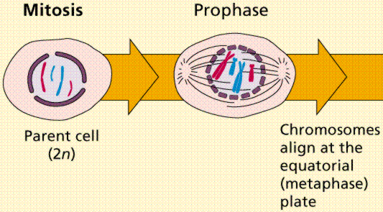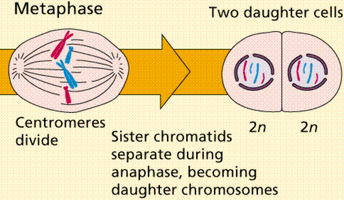
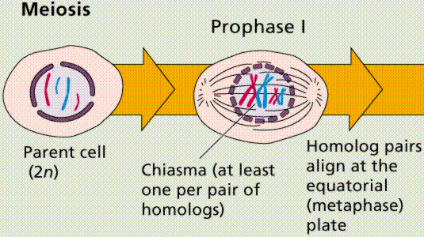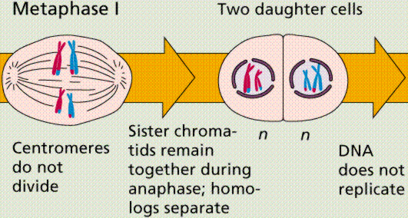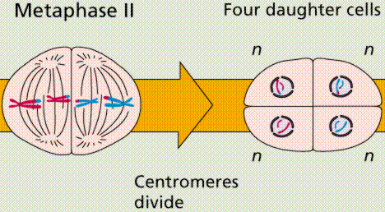Comparison of the events in Mitosis and Meiosis.

Gametogenesis
Gametogenesis is the process of forming gametes (by definition haploid, n) from diploid cells of the germ line. Spermatogenesis is the process of forming sperm cells by meiosis (in animals, by mitosis in plants) in specialized organs known as gonads (in males these are termed testes). After division the cells undergo differentiation to become sperm cells. Oogenesis is the process of forming an ovum (egg) by meiosis (in animals, by mitosis in the gametophyte in plants) in specialized gonads known as ovaries. Whereas in spermatogenesis all 4 meiotic products develop into gametes, oogenesis places most of the cytoplasm into the large egg. The other cells, the polar bodies, do not develop. This all the cytoplasm and organelles go into the egg. Human males produce 200,000,000 sperm per day, while the female produces one egg (usually) each menstrual cycle.
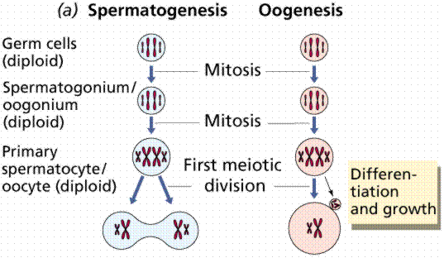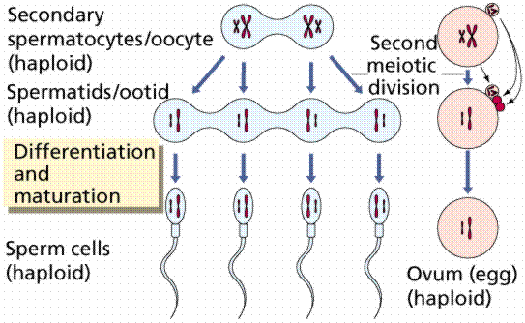
Gametogenesis.

Spermatogenesis
Sperm production begins at puberty at continues throughout life, with several hundred million sperm being produced each day. Once sperm form they move into the epididymis, where they mature and are stored.

Oogenesis
The ovary contains many follicles composed of a developing egg surrounded by an outer layer of follicle cells. Each egg begins oogenesis as a primary oocyte. At birth each female carries a lifetime supply of developing oocytes, each of which is in Prophase I. A developing egg (secondary oocyte) is released each month from puberty until menopause, a total of 400-500 eggs.
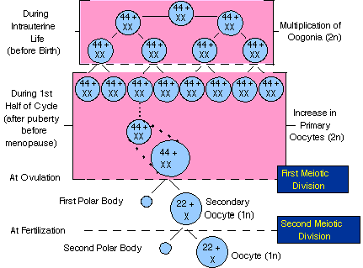
Oogenesis. The above image is from

Text ©1992, 1994, 1997, 1998, 2000, 2001, 2007, by M.J. Farabee, all rights reserved. Use for educational purposes is encouraged.

Meiosis
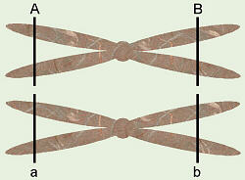
In sexual reproduction, two parents give rise to an offspring with an unique gene combination from either of them — each parent gives 1/2 of his/her genes to the offspring. A gene is a discrete unit of information on the DNA that codes for one protein, perhaps one of the many enzymes needed by our bodies.
Somatic cells have two sets of chromosomes; one set from each parent. For example, in humans one set = 23 chromosomes, so our somatic cells have 46 chromosomes arranged in 23 pairs. The two chromosomes in each pair are referred to as being homologous chromosomes, so we could say that humans have 23 pairs of homologous chromosomes. The two chromosomes of each pair carry genes for the same trait (for example, eye color) at the same location, but not necessarily the same form of that gene (for example, brown vs. blue eyes).
An important exception to this is the sex chromosomes, the X and Y chromosomes. Although these chromosomes pair with each other, they are not the same size. The X-chromosome is longer and has genes for many traits with no match on the Y-chromosome. A person with XX would be female and someone with XY would be male (although, that’s not true of all other organisms). All the other chromosomes are called autosomes.
Somatic cells have two sets of autosomes (however many pairs that is) and one pair of sex chromosomes so are called diploid or 2n cells. Thus, humans would have 44 + XX or 44 + XY chromosomes, and fruit flies would have 6 + XX or 6 + XY. Gametes or sex cells (eggs from female and sperm from male) have one chromosome from each autosome pair and one sex chromosome (one set of chromosomes), thus are called haploid or 1n. Human eggs would have 22 + X chromosomes, and human sperm would have 22 + X or 22 + Y chromosomes. Similarly, fruit fly eggs would have 4 + X chromsomes and their sperm would have 3 + X or 3 + Y chromosomes.
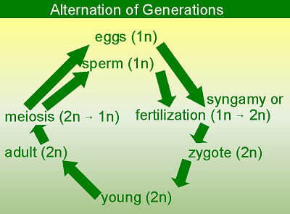
Meiosis is a special type of cell division that produces gametes with half as many chromosomes. The opposite process would be syngamy or fertilization, which is the union of the egg and sperm to restore the 2n number. This results in a zygote, the first cell formed by fertilization, a completely new and different organism with unique genetic information different from either parent. The zygote divides and grows to form an embryo which developes into a young organism, then an adult.
Life cycles of all sexually-reproducing organisms follow this pattern of alternation of generations. The 2n adult produces 1n gametes by the process of meiosis. These unite in the process of syngamy to produce a new 2n generation. Thus, the life cycles alternate between 1n and 2n stages, and between the processes of meiosis and syngamy. It is because of the way in which genes recombine in meiosis and syngamy that we have the whole study of genetics.

The steps in meiosis are similar to mitosis and even have the same names. However, there is a significant difference in how the chromosomes line up initially. In mitosis, chromosomes line up individually, while in meiosis, the two chromosomes in each homologous pair line up next to each other. This pairing process is called synapsis, and the resulting homologous pair is called a bivalent in reference to the two chromosomes or a tetrad in reference to the four sister chromatids involved.
Interphase is the same in both mitosis and meiosis, but in meiosis, it is followed by two cell divisions. These two division processes are referred to as Meiosis I and Meiosis II, and result in a total of four daughter cells, each with a 1n chromosome number.
In prophase I, notice the difference in how the homologous chromosomes behave. They come together and match up (synapsis) in pairs (tetrads or bivalents). In human females, this stage happens prior to birth when the ovaries are forming, and then stops. A baby girl is born with all the precursor egg cells she will ever have in a sort-of "suspended animation" until puberty (hence abdominal x-rays are dangerous for any young to middle-aged human female, not just pregnant women, and hence there is a greater likelihood that a 40-yr-old mother will have a baby with Down Syndrome – due to incorrect meiosis — than a 20-yr-old mother).
In metaphase I, the bivalents line up, not individual chromosomes, so there’s a 50:50 chance of which chromosome of each pair faces which pole of the cell. Human “eggs” go about this far through meiosis before they are shed from the ovaries at ovulation.
In anaphase I, the homologous chromosomes separate, and one of each pair travels to each of the two poles of the cell, thereby reducing the chromosome number from 2n to 1n. Note that the sister chromatids stay together.
Two daughter cells are formed during telophase I. These usually go immediately into the second cell division (meiosis II) to separate the sister chromatids.
Meiosis II is pretty much like mitosis, in that the sister chromatids are separated. This results in four daughter cells, each with an 1n chromosome number. In human females, meiosis II in the precursor egg cells never happens until/if a sperm first enters the egg to fertilize it. Fertilization triggers Meiosis II, and then the sperm nucleus unites with the resulting egg nucleus. Thus, the unfertilized “eggs” that a woman sheds each month are not true eggs. Also in human females, division of the cytoplasm is not even. This provides a way of keeping as much cytoplasm as possible with the future egg/zygote. Rather than equal-sized gametes, one big egg and three smaller polar bodies with minimal cytoplasm are formed.
Interestingly, because the homologous pairs line up during Metaphase I, there is a 50:50 chance of which one of each pair will go to each of the poles of the cell (like flipping a coin, where you can get either heads or tails). Therefore, in humans with 23 pairs of chromosomes, a gamete (egg or sperm) could have 2²³ or 8,388,604 possible combinations of chromosomes from that parent. Any couple could have 2²³ × 2²³ or 70,368,744,177,644 (70 trillion) different possible children, based just on the number of chromosomes, not considering the actual genes on those chromosomes. Thus, the chance of two siblings being exactly identical would be 1 in 70 trillion. In addition, something called crossing over, in which the two homologous chromosomes of a pair exchange equal segments during synapsis in Meiosis I, can add further variation to an individual’s genetic make-up.

