Microevolution
House sparrows have adapted to the climate of North America, mosquitoes have evolved in response to global warming, and insects have evolved resistance to our pesticides. These are all examples of microevolution — evolution on a small scale.
Here, you can explore the topic of microevolution through several case studies in which we've directly observed its action.
We can begin with an exact definition.
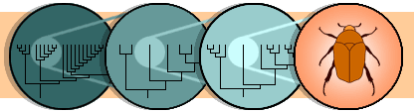
Defining microevolution
Microevolution is evolution on a small scale — within a single population. That means narrowing our focus to one branch of the tree of life.
If you could zoom in on one branch of the tree of life scale — the insects, for example — you would see another phylogeny relating all the different insect lineages. If you continue to zoom in, selecting the branch representing beetles, you would see another phylogeny relating different beetle species. You could continue zooming in until you saw the relationships between beetle populations. But how do you know when you've gotten to the population level?
Defining populations
For animals, it's fairly easy to decide what a population is. It is a group of organisms that interbreed with each other — that is, they all share a gene pool. So for our species of beetle, that might be a group of individuals that all live on a particular mountaintop and are potential mates for one another.
The potential to interbreed in nature defines the boundaries of a population.
Biologists who study evolution at this level define evolution as a change in gene frequency within a population.
Detecting microevolutionary change
We've defined microevolution as a change in gene frequency in a population and a population as a group of organisms that share a common gene pool — like all the individuals of one beetle species living on a particular mountaintop.
Imagine that you go to the mountaintop this year, sample these beetles, and determine that 80% of the genes in the population are for green coloration and 20% of them are for brown coloration. You go back the next year, repeat the procedure, and find a new ratio: 60% green genes to 40% brown genes.
You have detected a microevolutionary pattern: a change in gene frequency. A change in gene frequency over time means that the population has evolved.
The big question is, how did it happen?
Mechanisms of microevolution
There are a few basic ways in which microevolutionary change happens. Mutation, migration, genetic drift, and natural selection are all processes that can directly affect gene frequencies in a population.
Imagine that you observe an increase in the frequency of brown coloration genes and a decrease in the frequency of green coloration genes in a beetle population. Any combination of the mechanisms of microevolution might be responsible for the pattern, and part of the scientist's job is to figure out which of these mechanisms caused the change:
Mutation
Some "green genes" randomly mutated to "brown genes" (although since any particular mutation is rare, this process alone cannot account for a big change in allele frequency over one generation).
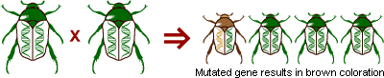
Migration (or gene flow)
Some beetles with brown genes immigrated from another population, or some beetles carrying green genes emigrated.
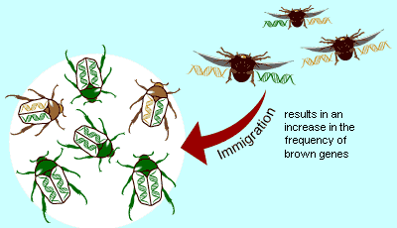
Genetic drift
When the beetles reproduced, just by random luck more brown genes than green genes ended up in the offspring. In the diagram at right, brown genes occur slightly more frequently in the offspring (29%) than in the parent generation (25%).
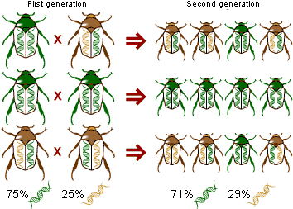
Natural selection
Beetles with brown genes escaped predation and survived to reproduce more frequently than beetles with green genes, so that more brown genes got into the next generation.
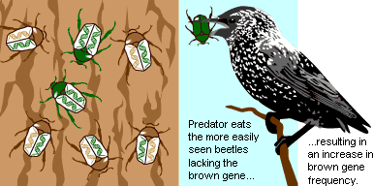
Speciation
What are species anyway, and how do new ones evolve?
Here, you can explore different ways to define a species and learn about the various processes through which speciation can occur. This section also addresses the topics of cospeciation — when two lineages split in concert with one another — and modes of speciation that are specific to plants.
Let's start by defining a species.
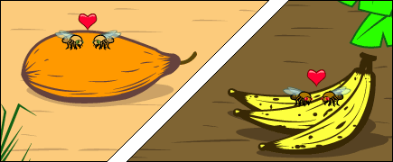
Defining a species
A species is often defined as a group of individuals that actually or potentially interbreed in nature. In this sense, a species is the biggest gene pool possible under natural conditions.
For example, these happy face spiders look different, but since they can interbreed, they are considered the same species: Theridion grallator.
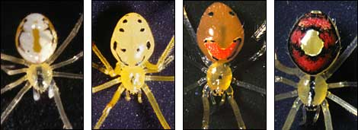
That definition of a species might seem cut and dried, but it is not — in nature, there are lots of places where it is difficult to apply this definition. For example, many bacteria reproduce mainly asexually. The bacterium shown at right is reproducing asexually, by binary fission. The definition of a species as a group of interbreeding individuals cannot be easily applied to organisms that reproduce only or mainly asexually.
Also, many plants, and some animals, form hybrids in nature. Hooded crows and carrion crows look different, and largely mate within their own groups — but in some areas, they hybridize. Should they be considered the same species or separate species?
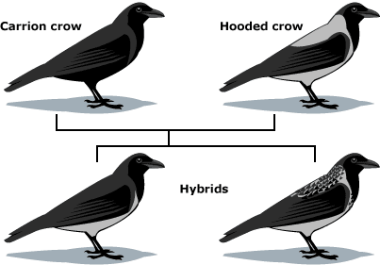
If two lineages of oak look quite different, but occasionally form hybrids with each other, should we count them as different species? There are lots of other places where the boundary of a species is blurred. It's not so surprising that these blurry places exist — after all, the idea of a species is something that we humans invented for our own convenience!
Defining speciation
Speciation is a lineage-splitting event that produces two or more separate species. Imagine that you are looking at a tip of the tree of life that constitutes a species of fruit fly. Move down the phylogeny to where your fruit fly twig is connected to the rest of the tree. That branching point, and every other branching point on the tree, is a speciation event. At that point genetic changes resulted in two separate fruit fly lineages, where previously there had just been one lineage. But why and how did it happen?
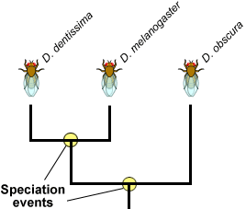
The branching points on this partial Drosophila phylogeny represent long past speciation events. Here is one scenario that exemplifies how speciation can happen:
- The scene: a population of wild fruit flies minding its own business on several bunches of rotting bananas, cheerfully laying their eggs in the mushy fruit...
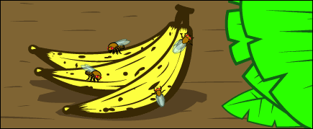
- Disaster strikes: A hurricane washes the bananas and the immature fruit flies they contain out to sea. The banana bunch eventually washes up on an island off the coast of the mainland. The fruit flies mature and emerge from their slimy nursery onto the lonely island. The two portions of the population, mainland and island, are now too far apart for gene flow to unite them. At this point, speciation has not occurred — any fruit flies that got back to the mainland could mate and produce healthy offspring with the mainland flies.
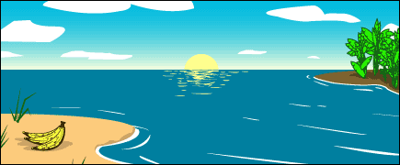
- The populations diverge: Ecological conditions are slightly different on the island, and the island population evolves under different selective pressures and experiences different random events than the mainland population does. Morphology, food preferences, and courtship displays change over the course of many generations of natural selection.
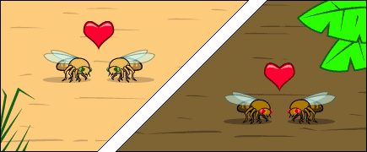
- So we meet again: When another storm reintroduces the island flies to the mainland, they will not readily mate with the mainland flies since they've evolved different courtship behaviors. The few that do mate with the mainland flies, produce inviable eggs because of other genetic differences between the two populations. The lineage has split now that genes cannot flow between the populations.
This is a simplified model of speciation by geographic isolation, but it gives an idea of some of the processes that might be at work in speciation. In most real-life cases, we can only put together part of the story from the available evidence. However, the evidence that this sort of process does happen is strong.
Causes of speciation
Geographic isolation
In the fruit fly example, some fruit fly larvae were washed up on an island, and speciation started because populations were prevented from interbreeding by geographic isolation. Scientists think that geographic isolation is a common way for the process of speciation to begin: rivers change course, mountains rise, continents drift, organisms migrate, and what was once a continuous population is divided into two or more smaller populations.
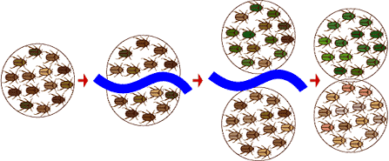
It doesn't even need to be a physical barrier like a river that separates two or more groups of organisms — it might just be unfavorable habitat between the two populations that keeps them from mating with one another.
Reduction of gene flow
However, speciation might also happen in a population with no specific extrinsic barrier to gene flow. Imagine a situation in which a population extends over a broad geographic range, and mating throughout the population is not random. Individuals in the far west would have zero chance of mating with individuals in the far eastern end of the range. So we have reduced gene flow, but not total isolation. This may or may not be sufficient to cause speciation. Speciation would probably also require different selective pressures at opposite ends of the range, which would alter gene frequencies in groups at different ends of the range so much that they would not be able to mate if they were reunited.
Even in the absence of a geographic barrier, reduced gene flow across a species' range can encourage speciation.
Reproductive isolation
The environment may impose an external barrier to reproduction, such as a river or mountain range, between two incipient species but that external barrier alone will not make them separate, full-fledged species. Allopatry may start the process off, but the evolution of internal (i.e., genetically-based) barriers to gene flow is necessary for speciation to be complete. If internal barriers to gene flow do not evolve, individuals from the two parts of the population will freely interbreed if they come back into contact. Whatever genetic differences may have evolved will disappear as their genes mix back together. Speciation requires that the two incipient species be unable to produce viable offspring together or that they avoid mating with members of the other group.
Here are some of the barriers to gene flow that may contribute to speciation. They result from natural selection, sexual selection, or even genetic drift:
- The evolution of different mating location, mating time, or mating rituals:
Genetically-based changes to these aspects of mating could complete the process of reproductive isolation and speciation. For example, bowerbirds (shown below) construct elaborate bowers and decorate them with different colors in order to woo females. If two incipient species evolved differences in this mating ritual, it might permanently isolate them and complete the process of speciation.
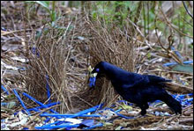 |  | 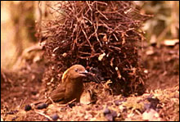
Different species of bowerbird construct elaborate bowers and decorate them with different colors in order to woo females. The Satin bowerbird (left) builds a channel between upright sticks, and decorates with bright blue objects, while the MacGregor’s Bowerbird (right) builds a tall tower of sticks and decorates with bits of charcoal. Evolutionary changes in mating rituals, such as bower construction, can contribute to speciation.
- Lack of "fit" between sexual organs:
Hard to imagine for us, but a big issue for insects with variably-shaped genitalia!
These damselfly penises illustrate just how complex insect genitalia may be.
- Offspring inviability or sterility:
All that courting and mating is wasted if the offspring of matings between the two groups do not survive or cannot reproduce.
In our fruit-flies-in-rotten-bananas-in-a-hurricane example, allopatry kicked off the speciation process, but different selection pressures on the island caused the island population to diverge genetically from the mainland population.
Geographic isolation can instigate a speciation event — but genetic changes are necessary to complete the process.
What might have caused that to happen? Perhaps, different fruits were abundant on the island. The island population was selected to specialize on a particular type of fruit and evolved a different food preference from the mainland flies.
Differing selection pressures on the two islands can complete the differentiation of the new species.
Could this small difference be a barrier to gene flow with the mainland flies? Yes, if the flies find mates by hanging out on preferred foods, then if they return to the mainland, they will not end up mating with mainland flies because of this different food preference. Gene flow would be greatly reduced; and once gene flow between the two species is stopped or reduced, larger genetic differences between the species can accumulate.
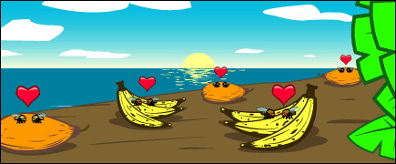
Evidence for speciation
Speciation in action?
In the summer of 1995, at least 15 iguanas survived Hurricane Marilyn on a raft of uprooted trees. They rode the high seas for a month before colonizing the Caribbean island, Anguilla. These few individuals were perhaps the first of their species, Iguana iguana, to reach the island. If there were other intrepid Iguana iguana colonizers of Anguilla, they died out before humans could record their presence.

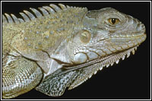 |  | Evolutionary biologists would love to know what happens next: will the colonizing iguanas die out, will they survive and change only slightly, or will they become reproductively isolated from other Iguana iguana and become a new species? We could be watching the first steps of an allopatric speciation event, but in such a short time we can't be sure.
A plausible model
We have several plausible models of how speciation occurs — but of course, it's hard for us to get an eye-witness account of a natural speciation event since most of these events happened in the distant past. We can figure out that speciation events happened and often when they happened, but it's more difficult to figure out how they happened. However, we can use our models of speciation to make predictions and then check these predictions against our observations of the natural world and the outcomes of experiments. As an example, we'll examine some evidence relevant to the allopatric speciation model.
Scientists have found a lot of evidence that is consistent with allopatric speciation being a common way that new species form:
- Geographic patterns: If allopatric speciation happens, we’d predict that populations of the same species in different geographic locations would be genetically different. There are abundant observations suggesting that this is often true. For example, many species exhibit regional "varieties" that are slightly different genetically and in appearance, as in the case of the Northern Spotted Owl and the Mexican Spotted Owl. Also, ring species are convincing examples of how genetic differences may arise through reduced gene flow and geographic distance.
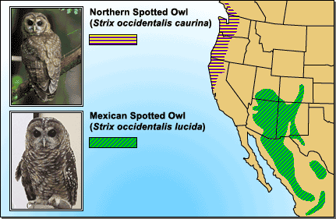
Spotted owl subspecies living in different geographic locations show some genetic and morphological differences. This observation is consistent with the idea that new species form through geographic isolation.
- Experimental results: The first steps of speciation have been produced in several laboratory experiments involving "geographic" isolation. For example, Diane Dodd examined the effects of geographic isolation and selection on fruit flies. She took fruit flies from a single population and divided them into separate populations living in different cages to simulate geographic isolation. Half of the populations lived on maltose-based food, and the other populations lived on starch-based foods. After many generations, the flies were tested to see which flies they preferred to mate with. Dodd found that some reproductive isolation had occurred as a result of the geographic isolation and selection for different food sources in the two environments: "maltose flies" preferred other "maltose flies," and "starch flies" preferred other "starch flies." Although, we can't be sure, these preference differences probably existed because selection for using different food sources also affected certain genes involved in reproductive behavior. This is the sort of result we'd expect, if allopatric speciation were a typical mode of speciation.
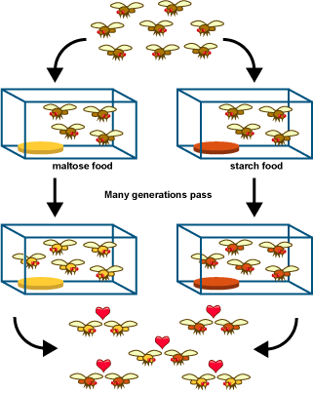
Diane Dodd’s fruit fly experiment suggests that isolating populations in different environments (e.g., with different food sources) can lead to the beginning of reproductive isolation. These results are consistent with the idea that geographic isolation is an important step of some speciation events.
Cospeciation
If the association between two species is very close, they may speciate in parallel. This is called cospeciation. It is especially likely to happen between parasites and their hosts.
To see how it works, imagine a species of louse living on a species of gopher. When the gophers get together to mate, the lice get an opportunity to switch gophers and perhaps mate with lice on another gopher. Gopher-switching allows genes to flow through the louse species.
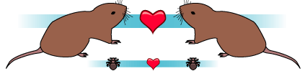
Consider what happens to the lice if the gopher lineage splits into lineages A and B:
- Lice have few opportunities for gopher-switching, and lice on gopher lineage A don't mate with lice living on gopher lineage B.
- This "geographic" isolation of the louse lineages may cause them to become reproductively isolated as well, and hence, separate species.
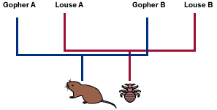
Evolutionary biologists can often tell when lineages have cospeciated because the parasite phylogeny will "mirror" the host phylogeny.
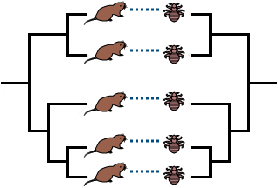
Observing parallel host and parasite phylogenies is evidence of cospeciation. Download the graphics on this page from the Image library.
This example is somewhat idealized — rarely do scientists find hosts and parasites with exactly matching phylogenies. However, sometimes the phylogenies indicate that cospeciation did happen along with some host-switching.
Macroevolution
Macroevolution is evolution on a grand scale — what we see when we look at the over-arching history of life: stability, change, lineages arising, and extinction.
Here, you can examine the patterns of macroevolution in evolutionary history and find out how scientists investigate deep history.
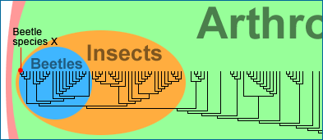
What is macroevolution?
Macroevolution generally refers to evolution above the species level. So instead of focusing on an individual beetle species, a macroevolutionary lens might require that we zoom out on the tree of life, to assess the diversity of the entire beetle clade and its position on the tree.
Macroevolution refers to evolution of groups larger than an individual species.
The history of life, on a grand scale.
Macroevolution encompasses the grandest trends and transformations in evolution, such as the origin of mammals and the radiation of flowering plants. Macroevolutionary patterns are generally what we see when we look at the large-scale history of life.
It is not necessarily easy to "see" macroevolutionary history; there are no firsthand accounts to be read. Instead, we reconstruct the history of life using all available evidence: geology, fossils, and living organisms.
Once we've figured out what evolutionary events have taken place, we try to figure out how they happened. Just as in microevolution, basic evolutionary mechanisms like mutation, migration, genetic drift, and natural selection are at work and can help explain many large-scale patterns in the history of life.
The basic evolutionary mechanisms — mutation, migration, genetic drift, and natural selection — can produce major evolutionary change if given enough time.
Download this, and the graphic at the top of the page, from the Image library.
A process like mutation might seem too small-scale to influence a pattern as amazing as the beetle radiation, or as large as the difference between dogs and pine trees, but it's not. Life on Earth has been accumulating mutations and passing them through the filter of natural selection for 3.8 billion years — more than enough time for evolutionary processes to produce its grand history.
Patterns in macroevolution
You can think of patterns as "what happened when." All of the changes, diversifications, and extinctions that happened over the course of life's history are the patterns of macroevolution.
However, beyond the details of individual past events — such as, when the beetle radiation began or what the first flowers looked like — biologists are interested in general patterns that recur across the tree of life:
1. |  | 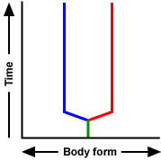  Stasis: Many lineages on the tree of life exhibit stasis, which just means that they don't change much for a long time, as shown in the figure to the right.  In fact, some lineages have changed so little for such a long time that they are often called living fossils. Coelacanths comprise a fish lineage that branched off of the tree near the base of the vertebrate clade. Until 1938, scientists thought that coelacanths went extinct 80 million years ago. But in 1938, scientists discovered a living coelacanth from a population in the Indian Ocean that looked very similar to its fossil ancestors. Hence, the coelacanth lineage exhibits about 80 million years' worth of morphological stasis.  A coelacanth swimming near Sulawesi, Indonesia

2. |  | Character change: Lineages can change quickly or slowly. Character change can happen in a single direction, such as evolving additional segments, or it can reverse itself by gaining and then losing segments. Changes can occur within a single lineage or across several lineages. In the figure to the right, lineage A changes rapidly but in no particular direction. Lineage B shows slower, directional change.  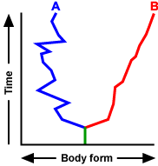  Trilobites, animals in the same clade as modern insects and crustaceans, lived over 300 million years ago. As shown below, their fossil record clearly suggests that several lineages underwent similar increases in segment number over the course of millions of years.
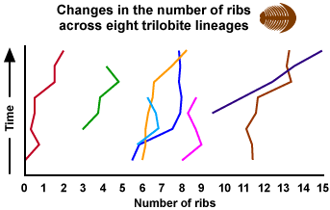
3. |  | Lineage-splitting (or speciation): Patterns of lineage-splitting can be identified by constructing and examining a phylogeny. The phylogeny might reveal that a particular lineage has undergone unusually frequent lineage-splitting, generating a "bushy" tuft of branches on the tree (Clade A, below). It might reveal that a lineage has an unusually low rate of lineage-splitting, represented by a long branch with very few twigs coming off (Clade B, below). Or it might reveal that several lineages experienced a burst of lineage-splitting at the same time (Clade C, below).
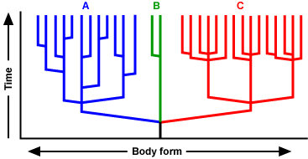
4. |  | Download all the graphics on this page from the Image library.  Extinction: Extinction is extremely important in the history of life. It can be a frequent or rare event within a lineage, or it can occur simultaneously across many lineages (mass extinction). Every lineage has some chance of becoming extinct, and overwhelmingly, species have ended up in the losing slots on this roulette wheel: over 99% of the species that have ever lived on Earth have gone extinct. In this diagram, a mass extinction cuts short the lifetimes of many species, and only three survive.
The big issues
A page from Darwin's notebook. |  | All available evidence supports the central conclusions of evolutionary theory, that life on Earth has evolved and that species share common ancestors. Biologists are not arguing about these conclusions. But they are trying to figure out how evolution happens, and that's not an easy job. It involves collecting data, proposing hypotheses, creating models, and evaluating other scientists' work. These are all activities that we can, and should, hold up to our checklist and ask the question: are they doing science?  All sciences ask questions about the natural world, propose explanations in terms of natural processes, and evaluate these explanations using evidence from the natural world. Evolutionary biology is no exception. Darwin's basic conception of evolutionary change and diversification (illustrated with a page from his notebook at left) explains many observations in terms of natural processes and is supported by evidence from the natural world.  Some of the questions that evolutionary biologists are trying to answer include:  - Does evolution tend to proceed slowly and steadily or in quick jumps?  - Why are some clades very diverse and some unusually sparse?  - How does evolution produce new and complex features?  - Are there trends in evolution, and if so, what processes generate them?

The pace of evolution
Does evolution occur in rapid bursts or gradually? This question is difficult to answer because we can't replay the past with a stopwatch in hand. However, we can try to figure out what patterns we'd expect to observe in the fossil record if evolution did happen in bursts, or if evolution happened gradually. Then we can check these predictions against what we observe.
What should we observe in the fossil record if evolution is slow and steady?
If evolution is slow and steady, we'd expect to see the entire transition, from ancestor to descendant, displayed as transitional forms over a long period of time in the fossil record.
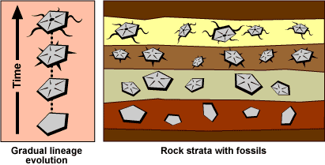
In the above example, the preservation of many transitional forms, through layers representing a length of time, gives a complete record of slow and steady evolution.
In fact, we see many examples of transitional forms in the fossil record. For example, to the right we show just a few steps in the evolution of whales from land-dwelling mammals, highlighting the transition of the walking forelimb to the flipper.
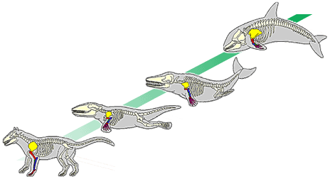
Transitional forms in whale evolution
What would we observe in the fossil record if evolution happens in "quick" jumps (perhaps fewer than 100,000 years for significant change)?
If evolution happens in "quick" jumps, we'd expect to see big changes happen quickly in the fossil record, with little transition between ancestor and descendant.
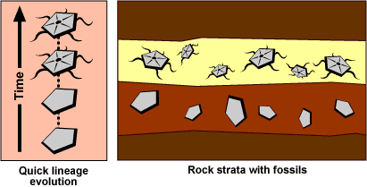
In the above example, we see the descendant preserved in a layer directly after the ancestor, showing a big change in a short time, with no transitional forms.
When evolution is rapid, transitional forms may not be preserved, even if fossils are laid down at regular intervals. We see many examples of this "quick" jumps pattern in the fossil record.
Does a jump in the fossil record necessarily mean that evolution has happened in a "quick" jump?
We expect to see a jump in the fossil record if evolution has occurred as a "quick" jump, but a jump in the fossil record can also be explained by irregular fossil preservation.
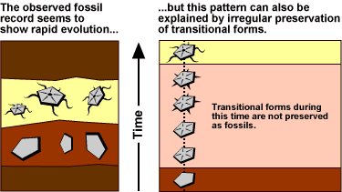
This possibility can make it difficult to conclude that evolution has happened rapidly.
We observe examples of both slow, steady change and rapid, periodic change in the fossil record. Both happen. But scientists are trying to determine which pace is more typical of evolution and how each sort of evolutionary change happens.
Diversity in clades
Imagine that you've traveled back in time to around 350 million years ago, give or take 50 million years. Your goal is to check out the cool insects living at this point in time. You see a lot of little insects that look like modern silverfish — no big deal.
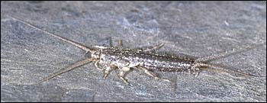
But something interesting and significant is happening that you can't see — a lineage has split into two. One of these newly isolated lineages will eventually give rise to about 400 extant species that look a lot like the ancient insects you see. But the other lineage will give rise to millions of extant insect species, the bulk of animal life on Earth today. Why is there such a big difference in diversity between these two lineages? After all, they were indistinguishable 350 million years ago...
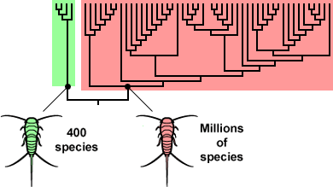
Why would one lineage lead to millions of species and the other to only 400?
- Opportunity knocks: One possibility is that the now-diverse lineage happened to be in the right place at the right time. The environment presented opportunities, and the lineage was able to take advantage of them. What sorts of factors in the environment might encourage diversification?
  - The environment may have offered opportunities for specialization.
  - A fragmented environment might make reproductive isolation likely.
  - The environment may have provided a release from competition with other insects.
All of these factors might be at work in some situations. Consider a plant-eating insect that colonizes a tropical island. On its mainland home, the insect's population size and range of resources is constrained by other species competing for the same resources. But the lack of similar species on the island means open niches and reduced competition from other species. Further, the island offers new kinds of food in the form of plants that the insect has never seen before. Selection might allow some insects to specialize on these new plants. Hanging around each kind of plant might mean that the insects get to mate with insects on a different plant less frequently, encouraging reproductive isolation. All of these factors can drive diversification — but only if the population has the genetic variation to take advantage of the opportunities presented by the environment.
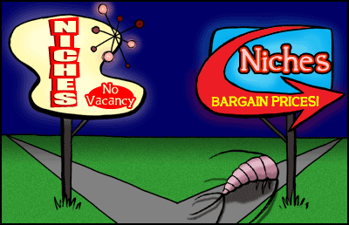
Being in the right place at the right time is a reason that one clade might be more diverse than another.
- Adaptive Radiation: If all of this diversification happens in a short amount of time, it is often referred to as an adaptive radiation. Although biologists have different standards for defining an adaptive radiation, it generally means an event in which a lineage rapidly diversifies, with the newly formed lineages evolving different adaptations. The rapid diversification of mammals shown below may constitute an adaptive radiation.
Download this graphic from the Image library.
- Historical changes in diversity: Many events have left their marks on the diversity of life on Earth, pruning or growing the tree of life, but a few stand out as unusually important:
a. Explosion: About 530 million years ago, a huge variety of marine animals suddenly burst onto the evolutionary scene. (Of course, "suddenly," in geological terms, means in perhaps 10 million years). These animals had a variety of new body forms that evolution has been using to produce "spin-offs" ever since, such as these representatives from the Burgess Shale.
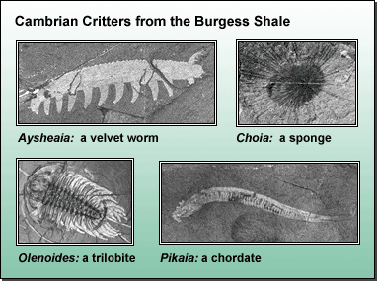
b. Extinction: About 225 million years ago, over 90% of the species alive at the time went extinct in fewer than 10 million years. Some groups that were dominant before the extinction never recovered. The cause of this extinction is the subject of much debate, but of equal significance is that it set the stage for a massive diversification of taxa that filled the empty niches.
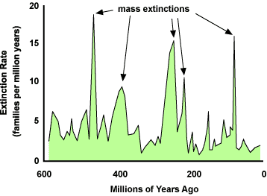
Looking at complexity
Life is full of grand complications, such as aerodynamic wings, multi-part organs like eyes, and intricate chemical pathways. When faced with such complexity, both opponents and proponents of evolution, Darwin included, have asked the question: how could it evolve?
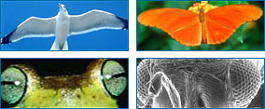
Complex adaptions: bird wings, insect wings, vertebrate eyes, and insect eyes.
Science does not sweep such difficult questions under the rug, but takes them up as interesting areas for research. The difficulty is as follows.
Since many of these complex traits seem to be adaptive, they are likely to have evolved in small steps through natural selection. That is, intermediate forms of the adaptation must have evolved before evolution arrived at a fully-fledged wing, chemical pathway, or eye. But what good is half a wing or only a few of the elements of an eyeball? The intermediate forms of these adaptations may not seem adaptive — so how could they be produced by natural selection?
There are several ways such complex novelties may evolve:
- Advantageous intermediates: It's possible that those intermediate stages actually were advantageous, even if not in an obvious way. What good is "half an eye?" A simple eye with just a few of the components of a complex eye could still sense light and dark, like eyespots on simple flatworms do. This ability might have been advantageous for an organism with no vision at all and could have evolved through natural selection.
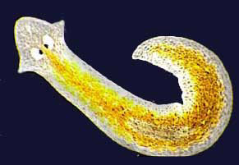
A Planaria flatworm with its light-sensitive eyespots.
- Co-opting: The intermediate stages of a complex feature might have served a different purpose than the fully-fledged adaptation serves. What good is "half a wing?" Even if it's not good for flying, it might be good for something else. The evolution of the very first feathers might have had nothing to do with flight and everything to do with insulation or display. Natural selection is an excellent thief, taking features that evolved in one context and using them for new functions.
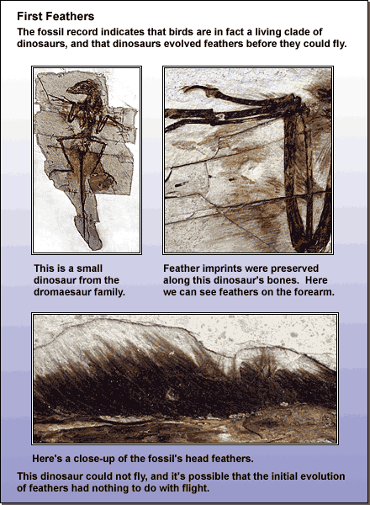
Trends in evolution
An evolutionary trend can be either directional change within a single lineage or parallel change across lineages, in other words, several lineages undergoing the same sort of change. However, not just any change counts as a trend. After all, if the weather gets warmer one day, you wouldn't call it a warming trend; warming would have to go on for some length of time before you'd call it a trend. Biologists think about evolutionary trends in the same way — there has to be something about the change that suggests that it's not just a random fluctuation before it counts as a "trend."
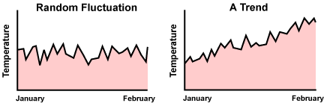
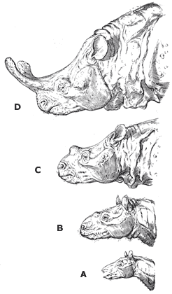
For example, titanotheres (a cool, extinct clade related to modern horses and rhinos) exhibit an evolutionary trend. Titanotheres had bony protuberances extending from their noses. The sequence of fossil skulls from these animals shows that evolutionary changes in the size of these "horns" were not random; instead, changes were biased in the direction of increasing horn size. And in fact, several different titanothere lineages experienced the same sort of change in horn size.
The titanothere reconstructions shown here range from about 55 mya (A) to 35 mya (D).The cause of this trend is not obvious. It may be a by-product of selection for increasing body size, and/or it may be a result of selection on horn size directly: big-horned individuals may have had an advantage in "butting" contests for females, as in sheep and goats.
Other evolutionary trends are not so consistent across lineages. For example, many different animal lineages have undergone cephalization, basically "the evolution of a head." Cephalization involves concentrating neurons into a brain at one end of the animal and evolving sensory organs at that same end. Arthropods (crustaceans, insects, and family), annelids (segmented worms), and chordates have all undergone increasing cephalization. However, many animal lineages have not undergone much cephalization (where's the head on a starfish?), and other lineages, such as many internal parasites, have gone in the reverse direction, losing the "heads" they started out with.
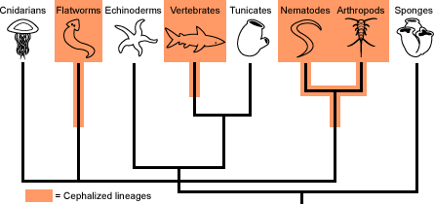
Is evolution progressive?
This is not an easy question to answer. From a plant's perspective, the best measure of progress might be photosynthetic ability; from a spider's it might be the efficiency of a venom delivery system.
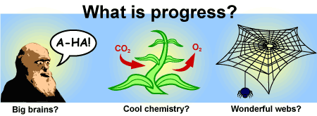
The problem is that we humans are hung up on ourselves. We often define progress in a way that hinges on our view of ourselves, a way that relies on intellect, culture, or emotion. But that definition is anthropocentric.
It is tempting to see evolution as a grand progressive ladder with Homo sapiens emerging at the top. But evolution produces a tree, not a ladder — and we are just one of many leaves on the tree.
