http://staff.tuhsd.k12.az.us/gfoster/standard/bgraph2.htm

Making Science Graphs and Interpreting Data
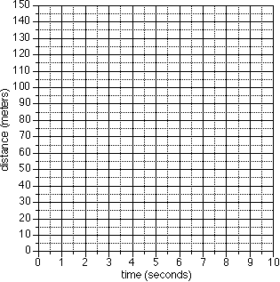
Scientific Graphs:
Most scientific graphs are made as line graphs. There may be times when other types would be appropriate, but they are rare.
The lines on scientific graphs are usually drawn either straight or curved. These "smoothed" lines do not have to touch all the data points, but they should at least get close to most of them. They are called best-fit lines.
In general, scientific graphs are not drawn in connect-the-dot fashon.

Here are two examples of best-fit graph lines.
One is drawn correctly, the other is not.
Best-Fit Line #1
Best-Fit Line #2
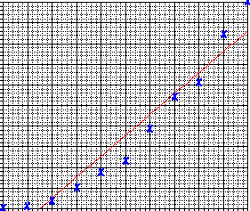
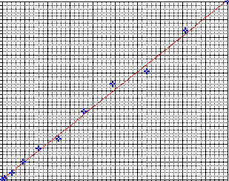
Practice Interpreting Data:
In addition to drawing graphs, it is also important that you be able to intrepret data that is represented in graph form. The following examples are provided to help you develop the ability to read information shown on a graph.

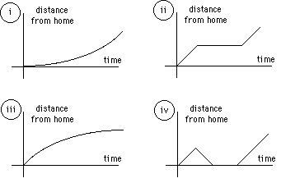
- Identify the graph that matches each of the following stories:
  - I had just left home when I realized I had forgotten my books so I went back to pick them up.
  - Things went fine until I had a flat tire.
  - I started out calmly, but sped up when I realized I was going to be late.

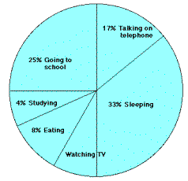
- The graph at the right represents the typical day of a teenager. Answer these questions:
  - What percent of the day is spent watching TV?
  - How many hours are spent sleeping?
  - What activity takes up the least amount of time?
  - What activity takes up a quarter of the day?
  - What two activities take up 50% of the day?
  - What two activities take up 25% of the day?

- Answer these questions about the graph at the right:
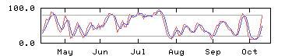
  - How many sets of data are represented?
  - On approximately what calendar date does the graph begin?
  - In what month does the graph reach its highest point?

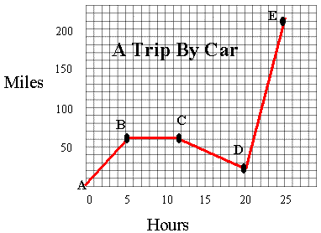
- Answer these questions about the graph on the right:
  - How many total miles did the car travel?
  - What was the average speed of the car for the trip?
  - Describe the motion of the car between hours 5 and 12?
  - What direction is represented by line CD?
  - How many miles were traveled in the first two hours of the trip?
  - Which line represents the fastest speed?

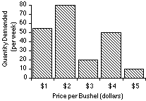
- Answer these questions about the graph at the right:
  - What is the dependent variable on this graph?
  - Does the price per bushel always increase with demand?
  - What is the demand when the price is 5$ per bushel?

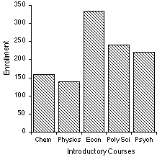
- The bar graph at right represents the declared majors of freshman enrolling at a university. Answer the following questions:
  - What is the total freshman enrollment of the college?
  - What percent of the students are majoring in physics?
  - How many students are majoring in economics?
  - How many more students major in poly sci than in psych?

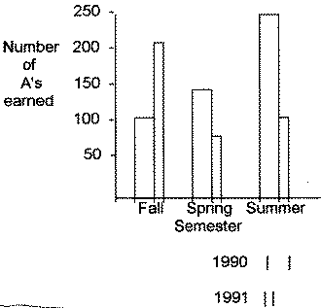
- This graph represents the number of A's earned in a particular college algebra class. Answer the following questions:
  - How many A's were earned during the fall and spring of 1990?
  - How many more A's were earned in the fall of 1991 than in the spring of 1991?
  - In which year were the most A's earned?
  - In which semester were the most A's earned?
  - In which semester and year were the fewest A's earned?

- Answer these questions about the graph at the right:
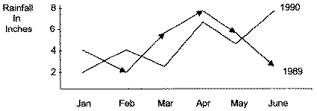
  - How much rain fell in Mar of 1989?
  - How much more rain fell in Feb of 1990 than in Feb of 1989?
  - Which year had the most rainfall?
  - What is the wettest month on the graph?

http://www.mathgoodies.com/lessons/graphs/line_graph_part3.html

Bottom of Form
Comparing Graphs

In this unit, we learned about line, bar and circle graphs. We learned how to read and interpret information from each type of graph, and how to construct these graphs. If you were asked to create a graph from a given set of data, how would you know which type of graph to use? Which graph we choose depends on the type of data given and what we are asked to convey to the reader. The information below will help you determine which type of graph to use.

Tables are used to organize exact amounts of data and to display numerical information. Tables do not show visual comparisons. As a result, tables take longer to read and understand. It is more difficult to examine overall trends and make comparisons with tables, than it is with graphs.
Line graphs are used to display data or information that changes continuously over time. Line graphs allow us to see overall trends such as an increase or decrease in data over time.
Bar graphs are used to compare facts. The bars provide a visual display for comparing quantities in different categories or groups. Bar graphs help us to see relationships quickly. However, bar graphs can be difficult to read accurately. A change in the scale in a bar graph may alter one's visual perception of the data.
Circle Graphs are used to compare the parts of a whole. Circle graphs represent data visually in the same proportion as the numerical data in a table: The area of each sector in a circle graph is in the same proportion to the whole circle as each item is to the total value in the table. Constructing an accurate circle graph is difficult to do without a computer. This is because you must first find each part of the whole through several elaborate calculations and then use a protractor to draw each angle. This leaves a lot of room for human error. Circle graphs are best used for displaying data when there are no more than five or six sectors, and when the values of each sector are different. Otherwise they can be difficult to read and understand.

Problem 1:
The table below shows the number of sneakers sold by brand for this month. Construct a graph which best demonstrates the sales of each brand.

Sneakers Sold This Month

Brand | Number Sold
Adidas | 25
New Balance | 18
Nike | 32
Reebok | 15
Other | 10

Analysis:
The numerical data in this table is not changing over time. So a line graph would not be appropriate for summarizing the given data. Let's draw a circle graph and a bar graph, and then compare them to see which one makes sense for this data. Before we can draw a circle graph, we need to do some calculations. We must also order the data from greatest to least so that the sectors of the circle graph are drawn from largest to smallest, in a clockwise direction.

Sneakers Sold This Month
Brand
Number Sold
Percent
Decimal
Angle Measure
Nike
32
32
0.32
0.32 x 360° = 115.2°
Adidas
25
25
0.25
0.25 x 360° = 90°
New Balance
18
18
0.18
0.18 x 360° = 64.8°
Reebok
15
15
0.15
0.15 x 360° = 54°
Other
10
10
0.10
0.10 x 360° = 36°
Total
100
100%
1.00 = 1
360°

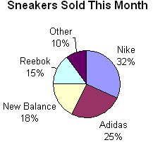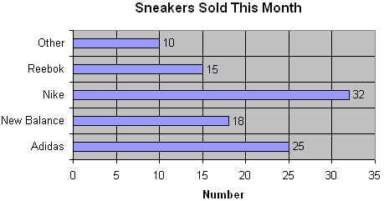

Circle graphs are best used to compare the parts of a whole.
Bar graphs are used to compare facts.
The circle graph above shows the entire amount sold. It also shows each brand's sales as part of that whole.
The bar graph stresses the individual sales of each brand as compared to the others.
The circle graph uses the total of all items in the table.
The bar graph does not use the total of all items in the table.
Each sector of the circle graph is in the same proportion to the whole circle as the number of sales for that industry is to the entire amount of sales from the table.
The bar graph simply gives a visual listing of the information in the table.
To construct an accurate circle graph, you must first order the data in the table from greatest to least. You also need to find each part of the whole through several elaborate calculations and then use a protractor to draw each angle.
The number of sneakers sold for each item in the table matches the value of each bar in the bar graph. This makes the bar graph a more direct and accurate way of representing the data in the table.
If we were asked to show that the Nike brand dominates the sneaker industry, then the circle graph would be a better choice for summarizing this data.
We were asked to construct a graph which best demonstrates the sales of each brand.

Solution:
Each graph above has its own strengths and limitations. However, the bar graph is the best choice for summarizing this data based on what we were asked to convey to the reader.

Problem 2:
The table below shows the humidity level, recorded in Small Town, NY for seven days. Construct a graph which best demonstrates the humidity level for each day.
Humidity Levels in Small Town, NY

Day | 1 | 2 | 3 | 4 | 5 | 6 | 7
Humidity level (%) | 51 | 59 | 65 | 68 | 70 | 67 | 72

Analysis:
The humidity level is given as a percent. At first glance, this might lead one to think that a circle graph should be used to summarize this data. However, the data in the table does not indicate any parts in relation to a whole. Thus, a circle graph is not the right choice. The data in this table is changing over time. So a line graph would be the appropriate choice for summarizing the given data.
Solution:
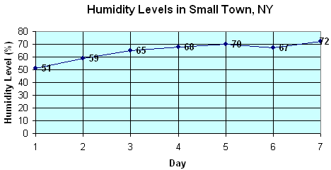

Problem 3:
The table below shows the composition of Earth's atmosphere. Construct a graph which best represents the composition of the Earth's Atmosphere.
Composition of Earth's Atmosphere

Gas | Nitrogen | Oxygen | Other
Percent | 77 | 21 | 2

Analysis:
The word composition indicates that we are looking at the parts of a whole. The Earth's Atmosphere is the whole (100%) and each gas is a part of that whole. Accordingly, a circle graph is the best choice for summarizing this data.
Solution:
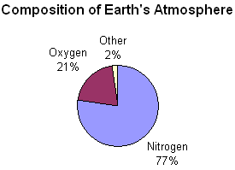

Problem 4:
The table below shows the surface area of each continent in square kilometers. Construct a graph which best represents this data.

Surface Area of Continents
Continent | Africa | Antarctica | Asia | Australia | Europe | North  America | South America
Surface Area (km²) | 15,000,000 | 14,200,000 | 44,936,000 | 7,614,500 | 10,525,000 | 23,5000,000 | 17,819,100

Analysis:
The numerical data in this table is not changing over time. So a line graph would not be appropriate choice for summarizing the given data. Let's draw a circle graph and a bar graph and compare them to see which one makes sense for this data. Before we can draw a circle graph, we need to do some calculations. We must also order the data from greatest to least so that the sectors of the circle graph are drawn from largest to smallest in a clockwise direction.

Surface Area of Continents
Continent
Surface Area (km²)
Percent
Decimal
Angle Measure
Asia
44,936,000
33.64
.3364
.3364 x 360° = 121.104°
North America
23,500,000
17.59
.1759
.1759 x 360° = 63.324°
South America
17,819,100
13.33
.1333
.1333 x 360° = 47.988°
Africa
15,000,000
11.23
.1133
.1133 x 360° = 40.788°
Antarctica
14,200,000
10.63
.1063
.1063 x 360° = 38.268°
Europe
10,525,000
7.88
.0788
.0788 x 360° = 28.358°
Australia
7,614,500
5.70
.0570
.0570 x 360° = 20.52°
Total
133,594,600
100.00
1.00 = 1
360°

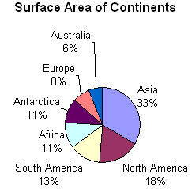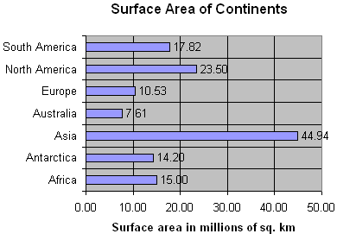

Do Africa and Antarctica really have the same surface area? The tool we used to create this circle graph rounded each value to the nearest whole percent. As a result, the circle graph shows that Africa and Antarctica both have a surface area of 11%; whereas the table shows numbers for these continents that are similar, but not the same.
The bar graph shows the surface area in millions of square kilometers. This was necessary in order to create a bar graph that is not confusing because of too many gridlines. The bar graph shows a surface area of 15.00 million sq. km for Africa and a surface area of 14.20 million sq km. for Antarctica.

Circle graphs are used to compare the parts of a whole. However, they are best used when there are no more than five or six sectors and when the values of each section are different.
Bar graphs are used to compare facts. The bar graph stresses the individual items listed in the table as compared to the others. The bar graph does not show the total of all items in the table.

The circle graph above has several sectors with similar sizes. It also has seven sectors. This makes it a bit difficult to compare the parts and to read the graph. However, the world has seven continents, so it does make sense to use a circle graph to compare the parts (continents) with the whole (world).

The bar graph above allows us to compare the surface area of each continent. However, it does not allow us to compare the parts to the whole. So we cannot see the relationship between the surface area of each continent and the surface area of all seven continents.

Solution:
It is difficult to determine which type of graph is appropriate for the given data in this problem. Each graph above has its own strengths and limitations. You must choose one of these solutions based on your own judgment.

Summary:
Graphs help us examine trends and make comparisons by visually displaying data. Before we can graph a given set of data from a table, we must first determine which type of graph is appropriate for summarizing that data. There are several types of graphs, each with its own purpose, and its own strengths and limitations. Which one we choose depends on the type of data given, and what we are asked to convey to the reader.

Exercises
Directions: Enter one of the following answers for each exercise below: line, bar or circle.

1.The ages of 7 trumpet players in a band are 13, 12, 11, 12, 11, 10 and 12. What type of graph would be appropriate for comparing the ages of these trumpet players?
Bottom of Form

2. The federal hourly minimum wage was recorded each year from 1990 to 2007. What type of graph would best show the changes in minimum wage during this time period?
Top of Form
Bottom of Form
3. When asked if "antidisestablishmentarianism" has 28 letters, 50 people said yes, 35 people said no and 15 people said I don't know. What type of graph would best compare these responses to each other and with the total?
Bottom of Form

4. The growth of 7 different plants was recorded in centimeters. What type of graph would be best for comparing the growth of each plant?
Top of Form
Bottom of Form
5. In a city, the rainfall was recorded in inches each month for 12 months. What type of graph would best display the change in rainfall?
Top of Form
Bottom of Form
Line Graphs, Part I
Example 1: | The table below shows daily temperatures for New York City, recorded for 6 days, in degrees Fahrenheit.
Temperatures In NY City
Day | Temperature
1 | 43° F
2 | 53° F
3 | 50° F
4 | 57° F
5 | 59° F
6 | 67° F

 | The data from the table above has been summarized in the line graph below.
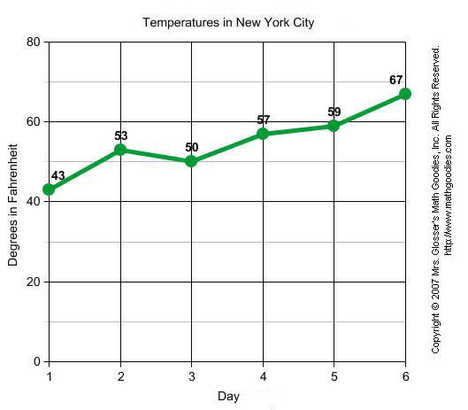
Example 2: | Sarah bought a new car in 2001 for $24,000. The dollar value of her car changed each year as shown in the table below.
Value of Sarah's Car
Year | Value
2001 | $24,000
2002 | $22,500
2003 | $19,700
2004 | $17,500
2005 | $14,500
2006 | $10,000
2007 | $ 5,800

 | The data from the table above has been summarized in the line graph below.
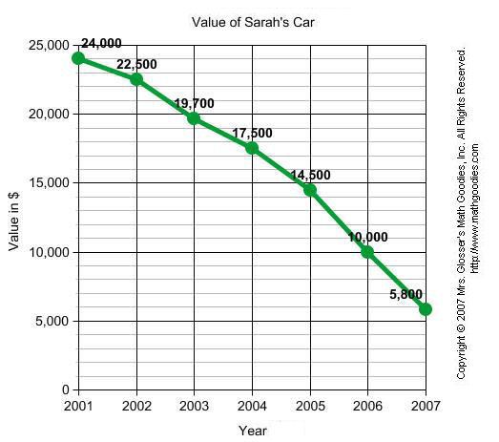

Example 3: | The table below shows Sam's weight in kilograms for 5 months.
Sam's Weight
Month | Weight in kg
January | 49
February | 54
March | 61
April | 69
May | 73

 | The data from the table above has been summarized in the line graph below.
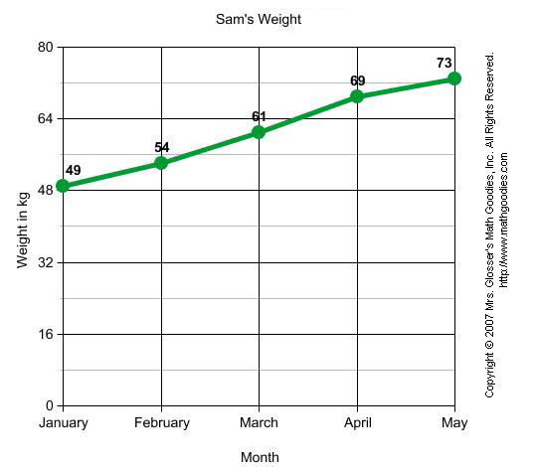

In Example1, the temperature changed from day to day. In Example 2, the value of Sarah's car decreased from year to year. In Example 3, Sam's weight increased each month. Each of these line graphs shows a change in data over time. A line graph is useful for displaying data or information that changes continuously over time. Another name for a line graph is a line chart.

Line Graphs, Part II
The graph below will be used to help us define the parts of a line graph.

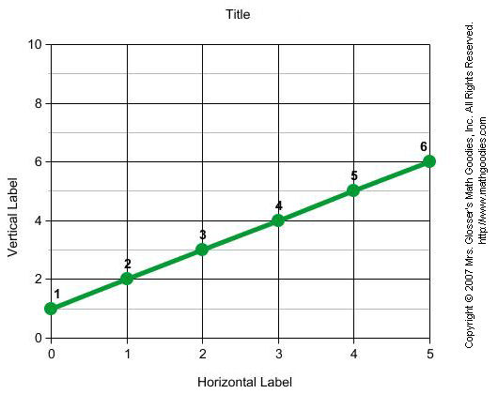
Let's define the various parts of a line graph.
Title | The title of the line graph tells us what the graph is about.
labels | The horizontal label across the bottom and the vertical label along the side tells us what kinds of facts are listed.
scales | The horizontal scale across the bottom and the vertical scale along the side tell us how much or how many.
points | The points or dots on the graph show us the facts.
lines | The lines connecting the points give estimates of the values between the points.

Now that we are familiar with the parts of a line graph, we can answer some questions about each of the graphs from the examples above.
QUESTION |  |  | ANSWER
1. | What is the title of this line graph? |  | Temperatures in New York City
2. | What is the range of values on the horizontal scale? |  | 1 to 6
3. | What is the range of values on the vertical scale? |  | 0 to 80
4. | How many points are in the graph? |  | 6
5. | What was the lowest temperature recorded? |  | 43° F
6. | What was the highest temperature recorded? |  | 67° F
7. | At what point did the temperature dip? |  | Day 3: 50° F

QUESTION |  |  | ANSWER
1. | What is the title of this line graph? |  | Value of Sarah's Car
2. | What is the range of values on the horizontal scale? |  | 2001 to 2007
3. | What is the range of values on the vertical scale? |  | 0 to 25,000
4. | How many points are in the graph? |  | 7
5. | What was the highest value recorded? |  | $24,000
6. | What was the lowest value recorded? |  | $5,800
7. | Did the value of the car increase or decrease over time? |  | decrease

QUESTION
1. | What is the title of this line graph?
2. | What is the range of values on the horizontal scale?
3. | What is the range of values on the vertical scale?
4. | How many points are in the graph?
5. | What was the highest value recorded?
6. | What was the lowest value recorded?
7. | Did Sam's weight increase or decrease over time?

Example 4: | The line graph below shows people in a store at various times of the day.
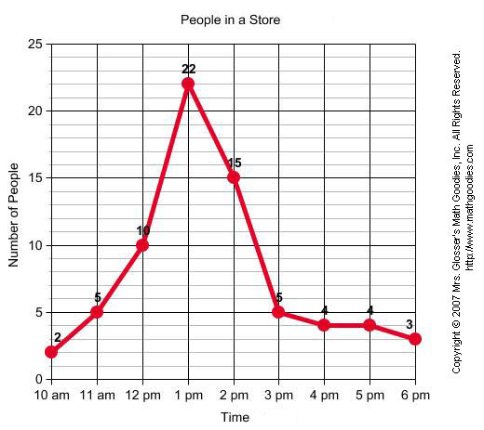
QUESTION |  |  | ANSWER
1. | What is the line graph about? |  | People in a Store
2. | What is the busiest time of day at the store? |  | 1 pm
3. | At what time does business start to slow down? |  | 3 pm
4. | How many people are in the store when it opens? |  | 2
5. | About how many people are in the store at 2:30 pm? |  | 11
6. | What was the greatest number of people in the store? |  | 22
7. | What was the least number of people in the store? |  | 2

Example 5: | The line graph below shows the number of teens ages 13 through 19 in Smalltown that have cell phones.
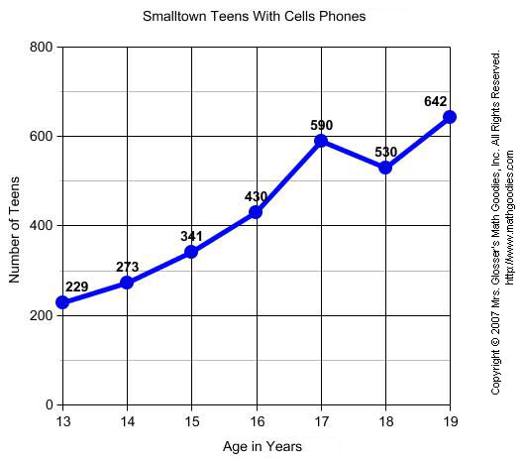
QUESTION
1. | What is the line graph about?
2. | At what age do teens have the greatest number cell phones?
3. | At what age do teens have the least number of cell phones?
4. | How many cell phones do 15 year-olds have?
5. | About how many cell phones do 16year-olds have?
6. | What was the greatest number of cell phones at any age?
7. | What was the least number of cell phones at any age?

Summary: |  | A line graph is useful in displaying data or information that changes continuously over time. The points on a line graph are connected by a line. Another name for a line graph is a line chart.
 | The graph below will be used to help us define the parts of a line graph.

Let's define the various parts of a line graph.
Title | The title of the line graph tells us what the graph is about.
labels | The horizontal label across the bottom and the vertical label along the side tells us what kinds of facts are listed.
scales | The horizontal scale across the bottom and the vertical scale along the side tell us how much or how many.
points | The points or dots on the graph show us the facts.
lines | The lines connecting the points give estimates of the values between the points.

Now that we are familiar with the parts of a line graph, we can answer some questions about each of the graphs from the examples above.
QUESTION
1. | What is the title of this line graph?
2. | What is the range of values on the horizontal scale?
3. | What is the range of values on the vertical scale?
4. | How many points are in the graph?
5. | What was the lowest temperature recorded?
6. | What was the highest temperature recorded?
7. | At what point did the temperature dip?

QUESTION |  |  | ANSWER
1. | What is the title of this line graph? |  | Value of Sarah's Car
2. | What is the range of values on the horizontal scale? |  | 2001 to 2007
3. | What is the range of values on the vertical scale? |  | 0 to 25,000
4. | How many points are in the graph? |  | 7
5. | What was the highest value recorded? |  | $24,000
6. | What was the lowest value recorded? |  | $5,800
7. | Did the value of the car increase or decrease over time? |  | decrease

QUESTION |  |  | ANSWER
1. | What is the title of this line graph? |  | Sam's Weight
2. | What is the range of values on the horizontal scale? |  | January to May
3. | What is the range of values on the vertical scale? |  | 0 to 80
4. | How many points are in the graph? |  | 5
5. | What was the highest value recorded? |  | 73 kg
6. | What was the lowest value recorded? |  | 49 kg
7. | Did Sam's weight increase or decrease over time? |  | increase

Example 4: | The line graph below shows people in a store at various times of the day.
QUESTION |  |  | ANSWER
1. | What is the line graph about? |  | People in a Store
2. | What is the busiest time of day at the store? |  | 1 pm
3. | At what time does business start to slow down? |  | 3 pm
4. | How many people are in the store when it opens? |  | 2
5. | About how many people are in the store at 2:30 pm? |  | 11
6. | What was the greatest number of people in the store? |  | 22
7. | What was the least number of people in the store? |  | 2

Example 5: | The line graph below shows the number of teens ages 13 through 19 in Smalltown that have cell phones.
QUESTION |  |  | ANSWER
1. | What is the line graph about? |  | Smalltown Teens With Cell Phones
2. | At what age do teens have the greatest number cell phones? |  | 19 years
3. | At what age do teens have the least number of cell phones? |  | 13 years
4. | How many cell phones do 15 year-olds have? |  | 341
5. | About how many cell phones do 16year-olds have? |  | 500
6. | What was the greatest number of cell phones at any age? |  | 642
7. | What was the least number of cell phones at any age? |  | 229

Summary: | A line graph is useful in displaying data or information that changes continuously over time. The points on a line graph are connected by a line. Another name for a line graph is a line chart.
Line Graphs, Part III

Exercises
Directions: Refer to the line graph below to answer each question. For each exercise below, click once in the ANSWER BOX, type in your answer; and then click ENTER. Your answers should be given as a word or as a whole number. After you click ENTER, a message will appear in the RESULTS BOX to indicate whether your answer is correct or incorrect. To start over, click CLEAR.

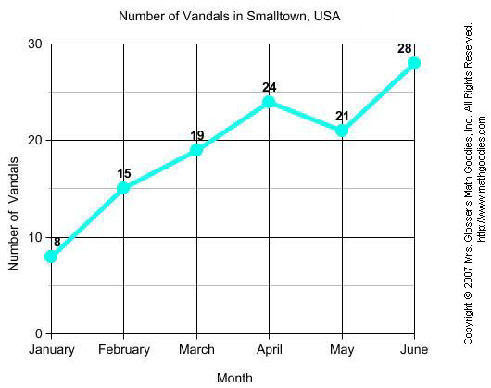
1. | In which month were there the most vandals?  ANSWER BOX:  RESULTS BOX:

2. | In which month were there the least vandals?  ANSWER BOX:  RESULTS BOX:

3. | How many vandals were there in March?  ANSWER BOX:  RESULTS BOX:

4. | In which month were there 24 vandals?  ANSWER BOX:  RESULTS BOX:
5. How many vandals were there in February?

Constructing Line Graphs
In the last lesson, we learned that a line graph is useful for displaying data or information that changes continuously over time. We read and interpreted information from various line graphs. However, we did not make any line graphs of our own. In this lesson, we will show you the steps for constructing a line graph.

Example 1: | The table below shows Jill's math scores in secondary school (grades 7 through 12). Construct a line graph to visually display this data.
Jill's Secondary Math Scores
Grade Level | Math Score (%)
7 | 72
8 | 75
9 | 81
10 | 80
11 | 83
12 | 91

Step 1: Find the range in values.
There are two sets of values. What units are used? What is the greatest value and the least value for the first set? What is the greatest value and the least value for the second set?
The units are grade level and math score (%). The grade level ranges from 7 to 12 and the math score ranges from 72 to 91.

Step 2: Determine a Scale.
Start with the horizontal scale. If you are using graph paper, let 1 unit on the graph paper equal 1 unit of the values you are graphing. Determine whether the greatest value will fit on the graph. If it doesn't, then change the scale and try again. Now repeat this process for the vertical scale.
The vertical scale must start at 0. So the vertical scale will range from 0 to 100.
Step 3: | Label the graph.
 | Mark each unit across the horizontal scale and along the vertical scale. Label the marks by the units they represent.
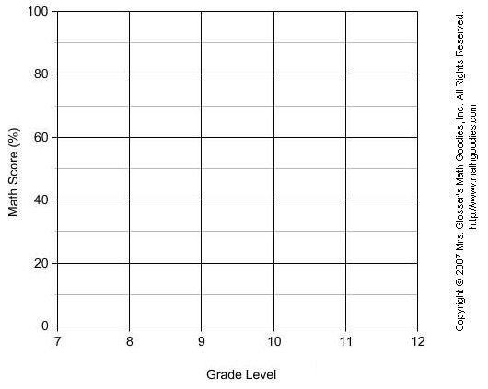
Step 4: Plot the points and connect them.
Plot a point for each pair of values. Which item of a pair is indicated by the horizontal scale? by the vertical scale? How many points will you plot? Connect the points with straight lines from left to right.
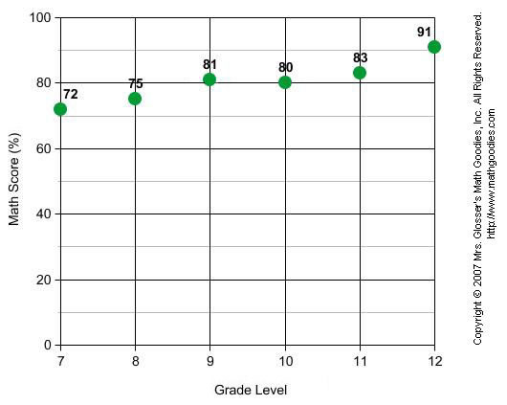
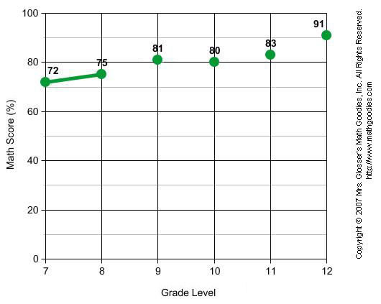
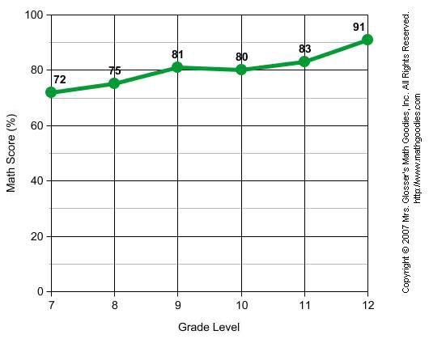
Step 5: Give the graph a title. What is your graph about?
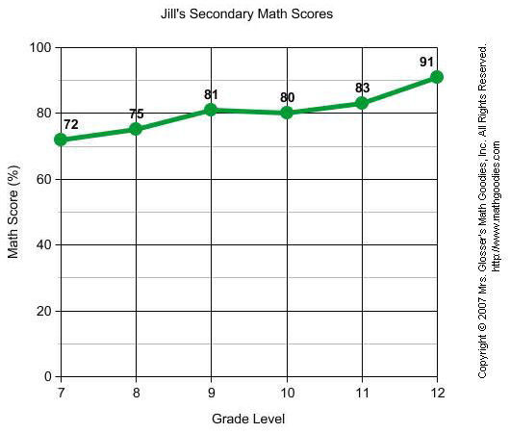
In Example 1, we wrote that the vertical scale must start at 0. Let's take a look at why this is so. Compare the line graph from Example 1 with the line graph below. The vertical scale in the graph below starts at 70. This makes the math scores appear to change much faster than they did in Example 1. Thus, by starting the vertical scale at 70, this graph is misleading.
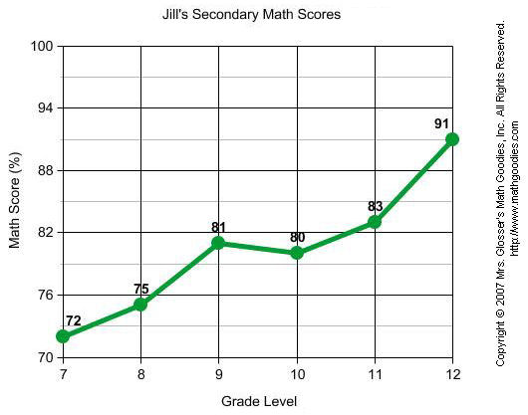

Example 2: | Anybank published its interest rates each day for 7 days as shown in the table below. Construct a line graph to visually display this data.
Anybank Interest Rates
Day | Interest Rate (%)
1 | 1.500
2 | 1.475
3 | 1.375
4 | 1.275
5 | 1.125
6 | 1.130
7 | 1.110

Step 1: Find the range in values. There are two sets of values. What units are used? What is the greatest value and the least value for the first set? What is the greatest value and the least value for the second set?
The units are day and interest rate (%). The day ranges from 1 to 7 and the interest rate ranges from 1.1 to 1.5.

Step 2: Determine a Scale. Start with the horizontal scale. If you are using graph paper, let 1 unit on the graph paper equal 1 unit of the values you are graphing. Determine whether the greatest value will fit on the graph. If it doesn't, then change the scale and try again. Now repeat this process for the vertical scale.
The vertical scale must start at 0. So, the vertical scale will range from 0 to 1.5.
Step 3: Label the graph.
Mark each unit across the horizontal scale and along the vertical scale. Label the marks by the units they represent.
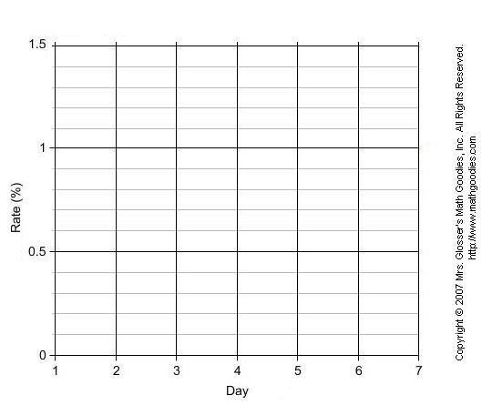
Step 4: | Plot the points and connect them.
 | Plot a point for each pair of values. Which item of a pair is indicated by the horizontal scale? by the vertical scale? How many points will you plot? Connect the points with straight lines from left to right.
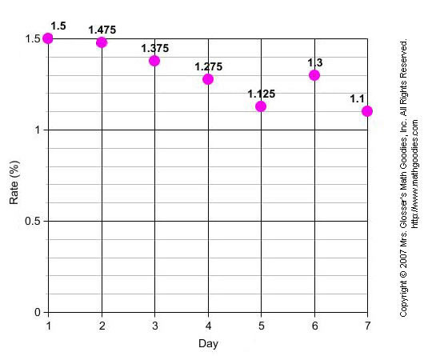
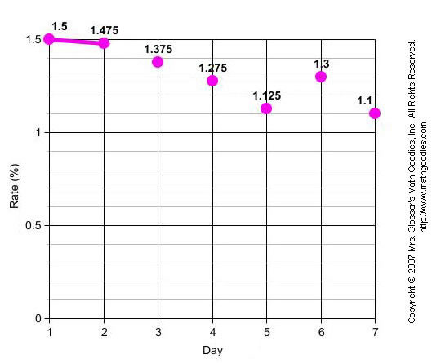
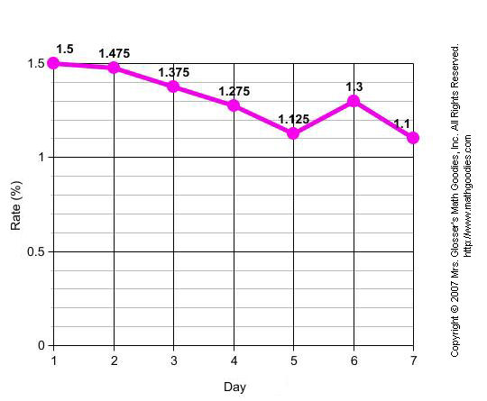
Step 5: Give the graph a title. What is your graph about?
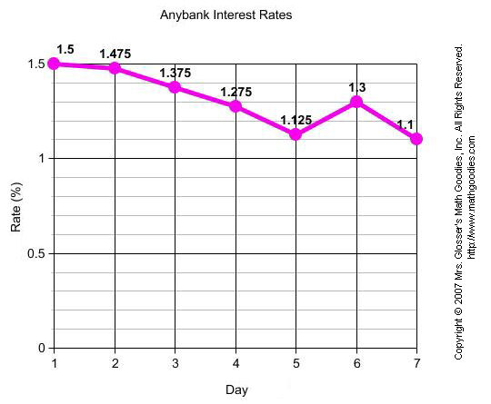

Summary: | There are 5 steps for constructing a line graph. These steps are listed below.
Procedure for Constructing a Line Graph
Step 1: | Find the range in values.
Step 2: | Determine a scale.
Step 3: | Label the graph.
Step 4: | Plot the points and connect them.
Step 5: | Give the graph a title.

Exercises
Directions: Use the procedure above to construct a line graph for each table given in the exercises below.

Exercise 1: | In 2000, a law was passed against the use of cell phones while driving in Anytown, N.Y. The number of people who use cell phones while driving in Anytown has changed each year since then as shown in the table below. Construct a line graph to visually display this data.
Cell Phone Use While Driving in Anytown, NY
Year | Number of People
2000 | 309
2001 | 274
2002 | 256
2003 | 238
2004 | 197
2005 | 203
2006 | 195
2007 | 192

Exercise 2: There were a total of 7 competitions for the 50-Meter Dash at a school. Winning times were recorded in seconds as shown in the table below. Construct a line graph to visually display this data.
50-Meter Dash
Competition Winning Time (seconds)
First 8.7
Second 11.6
Third 10.9
Fourth 12.7
Fifth 13.1
Sixth 9.5
Seventh 14.4

Constructing Bar Graphs

In the last lesson, we learned that a bar graph is useful for comparing facts. The bars provide a visual display for comparing quantities in different categories. Bar graphs can have horizontal or vertical bars. In this lesson, we will show you the steps for constructing a bar graph.

Example 1: The table below shows the number of students from various countries who attend an international school. Construct a bar graph to visually display this data.
International Students By Country
Country Number of Students
Australia 68
Canada 109
China 72
France 115
Japan 83
UK 94
USA 126

Step 1: Find the range in values.
What units are used? What is the greatest value? What is the least value?
The units are number of students. The greatest value is 126 and the least value is 68.
Step 2: Determine a scale.
Using graph paper, start with 1 box = 1 unit. What is the length (or height) of the longest bar? Will it fit? If not, change the scale and try again.
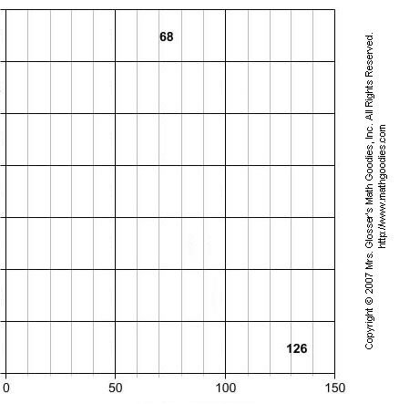
The scale must start at 0. So the horizontal scale will range from 0 to 150.
Step 3: Label the graph.
Mark each rectangle along the scale. Label the marks by the units they represent. Then decide how wide each bar should be. How much space will you allow between each bar?

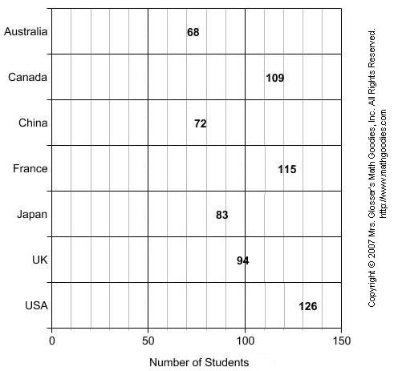

In the graph above, each grid line going from left to right represents a multiple of 10. More gridlines can make it easier to be exact with the quantities being shown on the bar graph, but too many can make it confusing.

Step 4a: Draw the bars.
Mark where each bar starts and write the labels. Use your scale to determine the length of each bar. The formula for determining the length of each bar is as follows:
bar length in rectangles = number of units each bar represents ÷ units per rectangle
Step 4b: Now draw the bars on your graph. Check two bars with values that are close. Will their bars show a difference?

Each small rectangle in the graph below represents 10 units. So to draw a horizontal bar that represents 68 students, divide 68 by 10. Your quotient is a bar length of 6.8 rectangles. Thus the bar for Australia is 6.8 rectangles in length (and represents 68 students).

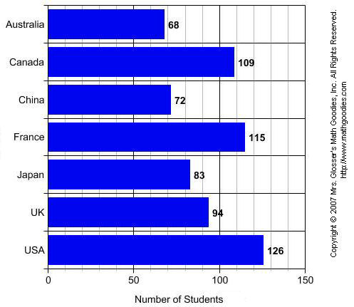

Step 5: Give the graph a title.
What is your graph about?

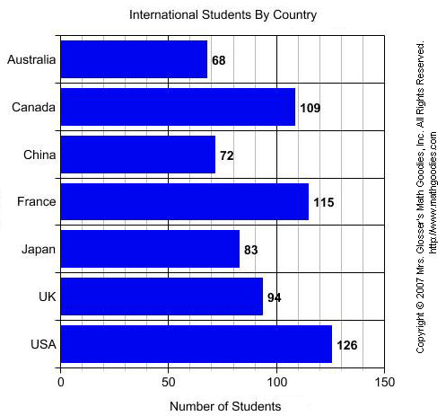

Example 2: The birth weight of several babies was recorded as shown in the table below. Construct a bar graph to visually display this data.
Birth Weight of Babies
Baby Weight (lbs)
Charlie 6.9
Dennis 8.1
Joan 7.9
Lori 6.2
Matthew 9.4
Sarah 10.5

Step 1: Find the range in values. What units are used? What is the greatest value? What is the least value?
The units are weight in lbs. The greatest value is 10.5 and the least value is 6.9.

Step 2: Determine a scale.
Using graph paper, start with 1 box = 1 unit. What is the length (or height) of the longest bar? Will it fit? If not, change the scale and try again.

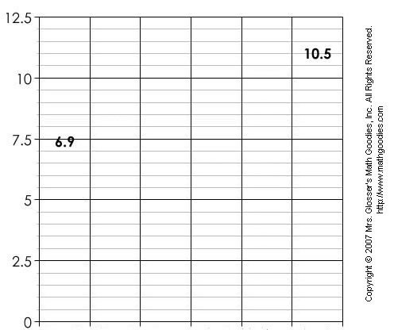

The scale must start at 0. So the vertical scale will range from 0 to 12.5.
Step 3: Label the graph.
Mark each rectangle along the scale. Label the marks by the units they represent. Then decide how wide each bar should be. How much space will you allow between each bar?

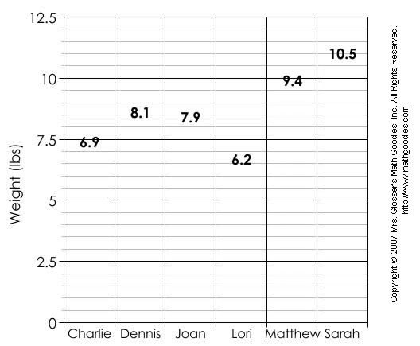

In the graph above, each grid line going from bottom to top represents a multiple of 0.5. More gridlines can make it easier to be exact with the quantities being shown on the bar graph, but too many can make it confusing.

Step 4a: Draw the bars.
Mark where each bar starts and write the labels. Use your scale to determine the height of each bar. The formula for determining the height of each bar is as follows:
bar height in rectangles = number of units each bar represents ÷ units per rectangle
Step 4b: Now draw the bars on your graph. Check two bars with values that are close. Will their bars show a difference?

Each small rectangle in the graph below represents 0.5 units. So to draw a vertical bar that represents 6.9 lbs, divide 6.9 by 0.5. Your quotient is a bar height of 13.8 rectangles. Thus the bar for Charlie is 13.8 rectangles in height (and represents 6.9 lbs). To draw a bar that represents 10.5 lbs, divide 10.5 by 0.5. Your quotient is a bar height of 21 rectangles. Thus the bar for Sarah is 21 rectangles in height (and represents 10.5 lbs).

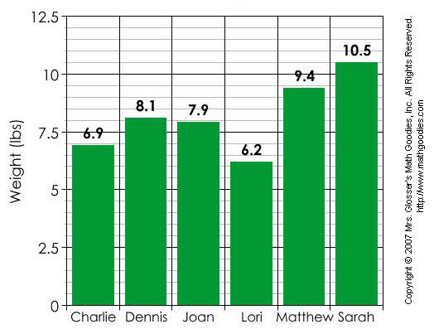
Step 5: Give the graph a title.
What is your graph about?

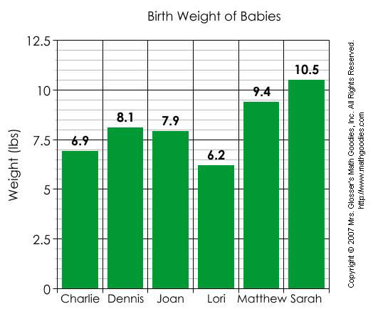

Summary: There are 5 steps for constructing a bar graph. These steps are listed below.
Procedure for Constructing a Bar Graph
Step 1: Find the range in values.
Step 2: Determine a scale.
Step 3: Label the graph.
Step 4: Draw the bars.
Step 5: Give the graph a title.

Exercises
Directions: Use the procedure above to construct a bar graph for each table in the exercises below.

Exercise 1: The average heights of various trees in the USA were recorded in meters as shown in the table below. Construct a bar graph to visually display this data.
Giant Trees in the USA
Tree Height in Meters
Acacia 43 m
Bold Cypress 42 m
American Birch 49 m
Painted Buckeye 44 m
Port-Oxford Cedar 67 m
Coast Redwood 110 m
Northeastern Oak 55 m

Exercise 2: Six children were surveyed to find out what percent increase each received in his/her allowance as shown in the table below. Construct a bar graph to visually display this data.
Increase in Allowance
Child Percent Increase
1 12.4
2 13.3
3 12.7
4 12.1
5 13.1
6 12.5

Bar Graphs

Example 1: A survey of students' favorite after-school activities was conducted at a school. The table below shows the results of this survey.
Students' Favorite After-School Activities
Activity Number of Students
Play Sports 45
Talk on Phone 53
Visit With Friends 99
Earn Money 44
Chat Online 66
School Clubs 22
Watch TV 37

Note that since the data in this table is not changing over time, a line graph would not be a good way to visually display this data. Each quantity listed in the table corresponds to a particular category. Accordingly, the data from the table above has been displayed in the bar graph below.

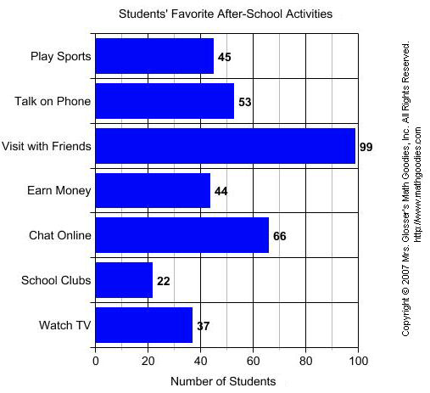
A bar graph is useful for comparing facts. The bars provide a visual display for comparing quantities in different categories. Bar graphs help us to see relationships quickly. Another name for a bar graph is a bar chart. Each part of a bar graph has a purpose.

title The title tells us what the graph is about.
labels The labels tell us what kinds of facts are listed.
bars The bars show the facts.
grid lines Grid lines are used to create the scale.
categories Each bar shows a quantity for a particular category.

Now that we have identified the parts of a bar graph, we can answer some questions about the graph in Example 1.
QUESTION
1. What is the title of this bar graph?
2. What is the range of values on the (horizontal) scale?
3. How many categories are in the graph?
4. Which after-school activity do students like most?
5. Which after-school activity do students like least?
6. How many students like to talk on the phone?
7. How many students like to earn money?
8. Which two activities are liked almost equally?
9. List the categories in the graph from greatest to least.

Example 2: Students in a class voted on their favorite fruit. Each student voted once. The bar graph below summarizes the data collected from the class vote.
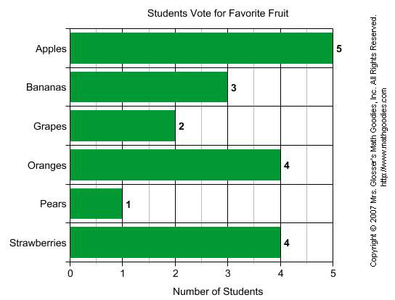
QUESTION
1. What is the range of values on the (horizontal) scale?
2. How many categories are in the graph?
3. Which fruit had the most votes?
4. Which fruit had the least votes?
6. How many students voted for bananas?
7. How many students voted for grapes?
8. Which two fruits had the same number of votes?
9. List the categories in the graph from least to greatest.

The bar graphs in Examples 1 and 2 each have horizontal bars. It is also possible to make a bar graph with vertical bars. You can see how this is done in Example 3 below.

Example 3: The amount of sugar in 7 different foods was measured as a percent The data is summarized in the bar graph below.
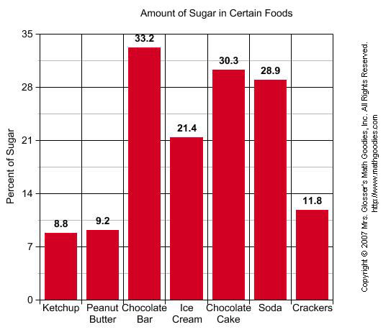
QUESTION
1. What is the title of this bar graph?
2. What is the range of values on the (vertical) scale?
3. How many categories are in the graph?
4. Which food had the highest percentage of sugar?
5. Which food had the lowest percentage of sugar?
6. What percentage of sugar is in soda?
7. What is the difference in percentage of sugar between ice cream and crackers?

Summary: A bar graph is useful for comparing facts. The bars provide a visual display for comparing quantities in different categories. Bar graphs help us to see relationships quickly. Bar graphs can have horizontal or vertical bars. Another name for a bar graph is a bar chart.

Exercises

Students in Mrs. Glosser's class were surveyed about snacks and asked to choose the one snack food they liked most from a list. The bar graph below summarizes the data collected from this survey.
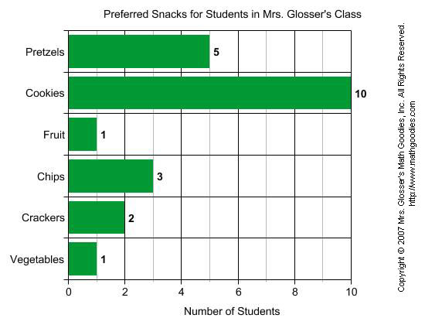
1. Which snack was preferred most?
2. Which snack was preferred by 2 students?
3. How many students preferred pretzels?
4. Which snack was preferred by 3 students?
5. According to the graph, what value corresponds to the number of students who preferred fruit and vegetables equally?

Constructing Circle Graphs
In the last lesson, we learned that a circle graph shows how the parts of something relate to the whole. A circle graph is divided into sectors, where each sector represents a particular category. Circle graphs are popular because they provide a visual presentation of the whole and its parts. However, they are best used for displaying data when there are no more than 5 or 6 sectors and when the values of each section are different.

Below are the circle graphs from each example in the last lesson. Do you notice a pattern in the way that these 4 circle graphs are drawn?

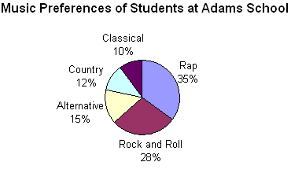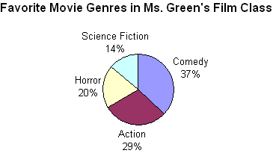
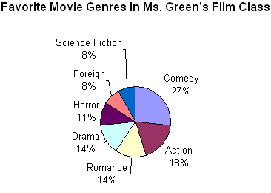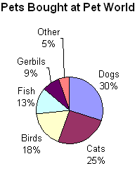

You will notice that in each circle graph above, the sectors are ordered by size: The sectors are drawn from largest to smallest in a clockwise direction. This information will help us as we learn how to draw a circle graph.

Example 1: | The table below shows how Cara spends each part of her earnings. Construct a circle graph to visually display this data.
Cara's Budget
Expense | Percent
Rent | 50%
Food | 20%
Clothing | 15%
Entertainment | 10%
Other | 5%

Step 1: Find the whole. What is the total value for the items on your graph? This is usually 100% or 1 whole.
Adding all of the expenses together, we get 50% + 20% + 15% + 10% + 5% = 100%. The total value for all items is 100%.

Step 2: Find the parts. Each item to be graphed represents a part of the whole. To complete the circle graph, you must find exactly what fraction or percent each item represents. The easiest way to do this is to take the quotient of the part and the whole and then convert the result to a percent.

The percent that each item represents was given in the table above.

Step 3: Find the degrees for each part. Every circle is made up of 360 degrees. To find the angle measure for each item, use this formula: angle measure for an item = percent the item represents x 360 degrees

Cara's Budget
Expense | Percent | Decimal | Degrees
Rent | 50% | 0.50 | 0.50 x 360° = 180°
Food | 20% | 0.20 | 0.20 x 360° = 72°
Clothing | 15% | 0.15 | 0.15 x 350° = 54°
Entertainment | 10% | 0.10 | 0.10 x 360° = 36°
Other | 5% | 0.05 | 0.05 x 360° = 18°
Total | 100% | 1.00 = 1 | 360°

Step 4a: Draw the parts. Draw a circle and a radius. Use a protractor to draw each angle. Each new angle should be measured from the previously drawn line segment. Draw the angles from largest to smallest in a clockwise direction.
Step 4b: Label each part of your graph.

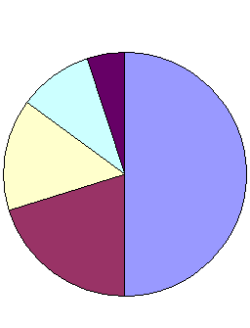 |  | 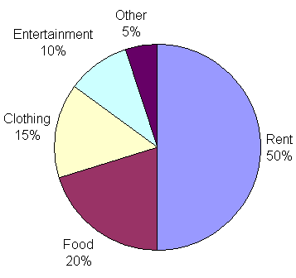

Step 5: Give the graph a title. What is your graph about?
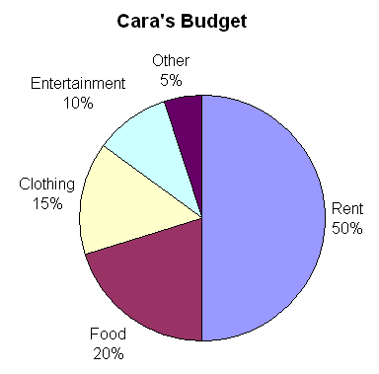

Example 2: | The table below shows the music preferences of 300 students at Adams School. Each student voted only once. Construct a circle graph to represent this data.
Music Preferences of Students at Adams School
Music Type | Number of Students
Rap | 105
Rock and Roll | 84
Alternative | 45
Country | 36
Classical | 30

Step 1: Find the whole. What is the total value for the items on your graph? This is usually 100% or 1 whole.

The total value for all items is 300 students (or 1 whole school).
Step 2: Find the parts. Each item to be graphed represents a part of the whole. To complete the circle graph, you must find exactly what fraction or percent each item represents. The easiest way to do this is to take the quotient of the part and the whole and then convert the result to a percent.

We know from the last lesson that a circle graph is easier to read when a percent is used to label the data. We need to find the percent that each item represents.

Music Preferences of Students at Adams School
Music Type | Number of Students | Percent
Rap | 105 | 105 ÷ 300 x 100 = 35%
Rock and Roll | 84 | 84 ÷ 300 x 100 = 28%
Alternative | 45 | 45 ÷ 300 x 100 = 15%
Country | 36 | 36 ÷ 300 x 100 = 12%
Classical | 30 | 30 ÷ 300 x 100 = 10%
Total | 300 | 100%

Step 3: Find the degrees for each part. Every circle is made up of 360 degrees. To find the angle measure for each item, use this formula: angle measure for an item = percent the item represents x 360 degrees

Music Preferences of Students at Adams School
Music Type | Number of Students | Percent | Decimal | Degrees
Rap | 105 | 35% | 0.35 | 0.35 x 360° = 126°
Rock and Roll | 84 | 28% | 0.28 | 0.28 x 360° = 100.8°
Alternative | 45 | 15% | 0.15 | 0.15 x 350° = 54°
Country | 36 | 12% | 0.12 | 0.12 x 360° = 43.2°
Classical | 30 | 10% | 0.10 | 0.10 x 360° = 36°
Total | 300 | 100% | 1.00 = 1 | 360°

Step 4a: Draw the parts. Draw a circle and a radius. Use a protractor to draw each angle. Each new angle should be measured from the previously drawn line segment. Draw the angles from largest to smallest in a clockwise direction.
Step 4b: Label each part of your graph.

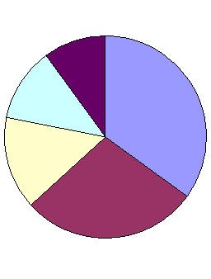 |  | 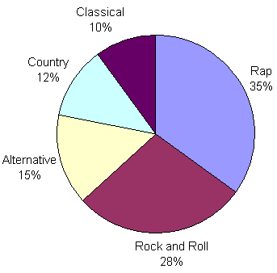

Step 5: | Give the graph a title.
 | What is your graph about?

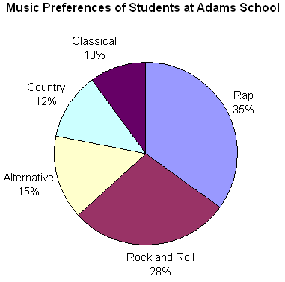
Note that the area of each sector is in the same proportion to the whole circle as the number for each item in the table is to the total of all items.

Summary: | There are 5 steps for constructing a circle graph. These steps are listed below.
Procedure for Constructing a Circle Graph
Step 1: | Find the whole.
Step 2: | Find the parts.
Step 3: | Find the degrees for each part.
Step 4: | Draw and label each part.
Step 5: | Give the graph a title.

Exercises
Directions: Use the procedure above to construct a circle graph for each table in the exercises below.
Exercise 1: | The revenue sources of the federal government were recorded as shown in the table below. Construct a circle graph to visually display this data.
Revenue Sources for the Federal Government
Source | Percent
Individual Income Tax | 40
Social Security | 33
Corporate Income Tax | 17
Other | 10

Exercise 2: | The students at a small school were surveyed to determine what method of transportation is used to get to and from school as shown in the table below. Construct a circle graph to visually display this data.
Transportation to School
Method | Percent
Bus | 46
Car | 21
Bicycle | 17
Walk | 11
Other | 5

Circle Graphs

Problem: | At a private school, 300 students and faculty voted on adopting uniforms for students. The results are shown in the table below. Display the results of this vote in a circle graph.
Adopt Student Uniforms?
Response | Number
Yes | 30
No | 180
Not Sure | 90

Analysis: | In order to draw a circle graph, we need to represent the number for each response as a fraction or as a percent.
Adopt Student Uniforms?
Response | Number | Fraction | Percent
Yes | 30 |  | 10%
No | 180 |  | 60%
Not Sure | 90 |  | 30%

Solution: | The results of this vote have been displayed in the two circle graphs below. In the graph on the left, fractions are used to label the data. In the graph on the right, percents are used to label the data.
 | As you can see, a circle graph is easier to read when a percent is used to label the data.

Example 1: | A poll was taken to find the music preferences of students at Adams School. Each student voted only once. The results of this poll are displayed in the circle graph below.

A circle graph shows how the parts of something relate to the whole. A circle graph is divided into sectors, where each sector represents a particular category. The entire circle is 1 whole or 100%, and a sector of the circle is a part. Let's define the various regions of a circle graph.

title | The title tells us what the graph is about.
sectors | The sectors of the circle graph show what percentage of the whole is being represented by each category.
labels | The labels identify the facts for each category.

Now that we have identified the parts of a circle graph, we can answer some questions about the graph in Example 1.
Example 1: | A poll was taken to find the music preferences of students at Adams School. Each student voted only once. The results of this poll are displayed in the circle graph below.

QUESTION
1. | What is the circle graph about?
2. | How many sectors are in the graph?
3. | Which type of music do students prefer most?
4. | Which type of music do students prefer least?
5. | What percentage of students prefer Alternative?
6. | What percentage of students prefer Rock and Roll?
7. | List the categories in the graph from greatest to least.

Note: | Another name for a circle graph is a pie chart. As you can see in the pie chart below, a slice of pie for country music has been separated from the rest of the chart. (Note: Such a separation is usually done to emphasize the importance of a piece of information.)
 | 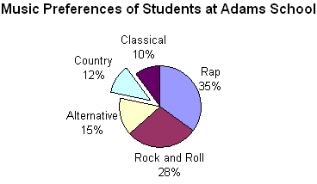

Let's look at some more examples of circle graphs.
Example 2: | Students in Ms. Green's film class voted for their favorite movie genre. Each student voted only once. The results of this vote are displayed in the circle graph below.

QUESTION
1. | What is the circle graph about?
2. | How many sectors are in the graph?
3. | Which movie genre do Ms. Green's students prefer most?
4. | Which movie genre do Ms. Green's students prefer least?
5. | What percentage of students prefer action movies?
6. | What percentage of students prefer horror movies?
7. | List the categories in the graph from least to greatest.

Let's look at a modified version of Example 2.
Example 3: | Students in Ms. Green's film class voted for their favorite movie genre. Each student voted only once. The results of this vote are displayed in the circle graph below.

The circle graph in Example 3 has seven sectors which makes it difficult to read. Although lines were used to connect some of the labels to their respective categories, this graph is too complicated because there is simply too much information. In general, if there are more than 5 or 6 categories in a set of data, then a circle graph is not a good choice for displaying that data. You will also notice that some of the sectors in the graph above have the same values. Romance and Drama each represent 14% of the class vote; Foreign and Science Fiction each represent 8% of the class vote. As a result, it is difficult to see the difference in size of the slices in this graph. The data above would be clearer and easier to read if it was displayed in a bar graph.

Summary: | A circle graph shows how the parts of something relate to the whole. A circle graph is divided into sectors, where each sector represents a particular category. Circle graphs are popular because they provide a visual presentation of the whole and its parts. However, they are best used for displaying data when there are no more than 5 or 6 sectors and when the values of each section are different.

Exercises

A survey was taken of which pets are bought by customers at a Pet World store. Each customer voted only once. The results of this survey are displayed in the circle graph below.
1. How many sectors are in the graph?

2. Which type of pet is bought most?
3. Which type of pet is bought least?
4. What percentage of customers buy gerbils?
5. What percentage of customers buy birds?

Practice Exercises:

Refer to the line graph below for Exercises 1 to 3.
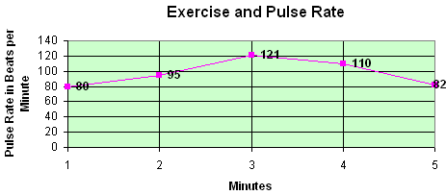
1. What is the largest number on the vertical scale?
2. What pulse rate was recorded at 2 minutes?
3. A pulse rate of 121 beats per minute was recorded at how many minutes?

Refer to the bar graph below for Exercises 4 to 6.
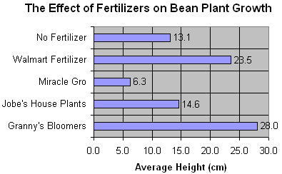
4. How many items are being compared in the graph?
5. What was the average height in cm for Granny’s Bloomers?
6. What was the average height in cm for No Fertilizer?

Refer to the circle graph below for Exercises 7 to 10.
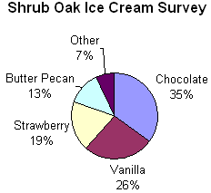
7. How many sectors are in this circle graph?
8. What percentage of people in Shrub Oak preferred chocolate ice cream?
9. What percentage of people in Shrub Oak preferred butter pecan ice cream?
10. If a total of 50 people were surveyed, then how many people preferred vanilla ice cream?

