Investigating cells
1. Obtain a prepared slide from instructor.
2. Write down the name of the slide.
3. Look at slide under lowest power.
4. Draw what you see. No scribbles.
5. Switch to a higher power and draw what you see.
6. Prepare an Elodea slide by removing one leaf from the plant, place it in the middle of the slide and cover with cover slip. Repeat steps 4 and 5.

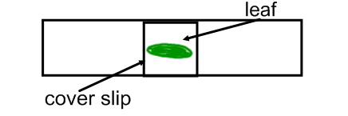
7. Prepare pond water slide
8. Use dropper to place drop of water on slide. Cover with cover slip. Repeat steps 4 and 5.

Questions
1. Name three scientists and their contribution to the cell theory.
2. Explain two problems/issues you had using the microscope.
Biology only 3. List one cell part you should have seen with the microscope and explain why you think you should have seen it.
Honors only 3. List two cell parts you should have seen with the microscope and explain why you think you should have seen it.

