How to write up your cucumber lab

Cover page with your name, lab title, date and hour
Procedure for lab using paragraph form
Data table of lab
Graph of lab data
Analysis of Data
Address these questions in your analysis of data
Was there a change in mass in the cucumber?
Explain why using the terms isotonic, hypertonic or hypotonic.
Was your hypothesis supported by your data. Explain why or why not.
Explain any sources of error you could have encountered in either lab.
Explain why they could have affected your results.

Data table template
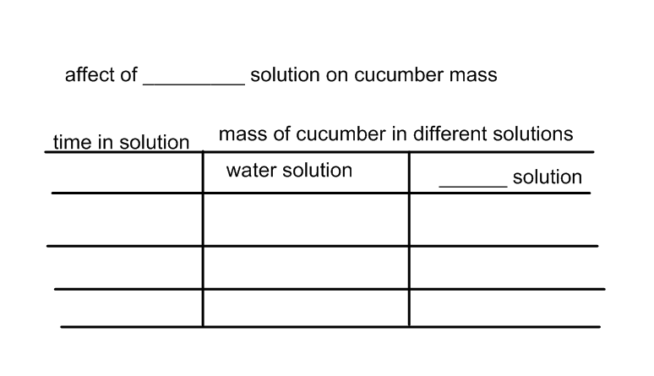
Include the following in your graph
Title of graph
Label the x axis with time in solution
Label the y axis with mass of cucumber
Plot the data points using a line graph

