Photosynthesis
Photosynthesis is the process of converting light energy to chemical energy and storing it in the bonds of sugar. This process occurs in plants and some algae (Kingdom Protista). Plants need only light energy, CO₂, and H₂O to make sugar. The process of photosynthesis takes place in the chloroplasts, specifically using chlorophyll, the green pigment involved in photosynthesis.
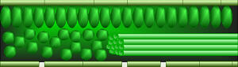
Photosynthesis takes place primarily in plant leaves, and little to none occurs in stems, etc. The parts of a typical leaf include the upper and lower epidermis, the mesophyll, the vascular bundle(s) (veins), and the stomates. The upper and lower epidermal cells do not have chloroplasts, thus photosynthesis does not occur there. They serve primarily as protection for the rest of the leaf. The stomates are holes which occur primarily in the lower epidermis and are for air exchange: they let CO₂ in and O₂ out. The vascular bundles or veins in a leaf are part of the plant's transportation system, moving water and nutrients around the plant as needed. The mesophyll cells have chloroplasts and this is where photosynthesis occurs.

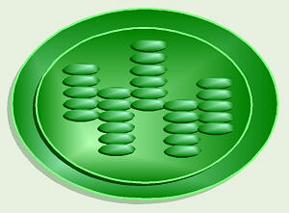
As you hopefully recall, the parts of a chloroplast include the outer and inner membranes, intermembrane space, stroma, and thylakoids stacked in grana. The chlorophyll is built into the membranes of the thylakoids.
Chlorophyll looks green because it absorbs red and blue light, making these colors unavailable to be seen by our eyes. It is the green light which is NOT absorbed that finally reaches our eyes, making chlorophyll appear green. However, it is the energy from the red and blue light that are absorbed that is, thereby, able to be used to do photosynthesis. The green light we can see is not/cannot be absorbed by the plant, and thus cannot be used to do photosynthesis.
The overall chemical reaction involved in photosynthesis is: 6CO₂ + 6H₂O (+ light energy) C₆H₁₂O₆ + 6O₂. This is the source of the O₂ we breathe, and thus, a significant factor in the concerns about deforestation.

There are two parts to photosynthesis:
The light reaction happens in the thylakoid membrane and converts light energy to chemical energy. This chemical reaction must, therefore, take place in the light. Chlorophyll and several other pigments such as beta-carotene are organized in clusters in the thylakoid membrane and are involved in the light reaction. Each of these differently-colored pigments can absorb a slightly different color of light and pass its energy to the central chlorphyll molecule to do photosynthesis. The central part of the chemical structure of a chlorophyll molecule is a porphyrin ring, which consists of several fused rings of carbon and nitrogen with a magnesium ion in the center.
The energy harvested via the light reaction is stored by forming a chemical called ATP (adenosine triphosphate), a compound used by cells for energy storage. This chemical is made 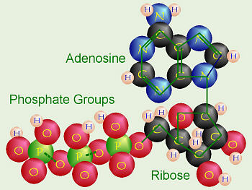of the nucleotide adenine bonded to a ribose sugar, and that is bonded to three phosphate groups. This molecule is very similar to the building blocks for our DNA.

The dark reaction takes place in the stroma within the chloroplast, and converts CO₂ to sugar. This reaction doesn't directly need light in order to occur, but it does need the products of the light reaction (ATP and another chemical called NADPH). The dark reaction involves a cycle called the Calvin cycle in which CO₂ and energy from ATP are used to form sugar. Actually, notice that the first product of photosynthesis is a three-carbon compound called glyceraldehyde 3-phosphate. Almost immediately, two of these join to form a glucose molecule.
Most plants put CO₂ directly into the Calvin cycle. Thus the first stable organic compound formed is the glyceraldehyde 3-phosphate. Since that molecule contains three carbon atoms, these plants are called C₃ plants. For all plants, hot summer weather increases the amount of water that evaporates from the plant. Plants lessen the amount of water that evaporates by keeping their stomates closed during hot, dry weather. Unfortunately, this means that once the CO₂ in their leaves reaches a low level, they must stop doing photosynthesis. Even if there is a tiny bit of CO₂ left, the enzymes used to grab it and put it into the Calvin cycle just don't have enough CO₂ to use. Typically the grass in our yards just turns brown and goes dormant. Some plants like crabgrass, corn, and sugar cane have a special modification to conserve water. These plants capture CO₂ in a different way: they do an extra step first, before doing the Calvin cycle. These plants have a special enzyme that can work better, even at very low CO₂ levels, to grab CO₂ and turn it first into oxaloacetate, which contains four carbons. Thus, these plants are called C₄ plants. The CO₂ is then released from the oxaloacetate and put into the Calvin cycle. This is why crabgrass can stay green and keep growing when all the rest of your grass is dried up and brown.
There is yet another strategy to cope with very hot, dry, desert weather and conserve water. Some plants (for example, cacti and pineapple) that live in extremely hot, dry areas like deserts, can only safely open their stomates at night when the weather is cool. Thus, there is no chance for them to get the CO₂ needed for the dark reaction during the daytime. At night when they can open their stomates and take in CO₂, these plants incorporate the CO₂ into various organic compounds to store it. In the daytime, when the light reaction is occurring and ATP is available (but the stomates must remain closed), they take the CO₂ from these organic compounds and put it into the Calvin cycle. These plants are called CAM plants, which stands for crassulacean acid metabolism after the plant family, Crassulaceae (which includes the garden plant Sedum) where this process was first discovered.

PHOTOSYNTHESIS

What is Photosynthesis?
Photosynthesis is the process by which plants, some bacteria, and some protistans use the energy from sunlight to produce sugar, which cellular respiration converts into ATP, the "fuel" used by all living things. The conversion of unusable sunlight energy into usable chemical energy, is associated with the actions of the green pigment chlorophyll. Most of the time, the photosynthetic process uses water and releases the oxygen that we absolutely must have to stay alive. Oh yes, we need the food as well!
We can write the overall reaction of this process as:
6H₂O + 6CO₂ ----------> C₆H₁₂O₆+ 6O₂
Most of us don't speak chemicalese, so the above chemical equation translates as: six molecules of water plus six molecules of carbon dioxide produce one molecule of sugar plus six molecules of oxygen

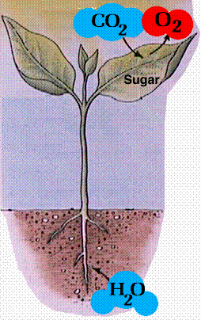
Diagram of a typical plant, showing the inputs and outputs of the photosynthetic process. Image from Purves et al., Life: The Science of Biology, 4th Edition, by Sinauer Associates (www.sinauer.com) and WH Freeman (www.whfreeman.com), used with permission.

Leaves and Leaf Structure |
Plants are the only photosynthetic organisms to have leaves (and not all plants have leaves). A leaf may be viewed as a solar collector crammed full of photosynthetic cells.
The raw materials of photosynthesis, water and carbon dioxide, enter the cells of the leaf, and the products of photosynthesis, sugar and oxygen, leave the leaf.
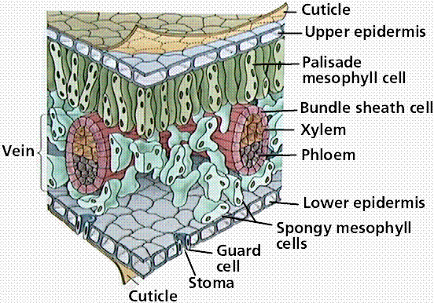
Cross section of a leaf, showing the anatomical features important to the study of photosynthesis: stoma, guard cell, mesophyll cells, and vein. Image from Purves et al., Life: The Science of Biology, 4th Edition, by Sinauer Associates (www.sinauer.com) and WH Freeman (www.whfreeman.com), used with permission.

The Nature of Light |
White light is separated into the different colors (=wavelengths) of light by passing it through a prism. Wavelength is defined as the distance from peak to peak (or trough to trough). The energy of is inversely porportional to the wavelength: longer wavelengths have less energy than do shorter ones.
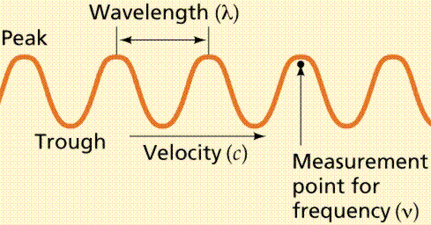
Wavelength and other saspects of the wave nature of light. Image from Purves et al., Life: The Science of Biology, 4th Edition, by Sinauer Associates (www.sinauer.com) and WH Freeman (www.whfreeman.com), used with permission.
The order of colors is determined by the wavelength of light. Visible light is one small part of the electromagnetic spectrum. The longer the wavelength of visible light, the more red the color. Likewise the shorter wavelengths are towards the violet side of the spectrum. Wavelengths longer than red are referred to as infrared, while those shorter than violet are ultraviolet.
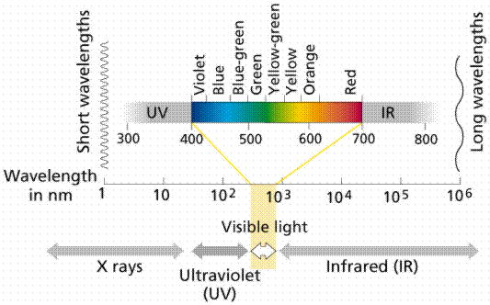
The electromagnetic spectrum. Image from Purves et al., Life: The Science of Biology, 4th Edition, by Sinauer Associates (www.sinauer.com) and WH Freeman (www.whfreeman.com), used with permission.
Light behaves both as a wave and a particle. Wave properties of light include the bending of the wave path when passing from one material (medium) into another (i.e. the prism, rainbows, pencil in a glass-of-water, etc.). The particle properties are demonstrated by the photoelectric effect. Zinc exposed to ultraviolet light becomes positively charged because light energy forces electrons from the zinc. These electrons can create an electrical current. Sodium, potassium and selenium have critical wavelengths in the visible light range. The critical wavelength is the maximum wavelength of light (visible or invisible) that creates a photoelectric effect.

Chlorophyll and Accessory Pigments |
A pigment is any substance that absorbs light. The color of the pigment comes from the wavelengths of light reflected (in other words, those not absorbed). Chlorophyll, the green pigment common to all photosynthetic cells, absorbs all wavelengths of visible light except green, which it reflects to be detected by our eyes. Black pigments absorb all of the wavelengths that strike them. White pigments/lighter colors reflect all or almost all of the energy striking them. Pigments have their own characteristic absorption spectra, the absorption pattern of a given pigment.
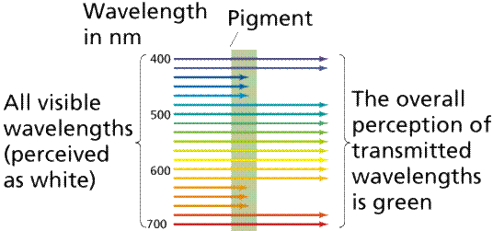
Absorption and transmission of different wavelengths of light by a hypothetical pigment.
Image from Purves et al., Life: The Science of Biology, 4th Edition, by Sinauer Associates (www.sinauer.com) and WH Freeman (www.whfreeman.com), used with permission.
Chlorophyll is a complex molecule. Several modifications of chlorophyll occur among plants and other photosynthetic organisms. All photosynthetic organisms (plants, certain protistans, prochlorobacteria, and cyanobacteria) have chlorophyll a. Accessory pigments absorb energy that chlorophyll a does not absorb. Accessory pigments include chlorophyll b (also c, d, and e in algae and protistans), xanthophylls, and carotenoids (such as beta-carotene). Chlorophyll a absorbs its energy from the Violet-Blue and Reddish orange-Red wavelengths, and little from the intermediate (Green-Yellow-Orange) wavelengths.
Carotenoids and chlorophyll b absorb some of the energy in the green wavelength. Why not so much in the orange and yellow wavelengths? Both chlorophylls also absorb in the orange-red end of the spectrum (with longer wavelengths and lower energy). The origins of photosynthetic organisms in the sea may account for this. Shorter wavelengths (with more energy) do not penetrate much below 5 meters deep in sea water. The ability to absorb some energy from the longer (hence more penetrating) wavelengths might have been an advantage to early photosynthetic algae that were not able to be in the upper (photic) zone of the sea all the time.

Stages of Photosynthesis |
Photosynthesis is a two stage process. The first process is the Light Dependent Process, requires the direct energy of light to make energy carrier molecules that are used in the second process. The Light Independent Process occurs when the products of the Light Reaction are used to form C-C covalent bonds of carbohydrates. The light independent reactions can usually occur in the dark, if the energy carriers from the light independent process are present. Recent evidence suggests that a major enzyme of the light independent reaction is indirectly stimulated by light, thus the term Dark Reaction is somewhat of a misnomer. The Light Reactions occur in the grana and the light independent reactions take place in the stroma of the chloroplasts.
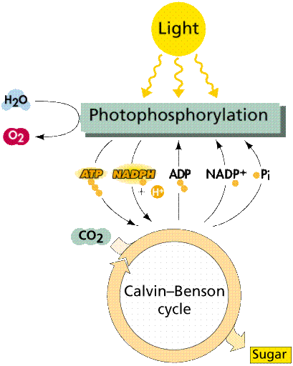
Overview of the two steps in the photosynthesis process. Image from Purves et al., Life: The Science of Biology, 4th Edition, by Sinauer Associates (www.sinauer.com) and WH Freeman (www.whfreeman.com), used with permission.

Light Reactions |
In the Light Dependent Processes light strikes chlorophyll a in such a way as to excite electrons to a higher energy state. In a series of reactions the energy is converted (along an electron transport process) into ATP and NADPH. Water is split in the process, releasing oxygen as a by-product of the reaction. The ATP and NADPH are used to make C-C bonds in the Light Independent Process (Dark Reactions).
In the Light Independent Process, carbon dioxide from the atmosphere (or water for aquatic/marine organisms) is captured and modified by the addition of Hydrogen to form carbohydrates (general formula of carbohydrates is [CH₂O]_{n}). The incorporation of carbon dioxide into organic compounds is known as carbon fixation. The energy for this comes from the first phase of the photosynthetic process. Living systems cannot directly utilize light energy, but can, through a complicated series of reactions, convert it into C-C bond energy that can be released by glycolysis and other metabolic processes.
Photosystems are arrangements of chlorophyll and other pigments packed into thylakoids. Many Prokaryotes have only one photosystem, Photosystem II (so numbered because, while it was most likely the first to evolve, it was the second one discovered). Eukaryotes have Photosystem II plus Photosystem I. Photosystem I uses chlorophyll a, in the form referred to as P700. Photosystem II uses a form of chlorophyll a known as P680. Both "active" forms of chlorophyll a function in photosynthesis due to their association with proteins in the thylakoid membrane.
Photophosphorylation is the process of converting energy from a light-excited electron into the pyrophosphate bond of an ADP molecule. This occurs when the electrons from water are excited by the light in the presence of P680. The energy transfer is similar to the chemiosmotic electron transport occurring in the mitochondria. Light energy causes the removal of an electron from a molecule of P680 that is part of Photosystem II. The P680 requires an electron, which is taken from a water molecule, breaking the water into H⁺ ions and O⁻² ions. These O⁻² ions combine to form the diatomic O₂ that is released. The electron is "boosted" to a higher energy state and attached to a primary electron acceptor, which begins a series of redox reactions, passing the electron through a series of electron carriers, eventually attaching it to a molecule in Photosystem I. Light acts on a molecule of P700 in Photosystem I, causing an electron to be "boosted" to a still higher potential. The electron is attached to a different primary electron acceptor (that is a different molecule from the one associated with Photosystem II). The electron is passed again through a series of redox reactions, eventually being attached to NADP⁺ and H⁺ to form NADPH, an energy carrier needed in the Light Independent Reaction. The electron from Photosystem II replaces the excited electron in the P700 molecule. There is thus a continuous flow of electrons from water to NADPH. This energy is used in Carbon Fixation. Cyclic Electron Flow occurs in some eukaryotes and primitive photosynthetic bacteria. No NADPH is produced, only ATP. This occurs when cells may require additional ATP, or when there is no NADP⁺ to reduce to NADPH. In Photosystem II, the pumping to H ions into the thylakoid and the conversion of ADP + P into ATP is driven by electron gradients established in the thylakoid membrane.

Light Independent Reaction |
Carbon-Fixing Reactions are also known as the Dark Reactions (or Light Independent Reactions). Carbon dioxide enters single-celled and aquatic autotrophs through no specialized structures, diffusing into the cells. Land plants must guard against drying out (desiccation) and so have evolved specialized structures known as stomata to allow gas to enter and leave the leaf. The Calvin Cycle occurs in the stroma of chloroplasts (where would it occur in a prokaryote?). Carbon dioxide is captured by the chemical ribulose biphosphate (RuBP). RuBP is a 5-C chemical. Six molecules of carbon dioxide enter the Calvin Cycle, eventually producing one molecule of glucose. The reactions in this process were worked out by Melvin Calvin (shown below).
The first stable product of the Calvin Cycle is phosphoglycerate (PGA), a 3-C chemical. The energy from ATP and NADPH energy carriers generated by the photosystems is used to attach phosphates to (phosphorylate) the PGA. Eventually there are 12 molecules of glyceraldehyde phosphate (also known as phosphoglyceraldehyde or PGAL, a 3-C), two of which are removed from the cycle to make a glucose. The remaining PGAL molecules are converted by ATP energy to reform 6 RuBP molecules, and thus start the cycle again. Remember the complexity of life, each reaction in this process, as in Kreb's Cycle, is catalyzed by a different reaction-specific enzyme.

