Enzyme reading

Enzymes

What Are Enzymes?
Substances that speed up chemical reactions are called catalysts. Organic catalysts are called enzymes.
Enzymes are specific for one particular reaction or group of related reactions. Many reactions cannot occur without the correct enzyme present. They are often named by adding "ase" to the name of the substrate. Example: Dehydrogenases are enzymes that remove hydrogen.

Induced-Fit Theory
An enzyme-substrate complex forms when the enzyme’s active site binds with the substrate like a key fitting a lock.
The shape of the enzyme must match the shape of the substrate. Enzymes are therefore very specific; they will only function correctly if the shape of the substrate matches the active site.
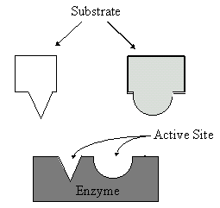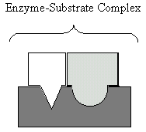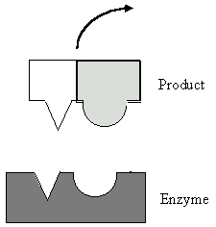
The substrate molecule normally does not fit exactly in the active site. This induces a change in the enzymes conformation (shape) to make a closer fit. In reactions that involve breaking bonds, the inexact fit puts stress on certain bonds of the substrate. This lowers the amount of energy needed to break them.The enzyme does not form a chemical bond with the substrate. After the reaction, the products are released and the enzyme returns to its normal shape.
Because the enzyme does not form chemical bonds with the substrate, it remains unchanged. As a result, the enzyme molecule can be reused. Only a small amount of enzyme is needed because they can be used repeatedly.

Conditions that Affect Enzymatic Reactions

Rate of Reaction
Reactions with enzymes are up to 10 billion times faster than those without enzymes. Enzymes typically react with between 1 and 10,000 molecules per second. Fast enzymes catalyze up to 500,000 molecules per second.
Substrate concentration, enzyme concentration, Temperature, and pH affect the rate of enzyme reactions.

Substrate Concentration
At lower concentrations, the active sites on most of the enzyme molecules are not filled because there is not much substrate. Higher concentrations cause more collisions between the molecules. With more molecules and collisions, enzymes are more likely to encounter molecules of reactant.
The maximum velocity of a reaction is reached when the active sites are almost continuously filled. Increased substrate concentration after this point will not increase the rate. Reaction rate therefore increases as substrate concentration is increased but it levels off.
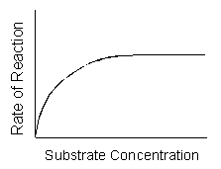

Enzyme Concentration
If there is insufficient enzyme present, the reaction will not proceed as fast as it otherwise would because all of the active sites are occupied with the reaction. Additional active sites could speed up the reaction.
As the amount of enzyme is increased, the rate of reaction increases. If there are more enzyme molecules than are needed, adding additional enzyme will not increase the rate. Reaction rate therefore increases as enzyme concentration increases but then it levels off.
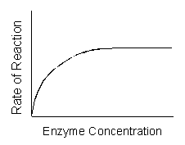

Temperature
Higher temperature generally causes more collisions among the molecules and therefore increases the rate of a reaction. More collisions increase the likelihood that substrate will collide with the active site of the enzyme, thus increasing the rate of an enzyme-catalyzed reaction.
Above a certain temperature, activity begins to decline because the enzyme begins to denature.
The rate of chemical reactions therefore increases with temperature but then decreases.
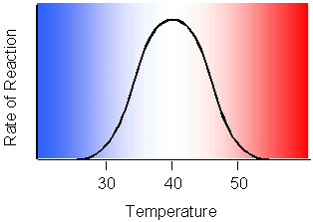

pH
Each enzyme has an optimal pH.
A change in pH can alter the ionization of the R groups of the amino acids. When the charges on the amino acids change, hydrogen bonding within the protein molecule change and the molecule changes shape. The new shape may not be effective.
The diagram below shows that pepsin functions best in an acid environment. This makes sense because pepsin is an enzyme that is normally found in the stomach where the pH is low due to the presence of hydrochloric acid. Trypsin is found in the duodenum, and therefore, its optimum pH is in the neutral range to match the pH of the duodenum.
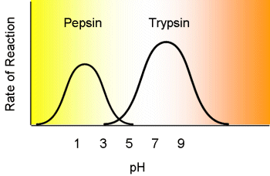

Regulation of Enzyme Activity
Cells have built-in control mechanisms to regulate enzyme concentration and activity.
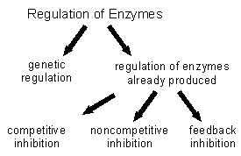

Competitive Inhibition
In competitive inhibition, a similar-shaped molecule competes with the substrate for active sites.

Noncompetitive Inhibition
Another form of inhibition involves an inhibitor that binds to an allosteric site of an enzyme. An allosteric site is a different location than the active site.
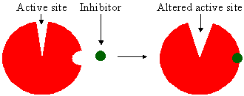
The binding of an inhibitor to the allosteric site alters the shape of the enzyme, resulting in a distorted active site that does not function properly.
The binding of an inhibitor to an allosteric site is usually temporary. Poisons are inhibitors that bind irreversibly. For example, penicillin inhibits an enzyme needed by bacteria to build the cell wall.

Feedback Inhibition
Negative feedback inhibition is like a thermostat. When it is cold, the thermostat turns on a heater which produces heat. Heat causes the thermostat to turn off the heater. Heat has a negative effect on the thermostat; it feeds back to an earlier stage in the control sequence as diagrammed below.
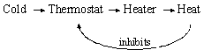
Many enzymatic pathways are regulated by feedback inhibition. As an enzyme's product accumulates, it turns off the enzyme just as heat causes a thermostat to turn off the production of heat. The end product of the pathway binds to an allosteric site on the first enzyme in the pathway and shuts down the entire sequence.
Feedback inhibition occurs in most cells.
Textbook website
http://163.16.28.248/bio/activelearner/06/ch6intro.html
Cells depend on enzymes to carry out the life-essential chemical reactions of metabolism. Enzymes are required catalysts of these chemical reactions. This tutorial will explain how enzymes work and how they are regulated.
ENZYMES WORK BY INDUCED FIT
The reason a particular enzyme will combine only with one kind of substrate is that the fit between the two is very precise. In fact, the fit is so precise, the combining of the enzyme and substrate results in a slight change in the shape of both. This precise fit that modifies both original molecules is called an induced fit. This "strained" fit acts to break old chemical bonds and form new ones, resulting in the formation of the product from the substrate. Once this change has occurred, the product is released from the enzyme, and the enzyme can combine with another molecule of substrate.

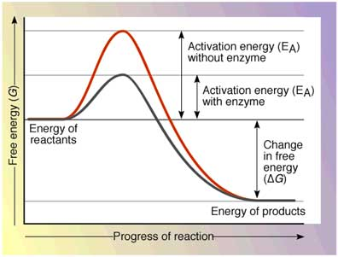
ENZYME FUNCTION AND ACTIVATION ENERGY
Enzymes are protein catalysts that carry out the chemical reactions of metabolism. All chemical reactions require activation energy to break chemical bonds and begin the reaction. The need for activation energy acts as a barrier to the chemical reaction occurring and/or to the speed at which it occurs.
Enzymes lower the barriers that normally prevent chemical reactions from occurring (or slow them down) by decreasing the required activation energy. Thus, in the presence of enzymes, reactions proceed and/or proceed at a faster rate.
Enzyme names end with the -ase suffix, unless they were named prior to adoption of the -ase naming system. Often when enzymes are named, the -ase suffix is added to the substrate name. For example, sucrase is the enzyme that breaks down the substrate sucrose, a disaccharide, into the monosaccharides glucose and fructose.
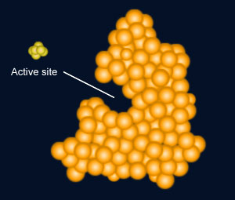
HOW ENZYMES LOWER ACTIVATION ENERGY
Enzymes carry out their function of lowering activation energy by temporarily combining with the chemicals involved in the reaction. These chemicals are called the substrate. Enzymes are specific for their substrate: A particular substrate molecule will combine temporarily with one enzyme type, and the active site of a particular enzyme will fit only one kind of substrate. For example, the enzyme sucrase will attach only to the substrate sucrose. The combination is called the enzyme- substrate complex. When the enzyme and substrate combine, the substrate is changed to a different chemical called the product. The enzyme is not consumed or altered by the reaction.
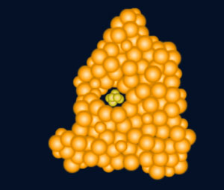
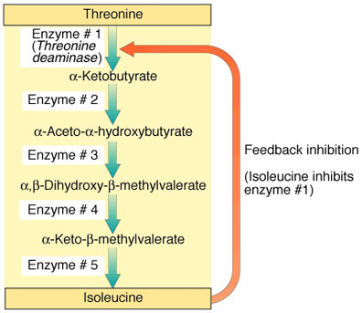
REGULATING ENZYMES: FEEDBACK INHIBITION
Enzymes often function in a metabolic pathway, a series of chemical reactions where the products of one reaction become the reactants (substrate) for the next reaction. A different enzyme catalyzes each step.
In feedback inhibition, the final product of the metabolic pathway inhibits an earlier reaction in the sequence.
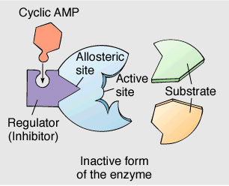
REGULATING ENZYMES: ALLOSTERIC ENZYMES
A chemical molecule can inhibit an enzyme in two ways: 1) by combining to an allosteric site or 2) by competitive inhibition.
An allosteric site is a location on an enzyme where a regulating molecule can attach. The regulating molecule can be a final product of a metabolic pathway. Such a molecule is called an allosteric regulator and does not directly block the active site. This is noncompetitive inhibition (that is, the inhibitor is not competing with the substrate for binding to the active site).
Allosteric regulators are specific to the enzyme they regulate. When an allosteric regulator attaches to its enzyme, the enzyme's active site changes shape. This shape change prevents substrate molecules from binding to the enzyme's active site, and thus the enzyme can no longer catalyze its reaction. This inhibits the metabolic pathway from producing the final product, resulting in a lower concentration of the allosteric regulator.
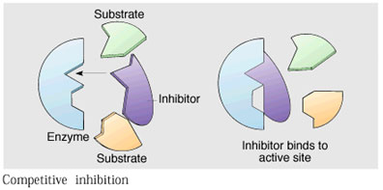

REGULATING ENZYMES: COMPETITIVE INHIBITION
Competitive inhibition involves a molecule that is not the substrate molecule but that can bind with an enzyme's active site. If this nonsubstrate molecule occupies the active site, then there is no room for the substrate to bind at that site. This prevents the enzyme from carrying out the chemical reaction for which it is suited.

SUMMARY
Enzymes are responsible for carrying out chemical reactions in living things. Enzymes act as catalysts that lower the activation energy of a chemical reaction by attaching to the substrate via induced fit.
Enzymes work in groups, forming metabolic pathways that produce specific cell products. To prevent waste of cell resources, metabolic pathways must be controlled. Because enzymes are responsible for carrying out the chemical reactions of metabolic pathways, if enzymes are inhibited, then the metabolic pathways are inhibited.
Both noncompetitive and competitive inhibitors affect enzymes. Noncompetitive inhibitors bind to allosteric sites on the enzymes. Competitive inhibitors compete with the substrate to bind to the enzyme's active site.

Complete the following.
- Take out your notebook label a page Enzymes and date it.
- Make the enlarged margin. You will write your key terms in it after you complete the steps below.
- Define enzyme
- Using the pictures above explain what a substrate is.
- Explain how an enzyme brings substrates together.
- Explain the conditions that affect enzymatic reactions
- Explain how enzymes are controlled.
- Explain the induced fit theory.
- Explain how enzymes lower the activation energy of a reaction.
- Write the key terms in your margin.
- Make several concept maps of the information above. Helpful hints.
  - Make a flow map of number five.
  - Make a tree map of number six.
  - Make a diagram of number seven.

