You are going to work in a group of four other students. In that group each student will have a roll/job. The jobs are
Facilitator- this person makes sure that everyone has a voice in the conversation
Transcriber- this person writes down what is discussed
Techie- this person checks out the computer and manages the links to be viewed.
Time keeper- this person monitors the time and makes sure you stay on task.
Your task consists of some reading, video watching, discussion and some interaction with websites. You need to read and follow the directions before each task. You will record your responses to discussion questions either on a separate sheet of paper or electronically.

How DNA replicates
- What the link below, read the essay and answer the discussion questions.
http://az.pbslearningmedia.org/resource/tdc02.sci.life.gen.dnaanimation/how-dna-replicates/
Whether it is a microbe, a rose, or a dolphin, any form of life gets its building and operating instructions from the molecule of life, DNA. DNA comprises the genes and chromosomes that govern the development of an individual organism. Coiled inside the nucleus of the cell, DNA stores all the information needed in reproducing that individual.
The information of life is packaged in genes, the units of heredity, distributed along the chromosomes of an organism; a human being has as many as 30,000 genes, and perhaps more. Each gene contains a coded instruction for making a single protein. The chemical code in which the information is written is stunningly simple, consisting of only four different chemical bases, or nucleotides: adenine (A), thymine (T), cytosine (C), and guanine (G). But various combinations of those four bases -- say, A A C G G A C T T A and so on, for thousands of "letters" -- can spell out the recipes for tens of thousands of different proteins.
In manufacturing the proteins it needs, the cell uses the gene sequence as a blueprint. A different nucleic acid molecule, known as messenger RNA, makes a copy of the gene sequence and carries it outside the nucleus. The message encoded in the messenger RNA is read by structures called ribosomes, which assemble the protein out of amino acids in the cell's cytoplasm. Each amino acid is specified by a combination of three of the chemical bases (the A, T, C, and Gs), and the amino acids are put together in a long chain to form the protein. The cell then uses the protein or sends it out of the cell to perform some job for the body.
When a cell divides, it makes a copy of its DNA instructions for the new cell. The twisted double strand structure -- the famed double helix -- unwinds and the strands separate. The nucleotides (A, T, G, and C) on each strand pair up with free nucleotides in the nucleus, creating two new strands. But only G can pair with C, and only T can pair with A. Therefore, the order of nucleotides in the original strand specifies the order in the new strand. After each of the old strands is copied in this way, there are two new double-helix molecules, each one containing one strand it inherited from the original molecule and one newly-formed strand.
Often this copying process makes errors, so that the wrong nucleotide is placed in position. The cell can correct these errors, called mutations, but some inevitably get through. How often these mutations are advantageous, neutral, or harmful to an organism depends on the genes affected and their cellular functions.
From DNA to Protein
- Watch link below, read essay and answer discussion questions

http://az.pbslearningmedia.org/resource/tdc02.sci.life.gen.proteinsynth/from-dna-to-protein/

How can millions of different and complex structures be built using only a few simple building blocks? Just ask your DNA. DNA (short for deoxyribonucleic acid) spells out the genetic codes of millions of species, using just four molecules: adenine (A), guanine (G), thymine (T), and cytosine (C). These molecules are called nucleotide bases. Different sequences of nucleotide bases are what define each species.
But DNA sequences are only templates for building and maintaining organisms. Alone they can't do anything. A living cell must provide the energy and "machinery" to extract and carry out DNA's instructions. Inside the living cell, DNA directs cellular activities -- growth, division, movement, maintenance, and even death -- in a surprisingly simple way. It just tells the cell to build the right proteins at the right times.
DNA contains discrete sequences, called genes, each of which holds the code for one or more proteins. But the DNA exists in a unique form that ensures that the codes are used only at the appropriate times. Two sugar-phosphate backbones, connected by "rungs" of nucleotide bases, are wound around each other to form a double helix. They are bound together by chemical bonds between the strands: adenines pair up with thymines, and cytosines with guanines.
When a cell needs to make a particular protein, an activation signal stimulates an enzyme (DNA helicase) to unwind the DNA in the region of the appropriate gene. As the two strands of DNA separate, the so-called "coding strand" becomes a template for building a molecule called messenger RNA (mRNA). RNA is similar to DNA, except that it is single-stranded and contains uracil (U) in place of DNA's thymine. An enzyme called RNA polymerase "transcribes" DNA into mRNA by piecing together complementary mRNA bases along the DNA template.
Once the DNA code has been transcribed into mRNA, it moves out of the nucleus and into the cytoplasm. There, two kinds of molecules interact with the mRNA to "translate" it into a protein: ribosomes and transfer RNA (tRNA).
Each transfer RNA contains a triplet of nucleotide bases (CGG, for example) and the corresponding amino acid (for example, CGG goes with alanine). The tRNAs need to link up in an order that complements the mRNA code, but tRNAs can't bind to mRNA directly; they need ribosomes to pair them up. Ribosomes are large RNA-protein complexes that can hold on to an mRNA strand plus two tRNAs at a time. As the ribosome ratchets along the mRNA, it brings together tRNAs, whose amino acids bind. This growing string of amino acid building blocks becomes (finally!) the protein.
While this ends the process of protein synthesis, it's only the beginning for the protein, which will pass through a series of organelles that may chop it apart and/or add sugars to it before finally sending it on to its final destination. Proteins may be used inside the cell, sent out to its surface, or excreted from the cell entirely.
- Read information below
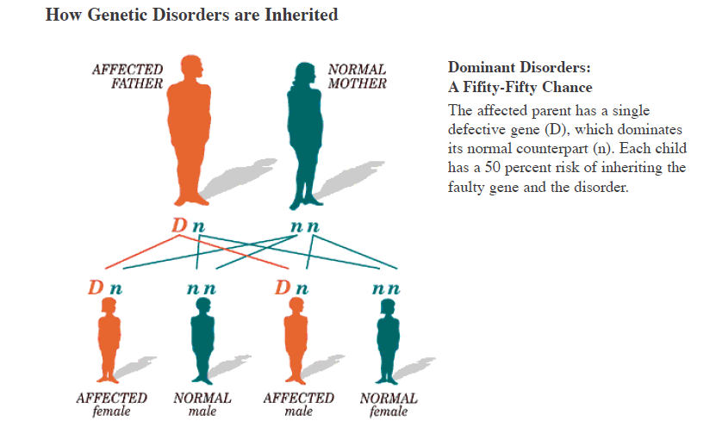
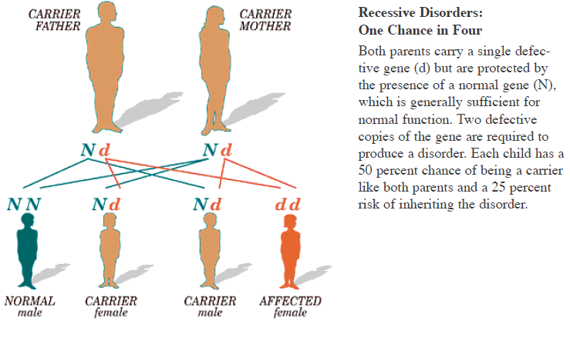
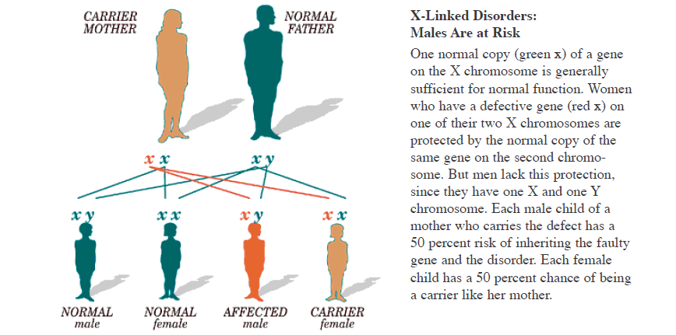
Hunting down the genes that cause disease is a difficult task, even with the human genome now fully decoded. Although humans have many fewer genes than once thought, scientists still estimate there are about thirty thousand genes held within the three billion or so nucleotides in each of our cells. So where and how do researchers begin to look for genes that cause disease?
Long before researchers finished sequencing the genome, some scientists began the painstaking process of isolating the location of genes that cause such rare disorders as Huntington disease and cystic fibrosis. Much of this pioneering work focused on families with well-documented lineages. Researchers traced diseases from one generation to the next, and compared the genomes of living family members in search of differences among them. The more two people are alike -- as are siblings, for instance -- the easier it is to find differences between them. Easier, yes. But not easy.
Researchers looking for "disease genes" received a boost in the late-1980s with the discovery of what are called single nucleotide polymorphisms, or SNPs (pronounced "snips"). Scientists believe that these single-letter misspellings in the DNA code are the key to finding the causes of many common diseases, given that many genetic diseases result from such misspellings. The problem is, scientists have identified about 1.4 million SNPs in the human genome. Even with today's advanced computer technology, testing each one of them for a correlation with a common disease is practically impossible. So how do you identify which SNPs cause disease, when there are too many to test?
Fortunately, SNPs travel in pairs, which means that one variation in the genetic code always has a corresponding variation somewhere else along the same strand. These paired variations act like bookends and, combined with the letters between them, form a relatively long segment of DNA. Thus, researchers wanting to find a specific variation can look for the whole segment -- a significantly larger target than the variation itself. And the bigger the segment, the easier it is to locate.
Until recently, scientists were unsure how long an average SNP segment might be. Estimates ranged as low as three thousand base pairs long -- still dauntingly tiny considering the genome is three billion bases long. It turns out that the average SNP segment (in northern Europeans) is about sixty thousand letters long. This makes searching for the location of a disease-related SNP about twenty times easier than once thought.

Tay-Sachs Disease
- Watch the link below and then read the article.
http://www.pbs.org/wgbh/nova/genome/media/2809_q056_03.html
Tay-Sachs disease is a fatal genetic disorder that causes progressive destruction of the brain in young children. The majority of children with Tay-Sachs appear to develop normally for the first six months of life before rapidly regressing. They develop severe seizures usually by the age of two. By three, most have become completely incapacitated. Children with Tay-Sachs usually die before they reach age five.
The disease is caused by the absence of a vital enzyme called hexosaminidase A, or Hex-A. This enzyme allows the body to break down a fat called GM2 ganglioside. Children with Tay-Sachs do not produce Hex-A, and thus have no way to metabolize GM2 ganglioside. The fat builds up in the body, especially in the brain and other nervous tissue. This buildup of fat creates swelling and ultimately an increase in cranial pressure that causes nerve cells to die.
Each of us has two genes responsible for coding for the enzyme Hex-A. We receive one of these genes from our mother and one from our father. Most of us have two normal, or active, Hex-A genes. Some people have one active and one inactive gene. Fortunately, that's all that is required to be free of Tay-Sachs. Tay-Sachs is a recessive disorder, which means that the presence of one "good," or active, Hex-A gene outweighs the presence of an inactive Hex-A gene.
Inactivity in a Hex-A gene is usually caused by a mutation on the gene itself, a mutation that can be passed from one generation to the next. Of the more than fifty mutations that have been identified, one of the most prevalent results from a single base difference. This means just one nucleotide on that gene is different from the normal sequence of an active Hex-A gene. This tiny difference, if a child were to inherit two of the same type, is enough to cause Tay-Sachs.
Unfortunately, even though the Hex-A gene has been identified, there is still no cure for Tay-Sachs, no way to replace bad genes with good ones. All that the identification of the gene can provide so far is a means to test people who think they might be carriers. Since the first Tay-Sachs screen was developed, millions of such people -- especially those in high-risk ethnic groups, like Eastern European Jews, and those who have a family history of Tay-Sachs -- have been tested for the Hex-A mutation.
A mutation story
- Watch video, read essay and answer discussion questions.
http://www.pbs.org/wgbh/evolution/library/01/2/quicktime/l_012_02.html

A gene known as HbS was the center of a medical and evolutionary detective story that began in the middle 1940s in Africa. Doctors noticed that patients who had sickle cell anemia, a serious hereditary blood disease, were more likely to survive malaria, a disease which kills some 1.2 million people every year. What was puzzling was why sickle cell anemia was so prevalent in some African populations.
How could a "bad" gene -- the mutation that causes the sometimes lethal sickle cell disease -- also be beneficial? On the other hand, if it didn't provide some survival advantage, why had the sickle gene persisted in such a high frequency in the populations that had it?
The sickle cell mutation is a like a typographical error in the DNA code of the gene that tells the body how to make a form of hemoglobin (Hb), the oxygen-carrying molecule in our blood. Every person has two copies of the hemoglobin gene. Usually, both genes make a normal hemoglobin protein. When someone inherits two mutant copies of the hemoglobin gene, the abnormal form of the hemoglobin protein causes the red blood cells to lose oxygen and warp into a sickle shape during periods of high activity. These sickled cells become stuck in small blood vessels, causing a "crisis" of pain, fever, swelling, and tissue damage that can lead to death. This is sickle cell anemia.
But it takes two copies of the mutant gene, one from each parent, to give someone the full-blown disease. Many people have just one copy, the other being normal. Those who carry the sickle cell trait do not suffer nearly as severely from the disease.
Researchers found that the sickle cell gene is especially prevalent in areas of Africa hard-hit by malaria. In some regions, as much as 40 percent of the population carries at least one HbS gene.
It turns out that, in these areas, HbS carriers have been naturally selected, because the trait confers some resistance to malaria. Their red blood cells, containing some abnormal hemoglobin, tend to sickle when they are infected by the malaria parasite. Those infected cells flow through the spleen, which culls them out because of their sickle shape -- and the parasite is eliminated along with them.
Scientists believe the sickle cell gene appeared and disappeared in the population several times, but became permanently established after a particularly vicious form of malaria jumped from animals to humans in Asia, the Middle East, and Africa.
In areas where the sickle cell gene is common, the immunity conferred has become a selective advantage. Unfortunately, it is also a disadvantage because the chances of being born with sickle cell anemia are relatively high.
For parents who each carry the sickle cell trait, the chance that their child will also have the trait -- and be immune to malaria -- is 50 percent. There is a 25 percent chance that the child will have neither sickle cell anemia nor the trait which enables immunity to malaria. Finally, the chances that their child will have two copies of the gene, and therefore sickle cell anemia, is also 25 percent. This situation is a stark example of genetic compromise, or an evolutionary "trade-off."
- Get Molecular level of genetics reading from teacher and answer discussion questions.

HIV
- Watch link below, read the essay and answer discussion questions.
http://www.pbs.org/wgbh/evolution/library/10/4/quicktime/l_104_05.html

The genetic scripts written in DNA code constantly undergo changes, or mutations. At times, these mistakes in a gene's message can be harmful; often, they have no significant effect. Occasionally, though, a mutation confers a survival advantage in the face of an environmental change. Most of the non-carriers of the mutation die, and those with the mutation are able to reproduce. With that powerful evolutionary selection force, the gene can become common in a population.
Recently, scientists were astonished to find that some individuals did not become infected with HIV, even after repeated exposure to the deadly virus.
For some reason, they were immune. A long and difficult scientific search, using blood samples from hundreds of HIV-resistant patients, finally teased out the genetic explanation. Resistant individuals had in their cells two copies of a mutation that disrupted the entryway through which HIV viruses entered white blood cells. People who inherited just one copy of the change could become infected, but their disease progressed more slowly.
With this being such a recent epidemic, where did peoples' immunity come from?
Another puzzle was the way this resistance is distributed throughout the world. In some Northern European populations it is relatively common. In Southern Europeans it is more rare, and it is almost entirely absent in Africans, Asians, and Native Americans. Logically, the mutation must have occurred in the past, acting as a defense against a different, previous epidemic caused -- like the AIDS epidemic -- by a pathogen that also targeted white blood cells.
Reading a chronological history, biologists traced the HIV-resistance gene mutation back about 700 years. That was the time at which the Black Death -- bubonic plague -- swept like a deadly scythe through Europe, killing one-third of the population. Then, as now, there were individuals who survived the lethal organism, perhaps because it could not enter their white blood cells. The areas that were hardest hit by the Black Plague match those where the gene for HIV resistance is the most common today.
At present, scientists are trying to infect such resistant cells with bubonic plague bacteria to test the hypothesis that the mutation in the CCR-5 receptor gene could have thwarted the plague in the Middle Ages, as it does HIV today. If it turns out that this mutation does protect against the plague, this coincidence will be yet another illustration of what scientists are finding over and over in the human genome: Nature's past successes often remain part of our genetic toolbox.

Genetic Drift and Founder effect
- Read the information below and answer discussion questions.

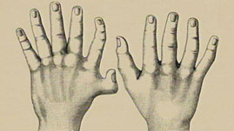
Eastern Pennsylvania is home to beautiful farmlands and countryside, but it's also a gold mine of information for geneticists, who have studied the region's Amish culture for decades. Because of their closed population stemming from a small number of German immigrants -- about 200 individuals -- the Amish carry unusual concentrations of gene mutations that cause a number of otherwise rare inherited disorders, including forms of dwarfism.
One form of dwarfism, Ellis-van Creveld syndrome, involves not only short stature but polydactyly (extra fingers or toes), abnormalities of the nails and teeth, and, in about half of individuals, a hole between the two upper chambers of the heart. The syndrome is common in the Amish because of the "founder effect."
When a small part of a population moves to a new locale, or when the population is reduced to a small size because of some environmental change, the genes of the "founders" of the new society are disproportionately frequent in the resulting population.
If individuals in the group tend to marry within it, there's a greater likelihood that the recessive genes of the founders will come together in the cells that produce offspring. Thus diseases of recessive genes, which require two copies of the gene to cause the disease, will show up more frequently than they would if the population married outside the group.
In the Amish, in fact, Ellis-van Creveld syndrome has been traced back to one couple, Samuel King and his wife, who came to the area in 1744. The mutated gene that causes the syndrome was passed along from the Kings and their offspring, and today it is many times more common in the Amish population than in the American population at large.
The founder effect is an extreme example of "genetic drift." Genes occurring at a certain frequency in the larger population will occur at a different frequency -- more or less often -- in a smaller subset of that population. As in the example of human diseases, genetically determined traits that would ordinarily be uncommon in the overall gene pool might crop up with distressing frequency in a small subset of that pool.

http://az.pbslearningmedia.org/asset/tdc02_int_hglandmarks/

Chromosomes

Read the Essay and answer the discussion questions
Inside every one of our cells (except red blood cells) is a nucleus containing 23 pairs of chromosomes. These chromosomes are built from long strands of a ladder-shaped molecule called deoxyribonucleic acid (DNA). The DNA molecule, in turn, is made up of many smaller components. These nucleotides, or bases, pair up to form the rungs of theDNA ladder. Although there are only four different types of nucleotides in DNA (usually referred to by the first letter of their chemical name ,A, T, C, and G), these molecules, repeated 3 billion times in the human genome, carry the instructions required to build our bodies and regulate our functions.
Usually, nucleotides are not particularly meaningful on their own. Combined, however, specific sequences of nucleotides -- ATTTCG, for example -- spell out the genetic instructions for building proteins. Agene is one such sequence, one section of a chromosome that provides the code that influences a trait -- like eye color, for instance. (Scientists believe that three or more genes interact to determine a person's eye color.)
Locating genes that influence specific physical traits among the 3 billion nucleotides in the human genome is a notoriously difficult task. To find genes, researchers often try to correlate physical differences with genetic differences. Genetic diseases are often caused by striking genetic differences, so one method gene hunters use is to compare the DNA of people who have a disorder with those who do not. When a scientist finds differences in DNA sequences between these groups, they have a clue to one possible culprit in the disease. Other methods are used to identify genes not implicated in disease. They include computational methods such as comparing human DNA sequences to those in animals that have been well studied and in which many genes have been identified. Current estimates of human genes are about 30,000-40,000, but the functions of the vast majority of these remain unknown.

