Fall final study guide

Parts of experiment

*S1 C1 PO4: Predict the outcome of an investigation based on prior evidence, probability, and/or modeling.*

1. A student notes that placing the light at different distances from an aquatic plant causes the rate of bubbling to vary. The student decided to test the effect of light intensity on the rate of bubble production. The results of the experiment are in the table below.

Effect of light intensity on bubble production

|  |  |
| --- | --- |
| Distance of light (cm) | Amount of bubbles per minute |
| 50 cm | 50 |
| 100 cm | 30 |
| 150 cm | 10 |

* 1. What is being tested in the above experiment?
  2. What is the independent variable?
  3. What is the dependent variable?
  4. What process is producing the bubbles?
  5. What type of relationship exists between the two variables? Explain your answer.
  6. What is the conclusion of the experiment?

1. Explain the difference between a Theory and a law?
2. Identify the types of relationships that exist between the variables in the data tables and graphs below.
   1. Human Body Surface Area as it Relates to Body Weight



* 1. Effect of Hormone on root length



* 1. Effect of pH level on Number of Bacterial Colonies



Cells

*S4 C1 PO3: Explain the importance of water to cells*

1. List the functions of water in a cell.
2. 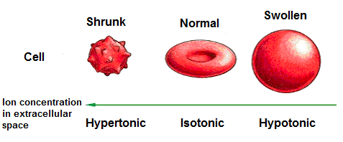Label the type of solution the following cells are in. Explain why the cell shrinks, and why it swells.

*S4 C1 PO4: Analyze mechanisms of transport of materials into and out of cells*



1. What process accounts for the change shown in lab setup A?
2. In lab setup B, structure Z prevents the movement of sugar molecules into side 1. Which part of a living cell serves the same purpose as structure Z?
3. When does diffusion stop?
4. Fill out the table below.

|  |  |  |
| --- | --- | --- |
| Type of transport | Definition | Example |
| Diffusion |  |  |
| Facilitated diffusion |  |  |
| osmosis |  |  |

1. Describe the process of exocytosis. What organelle will play a role?
2. When is diffusion over?
3. Which transport process is considered to be passive? What does it mean that they are passive?
4. Describe the process of active transport?
5. What direction are the water molecules going to move in the picture below? What is this process called?

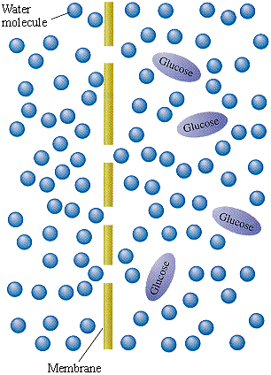

1. What organelles are common to plant and animal cells?
2. What organelles do plants have that animal cells don’t?
3. What structures/organelles are common to both eukaryotes and prokaryotes?
4. Which organelles do eukaryotes have that prokaryotes do not?
5. What is the function of the following organelles: mitochondria, lysosomes, nucleus, ribosomes?
6. What organisms have cell walls?
7. Why is the cell membrane called a fluid mosaic?
8. What are the structures contained within cells called?
9. List the level of organization from smallest to largest. Be able to identify which level contains the other.

DNA

*S2 C1 PO2:*

*Describe how diverse people and/ or cultures, past and present, have made important contributions to scientific innovations.*

1. Explain how Watson and Crick, Rosalind Franklin, Chargaff and Wilkins contributed to the discovery of the DNA model
2. If an organism has 24 chromosomes how many chromosomes will it have at the end of mitosis and meiosis?
3. What is a gene?
4. What is the relationship between DNA, genes and chromosomes? In other words are they made out of the same material? Do they have the same function or how is their function related?
5. What are the parts of a DNA strand?
6. What is the difference between RNA and DNA?
7. Explain the difference between a haploid cell and a diploid cell. Give an example where haploid cells become diploid.
8. What monitors a cells progress through the cell cycle?
9. Describe what happens during each phase of mitosis.
10. In what phase of the cell cycle does the cell spend most of its time?
11. What is the difference between a gametic and somatic cell in terms of chromosome number and function?
12. The union of egg and sperm results in a zygote. How much DNA does each gamete contribute to the zygote?

Cell energy

1. Which cellular process breaks down carbohydrates and makes ATP? Make a flow chart that includes how many ATP and the reactants and products used during each step.
2. List the reactants and products of photosynthesis.
3. Summarize what happens during the light dependent and light dependent reaction of photosynthesis

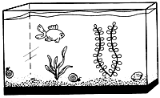

1. Using the diagram above label the following.
   1. The organism(s) that goes through the process of respiration,
   2. The organism(s) that goes through the process of photosynthesis.
   3. Which organism(s) produce carbon dioxide?
   4. Which organism(s) produce oxygen?
   5. Which organism(s) produce glucose?
   6. Which organism(s) use oxygen?
   7. Which organism(s) use carbon dioxide?
   8. Which organism(s) produce water?
2. What is the function of cristae in respiration? If you increase the percentage of cristae how do you affect respiration?
3. Why do you see leave as green?
4. Compare and contrast anaerobic vs. aerobic respiration in terms of number of steps, reactants, and products.

**Macromolecules**

1. What are the monomers for carbohydrates, proteins, and lipids?
2. What are the functions of carbohydrates, proteins, and lipids?
3. Describe characteristics of enzymes.
4. List some factors that affect enzyme activity.