DNA and Protein synthesis Review
Name _____________________________ Hour ___________ Date __________
DNA Scientists: Answer the following questions about the following scientists experiments.
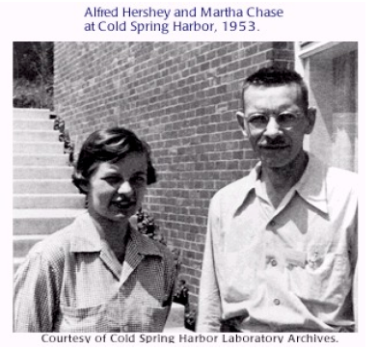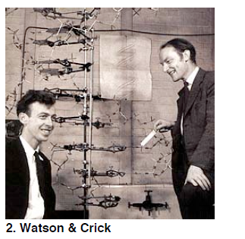
- Hershey and Chase 2. Watson and Crick
- Which two molecules was the possible genetic material of chromosomes? __proteins and DNA_____________ | a. What did Watson and Crick discover? ____________DNA shape____________________
- From their experiment what conclusion was made? DNA is genetic material | b. What is the shape of DNA?  ______________helix__________________
- What two organisms did they use to determine DNA was the genetic material? Bacteria and bacteriophage

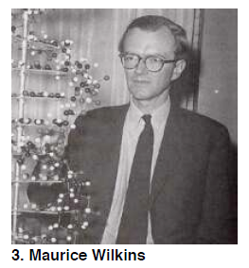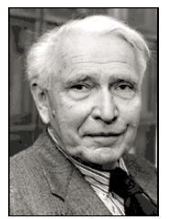
3. Maurice Wilkins 4. Erwin Chargaff
a. What did Maurice Wilkins give Watson and Crick?  A picture of DNA | a. What is Chargaff’s rule? Amounts of A= T and amounts of C=G in a sample of DNA
b. Who did he work closely with? Rosalind Franklin

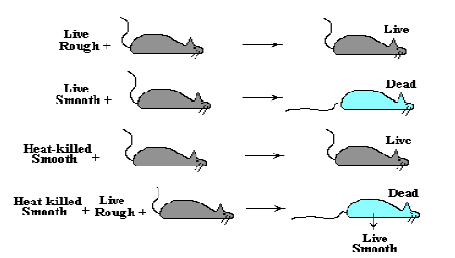
5. Fredrick Griffith’s Experiment
a. What type of bacteria did Griffith work with? ___Streptococcus pnemonia______________________
b. What strain was virulent (harmful)? _______smooth strain____
c. What strain was harmless? _rough strain________
d. What term did he phrase that means bacteria takes in outside DNA and genetically change? _________transformation__________
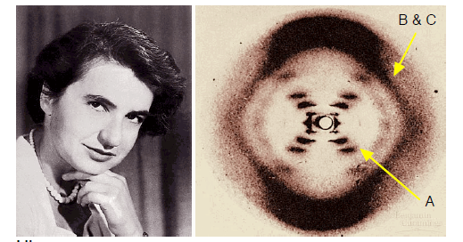
6. Rosalind Franklin
a. What did Franklin do with DNA? _took pictures of it_______
b. What type of technology did she use to take pictures of DNA? __________X-ray crystallography____
c. What does the picture above show about DNA? _________shape of DNA_______
d. What are the structures labeled A? Bases___________________
e. What are the structures labeled B and C? phosphate and sugars_______
The structure of DNA:
7. Label the diagram
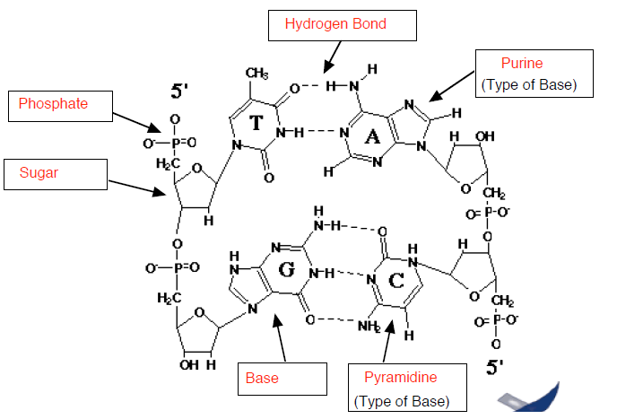
8. What type of sugar is found in DNA? _____________________Deoxyribose________
9. What type of bonds hold the bases of DNA together? ______hydrogen__________________
10. Which two molecules form the back bone of DNA? ______sugar and phosphate___________
11. What is the monomer of DNA? _____nucleotide_______
12. What does DNA stand for? _______deoxyribonucleic acid.
13. Looking at the diagram, what is the difference between a purine and pyramidine? _________they should put that a pyramidine is a single ring and purine is a double ring__________________________________________________________________________________________________
__________________________________________________________________________________________________
__________________________________________________________________________________________________
14. Which two bases are purines? ______guanine and adenine_____________
15. Which two bases are pyramidines? ___thymine and cytosine______

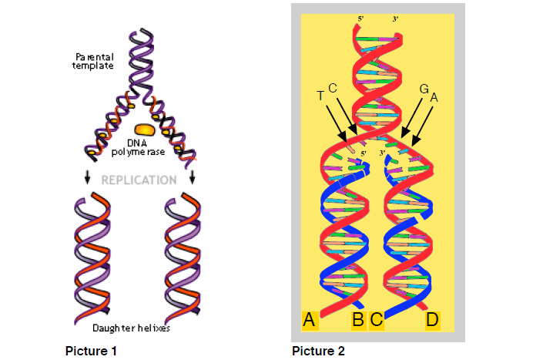
16. What is the first step of Replication? _____DNA molecule unzips________________________________
17. Which enzyme helps with the question above? ____helicase___________
18. Which enzyme matches up free floating nucleotides to the parent strand? DNA polymerase
19. Why is replication called semiconservative? Because an old strand bonds with a new one
__________________________________________________________________________________________________
20. Where does DNA replication occur? _______nucleus_____________
21. Why does DNA replication occur? _______________so a cell can go through cell division___________
__________________________________________________________________________________________________
Honors only
22. Explain why Okasaki fragments occur on the lagging strand. ____because replication has to proceed 5’ to 3’ and the other strand has to go in the other direction._________________________________________
__________________________________________________________________________________________________
__________________________________________________________________________________________________
22. Which enzyme is used to fill in spaces in the new DNA strand? __________ligase______

DNA v.s. DNA: identify the following characteristics as DNA or RNA.
23. ___DNA___________ contains deoxyribose 24. ______DNA_________ contains A, T, C and G
25. ___RNA___________ single stranded molecule 26. __________DNA_____ double helix
27. _____RNA_________ contains ribose 28. ___RNA___________ Contains A, U, C and G
29. ____DNA__________ found only in the nucleus 30. ______RNA___ found in nucleus and cytoplasm
31. ___RNA___________ 3 different types
32. Label the diagram below
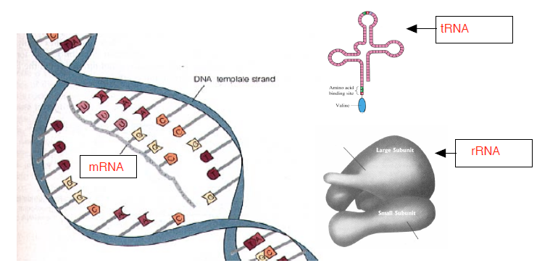
33. What process makes mRNA __________Translation____________?
34. What type of RNA makes up the ribosome? _______rRNA______________________
35. What type of RNA carries amino acids to the ribosome? __tRNA_____________________________
36. What does the “m” in mRNA stand for? _________messenger______
37. Where in the cell is mRNA made? __________________Nucleus____________
38. Where does mRNA go after it leaves the nucleus? __________cytoplasm to ribosome__________________________
39. What does the “t” in tRNA stand for? _________transfer______________________________
40. What process occurs at the ribosome? ______________transcription______________________________
41. What would be the mRNA for the following DNA strand?
DNA: T A C G G C A T C G T A G C T A
A T G C C G T A G C A T C G A T

Genetic code: Use the chart below to answer the following questions:
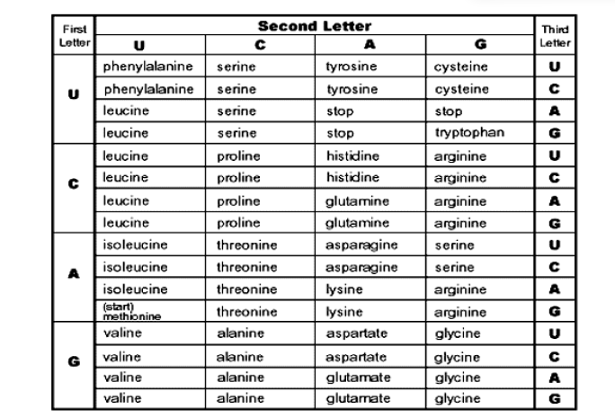
42. Indicate the following amino acids that are represented by the codons in the chart.
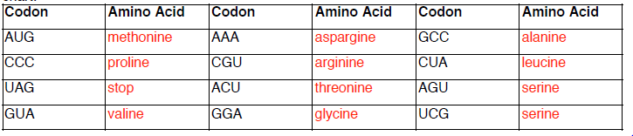
43. What Amino acid must every protein begin with?________Methionine______________________________________
44. Which codon codes for the above question? ____________________AUG______________________________
45. What would happen if a transcribed mRNA did not have the codon in question 44? _______translation would not proceed_______________________________________________________________________________________________
46. What must every protein end with? ________________________stop______
47. Which three codons code for question 46? _____________UAA, UAG & UGA_______

48. Label the diagram below.

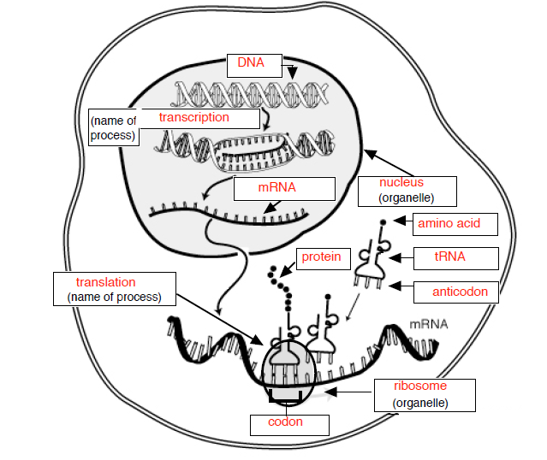
49. What is the term for the 3 bases on the tRNA that matches with the three bases on the mRNA? _____Anticodon
50. What occurs during translation? ______protein is made______________________________________
51. What occurs during transcription _________mRNA molecule is made________________________
52. How are transcription and translation different? ________Transcription occurs in nucleus and makes the message of DNA, translation occurs in the cytoplasm and takes the message of mRNA and makes a protein
__________________________________________________________________________________________________
__________________________________________________________________________________________________
53. What does the tRNA carry to the ribosome? ___amino acid__________
54. What are the bonds between amino acids called? ____peptide_______
55. Which organelle is involved in translation? __________________________________________________________

Mutations: use the notes, workbook or textbook to answer the questions below
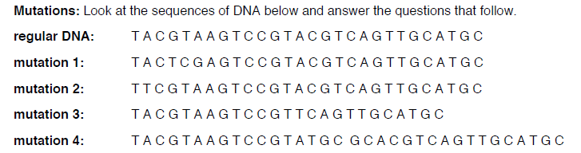
56. What type of mutation is shown in mutation 1? ____________substitution____________
57. What type of mutation is shown in mutation 2? ____________point mutation________
58. What type of mutation is shown in mutation 3? ________deletion_______
59. What type of mutation is shown in mutation 4? _______addition_______

