Name:
Period:

Discovering DNA

Introduction. How is genetic information stored in chromosomes? And by what code—or language—does the cell interpret this information? To answer these questions, biologists first had to learn which molecule inside chromosomes contains genes—proteins, DNA or carbohydrates. In other words, they had to find the molecule or molecules of heredity. In this investigation you will retrace the work of other scientists that proved DNA is the genetic material of life and then you will duplicate the work of Watson and Crick in order to create a model of DNA from some basic evidence.

Task #1: We now know that DNA determines traits, but for a long time scientist could not answer the basic question… What molecule found within cells is the genetic material that determines traits? The answer to this question was not an easy one to answer. A scientist named T.H. Morgan showed that genes are found on chromosomes, so scientist suspected that DNA, carbohydrates or a protein determines the traits of an organism because those molecules can be found within chromosomes. But is it DNA, protein, a carbohydrate or a combination of these? Your task is to use the results of the following experiments to prove which molecule determines traits.

Griffith and his work with Pneumonia

In 1928, a British doctor named Frederick Griffith was investigating the way in which a certain type of bacteria, Diplococcus pneumoniae, caused pneumonia, a serious and often-fatal lung disease. Scientists already knew which type of bacteria caused the disease, but they were trying to learn how bacteria caused the disease.
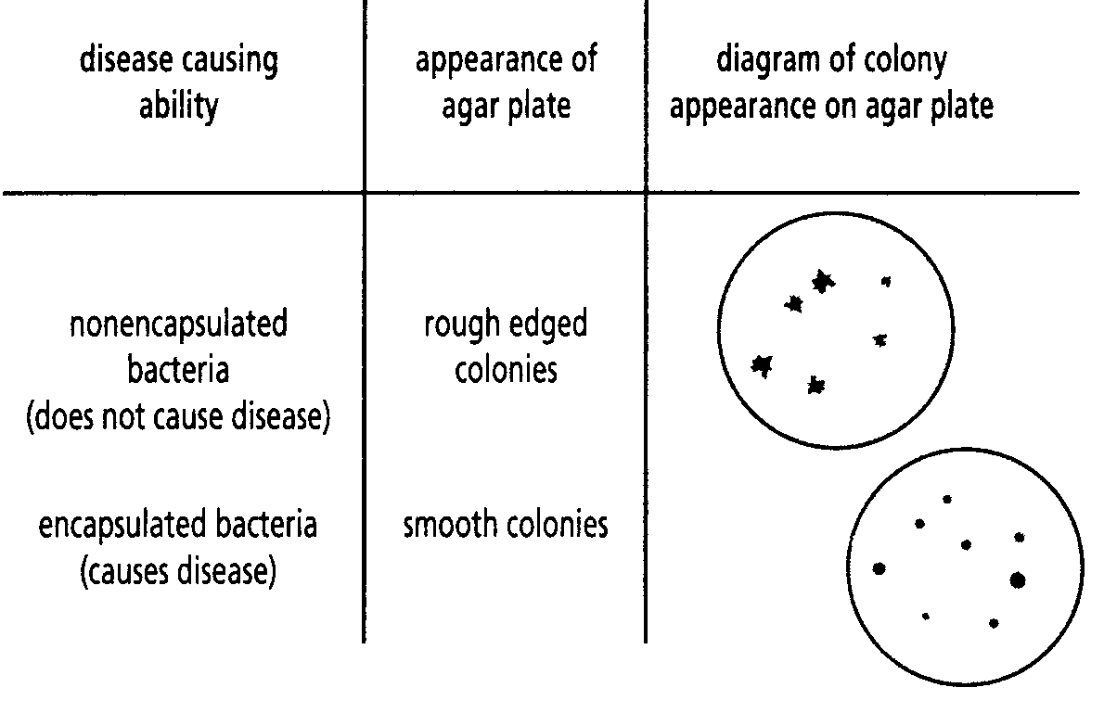
Griffith studied two strains of D. pneumoniae. Both grew very well in his laboratory, but only one actually caused pneumonia when injected into mice. Griffith was able to distinguish between these two strains based on how they grew on agar plate.

Bacteria grow in colonies (a mass of cells) on agar plates, and colonies that appeared smooth caused disease, while colonies that appeared rough did not. The reason the two strains look different is because the strain that appears smooth produces a capsule (which is made up of a carbohydrate) that protects the bacterium from the host’s immune system while the one that appears rough cannot produce a protective capsule.

Griffith hypothesized that the carbohydrate capsule that surrounds the smooth bacteria was responsible for the disease. He has two important pieces of information before he started his experiment: the bacteria with carbohydrate capsules could kill mice, while the non-capsule forming bacteria could not. (See diagram at right)

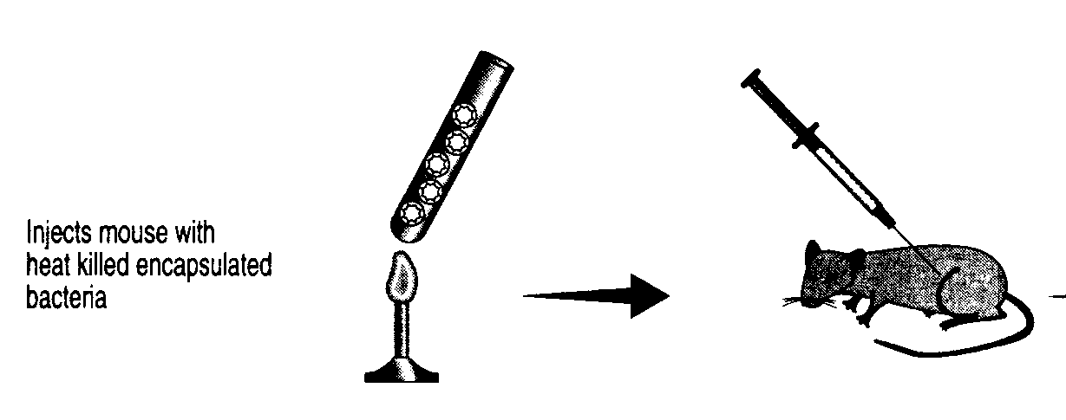
With this information he conducted the experiment at right:

Use this information to fill in the flow chart based on this experiment

Griffith’s First Experimental Question

Hypothesis 1

If…

Experiment Things he would have needed to controlled (at least two)

And…

Predicted Result if Hypothesis 1 is True

Actual Result Conclusion

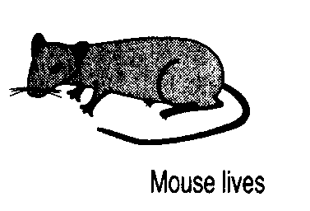

Then… Therefore…

No bacteria in
mouse’s blood

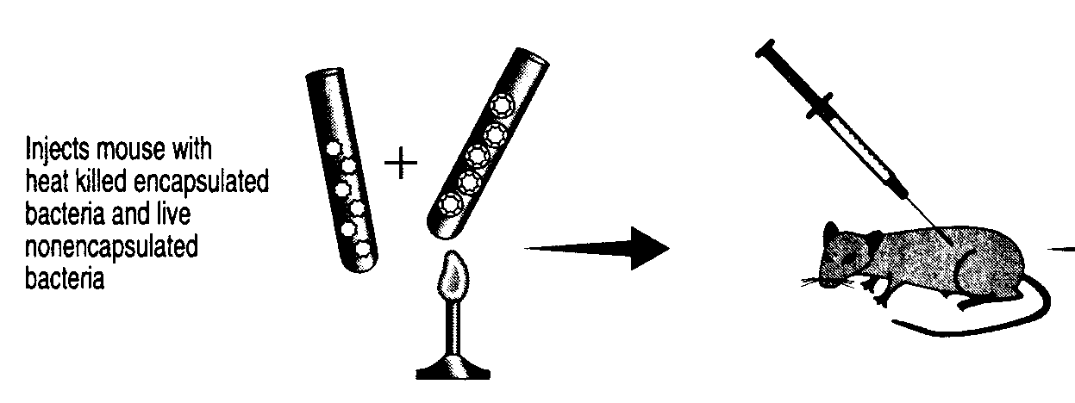
Griffith then conducted a second experiment, illustrated at right:

Use this information to fill in the flow chart based on this experiment.

Griffith’s Second Experimental Question

Hypothesis 1

If…

Experiment Things he would have needed to control (at least two)

And…

Predicted Result if hypothesis 1 is True

Actual Result Conclusion

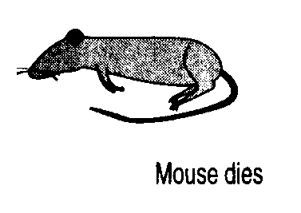

Then… Therefore…

Smooth Bacteria found
In mouse’s blood

When Griffith, removed the bacteria from dead mice in his experiment, and grew them on agar plates, he found only colonies of smooth bacteria. Somehow the harmless, non-capsule forming bacteria had changed into the disease causing strain. Something had been transferred from the killed, disease causing strain, to the living, non-disease causing stain giving it the ability to make the carbohydrate capsule and cause disease. But what was it, DNA or Protein?

Hershey and Chase and their work with Viruses

In 1952, two American scientists, Alfred Hershey and Martha Chase carried out an experiment that answered this question once and for all. Hershey and Chase worked with viruses, tiny particles that are made up of only DNA and Protein (similar to a pill with a powder on the inside of it). Hershey and Chase knew that viruses injected their genes into a host cell, where the genes took over the host cell and forced that cell to make 1000’s of new viruses. If they could determine which of these two molecules, DNA or Protein, entered a host cell when a virus infects it they could determine what genes are made of, DNA or Protein.

To accomplish this task, they used radioactive particles to mark the DNA and the Protein within viruses. Hershey and Chase prepared two samples of viruses, one sample with a radioactive marker called phosphorus-32 that marks DNA, and the other sample with sulfer-35, which marks protein. See below.
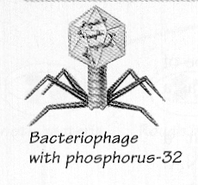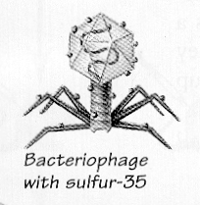
Phosphorus-32 only marks the DNA of a virus like the bacteriophage pictured above.
Sulfer-35 only marks the Protein that makes up a virus like the bacteriophage pictured above.

Hershey and Chase then allowed both samples of viruses (also known as Bacteriophage) to infect different samples of bacteria and then tested those samples of bacteria to see if they contained any radioactive material from the viruses. Only one of the samples had bacteria that were radioactive. See the diagram below.
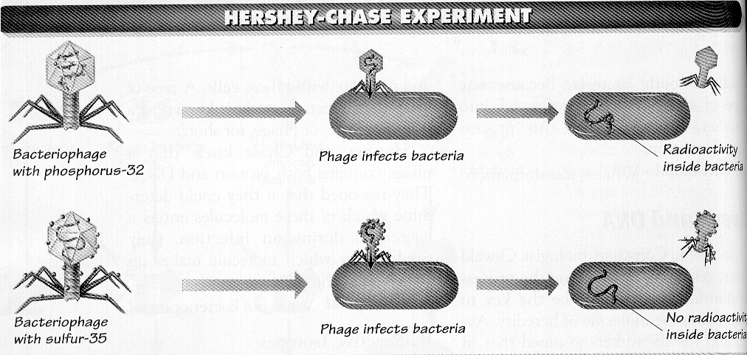
Use the information above and from pages 173-174 in your textbook to fill in the flow chart based on this experiment.
Hershey and Chase’s Experimental Question

Hypothesis 1

If…

Experiment Things they would have needed to Control (at least two)
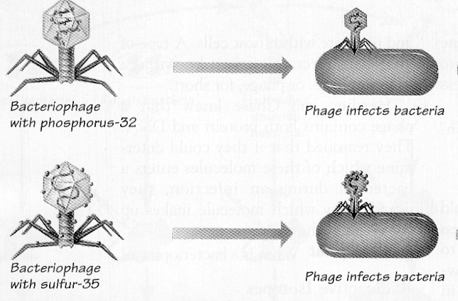

And…

Predicted Result if Hypothesis 1 was True

Actual Result Conclusion

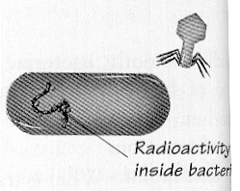
Phosphorus-32 found within bacteria

Then… Therefore…

Task #2: The American biochemist Erwin Chargaff was testing samples of DNA and made an important discovery in 1950. He figured out which base bonded to which base on strand of DNA. Your task is to reproduce the investigation of Chargaff.

You will reproduce Chargaff’s investigation by using a paper bag as your beaker and colored shapes as the bases of DNA. Take the shapes out one by one and record the number of each base you find in the chart below.

Amount of Adenine | Amount of Cytosine | Amount of Thymine | Amount of Guanine

Using the above information make a conclusion about which bases are bonded together.
_____________________________________________________________________________________________

_____________________________________________________________________________________________

Task #3: Imagine that you are on a team of research scientists involved in an effort to describe the structure of the DNA molecule. You have decided to tackle this task by modeling, that is, by building a physical representation of a possible structure for DNA. You will then be able to change this model to reflect new information as it becomes available.

The DNA Molecule—Examine the information about DNA available to you listed in the box below. Use this information and colored shapes to build a model of what you think a DNA molecule looks like. Once you have built your model, draw a color-coded picture in the box on the next page and include a key. On the diagram of your DNA model, show how you model takes all these properties into account by labeling these properties on your model.

Properties of DNA

- DNA is a very long, chain-like molecule composed of smaller (subunit) molecules. Subunit molecules are like the links of a chain.
- DNA is composed of 6 different subunit molecules:
Guanine (a base) Thymine (a base)
Deoxyribose (a sugar) Adenine (a base)
Phosphate Cytosine (a base)
Each colored hexagon will be used to represent a different subunit in your model!
- DNA consists of two long chains of subunits twisted around each other to form a “double” helix (a helix is the shape a pipe cleaner takes when you wrap it around a pencil)
- The two chains are bonded (connected) together. A subunit from one strand bonds to a subunit on the other.
- The diameter of DNA is the same along its entire length (exactly 4 molecules or subunits wide)—which was discovered by Rosalind Franklin in 1951.
- In a molecule of DNA, a sugar can only bind with a base and a phosphate
- In a molecule of DNA, a base can only bind with a sugar and another base
- In a molecule of DNA, a phosphate can only bind with a sugar

Your Model

Key
Phosphate

Deoxyribose (sugar)

Adenine (base)

Cytocine (base)

Thymine (base)

Guanine (base)

A

The Actual Structure of DNA—Examine the video model of DNA and read DNA “Structure and Replication” (page 175-180 in Biology: The Living Science) and then answer the following questions.

Label each part of the DNA molecule in the diagram below.

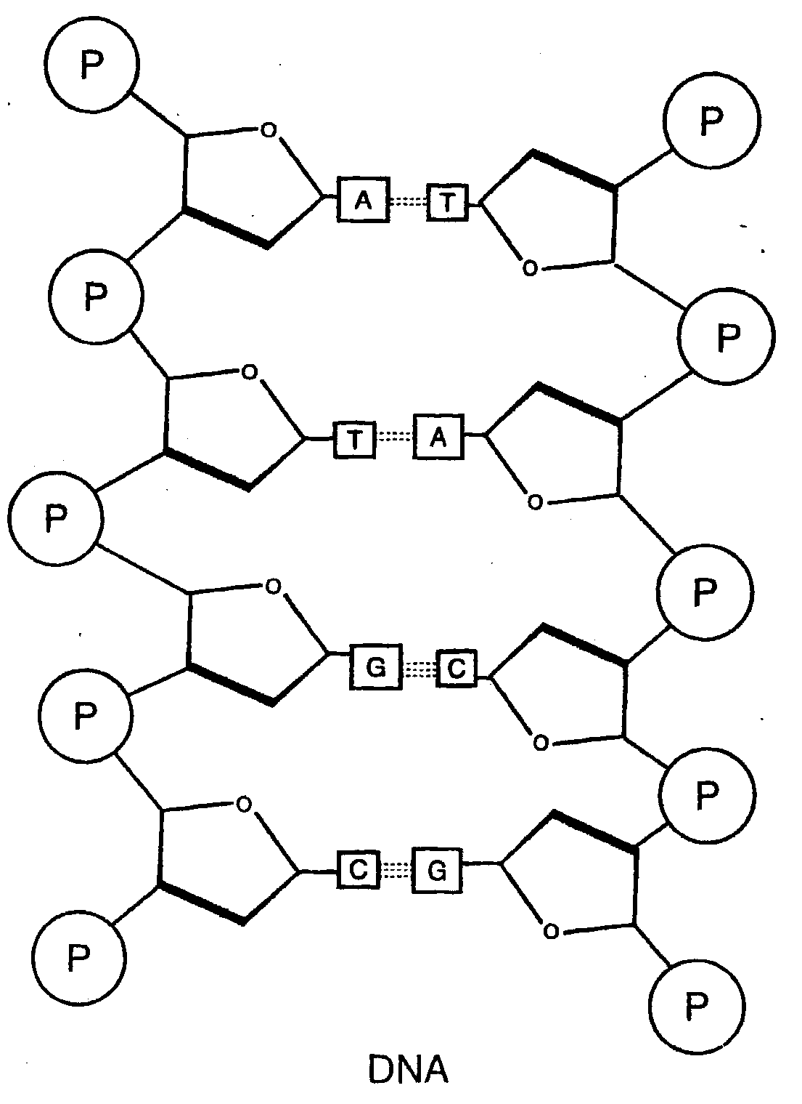

Explain how DNA is able to store genetic information. Include a diagram if needed.

Explain how DNA is copied (replicated) so it can be passed on to the four cells formed through meiosis. Include diagrams as needed.

