Biology for kids

PHOTOSYNTHESIS -
PART I: THE SUN AND LIGHT
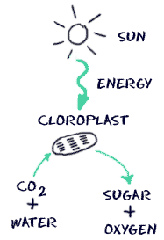
Not all of the light from the Sun makes it to the surface of the Earth. Even the light that does make it here is reflected and spread out. The little light that does make it here is enough for the plants of the world to survive and go through the process of photosynthesis. Light is actually energy, electromagnetic energy to be exact. When that energy gets to a green plant, all sorts of reactions can take place to store energy in the form of sugar molecules.
Remember we said that not all the energy from the Sun makes it to plants? Even when light gets to a plant, the plant doesn't use all of it. It actually uses only certain colors to make photosynthesis happen. Plants mostly absorb red and blue wavelengths. When you see a color, it is actually a color that the object does NOT absorb. In the case of green plants, they do not absorb light from the green range.

PART II: THE CHLOROPLAST
We already spoke about the structure of chloroplasts in the cells tutorials. We want to reinforce that photosynthesis happens in the chloroplast. Within this cell organelle is the chlorophyll that captures the light from the Sun. The molecules are moved and converted in the area called the stroma.

PART III: THE MOLECULES
Chlorophyll is the magic compound that can grab that sunlight and start the whole process. Chlorophyll is actually quite a varied compound. There are four (4) types: a, b, c, and d. Chlorophyll can also be found in many microorganisms and even some prokaryotic cells. However, as far as plants are concerned, the chlorophyll is found in the chloroplasts. The other big molecules are water (H₂O), carbon dioxide (CO₂), oxygen (O₂) and glucose (C₆H₁₂O₆). Carbon dioxide and water combine with light to create oxygen and glucose. That glucose is used in various forms by every creature on the planet. Animal cells require oxygen to survive. Animal cells need an aerobic environment (one with oxygen).

PART IV: LIGHT Dependent and Light Independent reactions
The whole process doesn't happen all at one time. The process of photosynthesis is divided into two main parts. The first part is called the light dependent reaction. This reaction happens when the light energy is captured and pushed into a chemical called ATP. The second part of the process happens when the ATP is used to make glucose (the Calvin Cycle). That second part is called the light independent reaction.

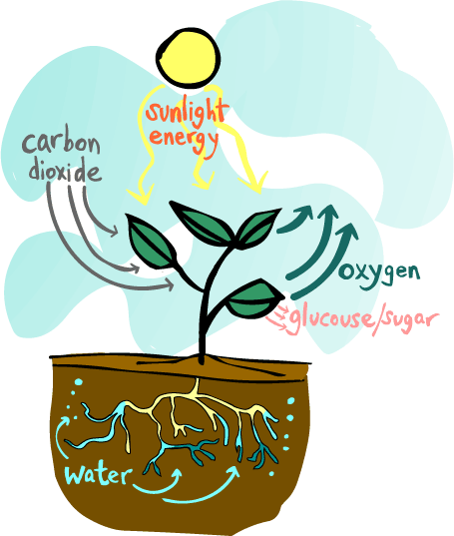
Photosynthesis
Photosynthesis is the process of converting light energy to chemical energy and storing it in the bonds of sugar. This process occurs in plants and some algae (Kingdom Protista). Plants need only light energy, CO₂, and H₂O to make sugar. The process of photosynthesis takes place in the chloroplasts, specifically using chlorophyll, the green pigment involved in photosynthesis.
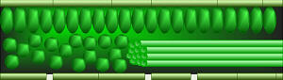
Photosynthesis takes place primarily in plant leaves, and little to none occurs in stems, etc. The parts of a typical leaf include the upper and lower epidermis, the mesophyll, the vascular bundle(s) (veins), and the stomates. The upper and lower epidermal cells do not have chloroplasts, thus photosynthesis does not occur there. They serve primarily as protection for the rest of the leaf. The stomates are holes which occur primarily in the lower epidermis and are for air exchange: they let CO₂ in and O₂ out. The vascular bundles or veins in a leaf are part of the plant's transportation system, moving water and nutrients around the plant as needed. The mesophyll cells have chloroplasts and this is where photosynthesis occurs.

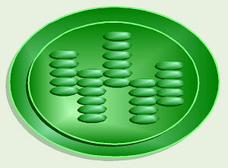
As you hopefully recall, the parts of a chloroplast include the outer and inner membranes, intermembrane space, stroma, and thylakoids stacked in grana. The chlorophyll is built into the membranes of the thylakoids.
Chlorophyll looks green because it absorbs red and blue light, making these colors unavailable to be seen by our eyes. It is the green light which is NOT absorbed that finally reaches our eyes, making chlorophyll appear green. However, it is the energy from the red and blue light that are absorbed that is, thereby, able to be used to do photosynthesis. The green light we can see is not/cannot be absorbed by the plant, and thus cannot be used to do photosynthesis.
The overall chemical reaction involved in photosynthesis is: 6CO₂ + 6H₂O (+ light energy) C₆H₁₂O₆ + 6O₂. This is the source of the O₂ we breathe, and thus, a significant factor in the concerns about deforestation.

There are two parts to photosynthesis:
The light reaction happens in the thylakoid membrane and converts light energy to chemical energy. This chemical reaction must, therefore, take place in the light. Chlorophyll and several other pigments such as beta-carotene are organized in clusters in the thylakoid membrane and are involved in the light reaction. Each of these differently-colored pigments can absorb a slightly different color of light and pass its energy to the central chlorphyll molecule to do photosynthesis. The central part of the chemical structure of a chlorophyll molecule is a porphyrin ring, which consists of several fused rings of carbon and nitrogen with a magnesium ion in the center.
The energy harvested via the light reaction is stored by forming a chemical called ATP (adenosine triphosphate), a compound used by cells for energy storage. This chemical is made 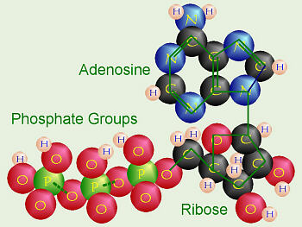of the nucleotide adenine bonded to a ribose sugar, and that is bonded to three phosphate groups. This molecule is very similar to the building blocks for our DNA.

The dark reaction takes place in the stroma within the chloroplast, and converts CO₂ to sugar. This reaction doesn't directly need light in order to occur, but it does need the products of the light reaction (ATP and another chemical called NADPH). The dark reaction involves a cycle called the Calvin cycle in which CO₂ and energy from ATP are used to form sugar. Actually, notice that the first product of photosynthesis is a three-carbon compound called glyceraldehyde 3-phosphate. Almost immediately, two of these join to form a glucose molecule.
Most plants put CO₂ directly into the Calvin cycle. Thus the first stable organic compound formed is the glyceraldehyde 3-phosphate. Since that molecule contains three carbon atoms, these plants are called C₃ plants. For all plants, hot summer weather increases the amount of water that evaporates from the plant. Plants lessen the amount of water that evaporates by keeping their stomates closed during hot, dry weather. Unfortunately, this means that once the CO₂ in their leaves reaches a low level, they must stop doing photosynthesis. Even if there is a tiny bit of CO₂ left, the enzymes used to grab it and put it into the Calvin cycle just don't have enough CO₂ to use. Typically the grass in our yards just turns brown and goes dormant. Some plants like crabgrass, corn, and sugar cane have a special modification to conserve water. These plants capture CO₂ in a different way: they do an extra step first, before doing the Calvin cycle. These plants have a special enzyme that can work better, even at very low CO₂ levels, to grab CO₂ and turn it first into oxaloacetate, which contains four carbons. Thus, these plants are called C₄ plants. The CO₂ is then released from the oxaloacetate and put into the Calvin cycle. This is why crabgrass can stay green and keep growing when all the rest of your grass is dried up and brown.
There is yet another strategy to cope with very hot, dry, desert weather and conserve water. Some plants (for example, cacti and pineapple) that live in extremely hot, dry areas like deserts, can only safely open their stomates at night when the weather is cool. Thus, there is no chance for them to get the CO₂ needed for the dark reaction during the daytime. At night when they can open their stomates and take in CO₂, these plants incorporate the CO₂ into various organic compounds to store it. In the daytime, when the light reaction is occurring and ATP is available (but the stomates must remain closed), they take the CO₂ from these organic compounds and put it into the Calvin cycle. These plants are called CAM plants, which stands for crassulacean acid metabolism after the plant family, Crassulaceae (which includes the garden plant Sedum) where this process was first discovered.

http://www.youtube.com/watch?v=zEgIO9Kq2_Y&feature=related

bill nye plants part one
http://www.youtube.com/watch?v=QlXVF3uVMJY&feature=related

bill nye plants part two
http://www.youtube.com/watch?feature=endscreen&v=dsO41rUjc28&NR=1

